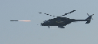
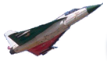
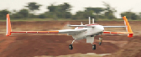
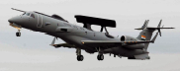

Standard of Equipment for <Name>

Document No: <Doc No>, Revision: -

Coordination Sheet

PREPARED BY | Design Eng. | <Name> | <Signature>
REVIEWED BY | Design Eng. | <Name> | <Signature>
APPROVED BY | Design Head | <Name> | <Signature>
 | CEMILAC/RCMA | <Name> | <Signature>

Revisions

Rev No. | Date | Description

Standard of Equipment to be prepared at platform level such as Aircraft, Air Launched Weapon or UAV. SOE document is a compilation of subsystems which are applicable to the platform configuration.

Sl. no. | System Name | Part. No. with Mod | Software Version | OEM | Remarks

