Man Mounted Air Conditioning System

Background:

Microclimate cooling garments has been found to be very effective in alleviating effects of high temperature. A solid state cooling system, called Man Mounted Air Conditioning System (MMACS), has been developed by DIPAS on the principle of ‘Peltier Effect’.

Key Features:

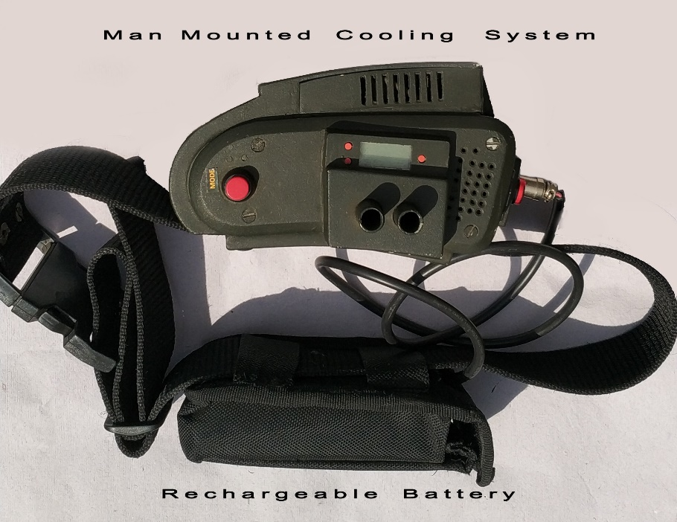
- Thermoelectric cooling is based on ‘Peltier Effect’ in which current passed around a circuit of different materials, one junction gets heated while other junction is cooled depending on the direction of current flow.
- Design of components was carried out by thermal impedance matching principle.
- The cooling systems, employing this technology are solid state and CFC gas free device. These are highly reliable , low power consuming, and easily maintainable devices.
- The portable unit would be meant for individual use. Cooling unit weighting of 1500 gm and battery of 750 gm. Power requirement is 3 AMP and 12 V and this rechargeable battery provide power support for period 150 minutes. The unit would be a wearable on body and the user will be able to carry the unit comfortably (light weight).

Potential Applications:

- The unit can be used to provide microclimatic cooling and if direction of current flow is reversed its capable of providing heat.
- The system can be used as both microclimate cooling and heating device for working in extreme high and sub-zero ambient temperature.

Patent: Indian design patent granted (No: 230076)

