In Vitro Culture Technology of mycelium of Cordyceps sinensis
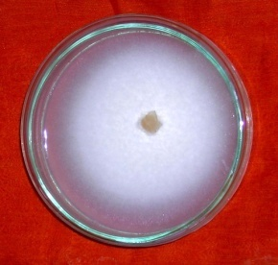

The live specimens of Cordyceps sinensis were collected carefully from their natural habitat in the high altitude region above 10,000fts of Central Himalayan hills and Pure culture of Cordyceps sinensis has been raised at Defence Institute of Bioenergy Research,, Haldwani(Uttarakhand) after culturing tissues from stroma region of the living specimen.
First starter culture is standardized than mycelium multiplied on broth culture which yields a thick mat of mycelium which could be converted into powder form after freeze drying. The powder of mycelial mat could be utilized in the production of nutriceuticals in the form of tablets and capsules. This powder of Cordyceps may also be used in the development of various types of functional foods.
Salient Features
- Cultured Mycelium is having same biochemical composition as natural samples.
- Toxicity studies has been done and mycelium was found safe to use for the formulation of products.

Current Status
- Technology Ready for ToT

