Infrared Guided Missile Tester (IRGMT)

LASTEC has developed a test system for performing serviceability check of the seeker head and guidance/ avionics system functionality of heat seeking missiles. The developed test system is basically a source of IR radiation that produces a known CW power output. Emission in these bands is characteristic of electromagnetic emission from jet exhaust and the mainframe of aircraft. The emission wavelength profile slightly varies in case of aircraft mainframe and the exhaust but invariably remains within the 3-12 micron band in both the cases. This wavelength signature is judiciously used in the guidance of Air-to-Air Missiles. Magic IR guided missiles are some examples.

The developed IR Guided Missile Tester is a source of IR radiation that simulates the jet exhaust signatures for performing serviceability check of missiles on ground. The lock on check on missile is performed as an end to end check to confirm the serviceability of seeker head and missile guidance unit in loop with the Aircraft avionics system. The developed system is a standalone gadget with own rechargeable battery pack having battery endurance for 60 minutes continuous operation. The following are the salient features of the system developed for the mentioned application:
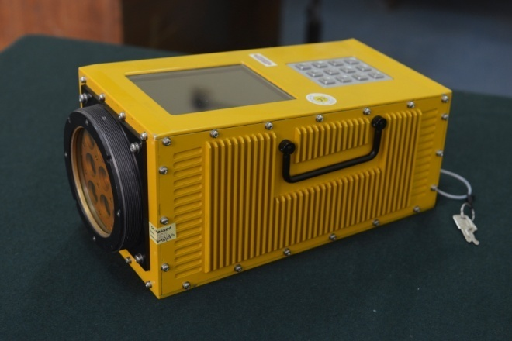
Simulate the target signature corresponding to distance
of 100m, 5km, 10km, 15km and 20km by controlling
intensity of IR emitters
Photograph of developed System
The System is environmentally qualified and CEMILAC certified and has been extensively demonstrated to several potential users like Hindustan Aeronautics Limited (HAL) and Indian Air Force. Various agencies viz. Aeronautical Development Agency (ADA), Bangalore and Hindustan Aeronautics Ltd. (HAL), Bangalore have shown keen interest in this system. Two numbers of CEMILAC certified test systems have already been delivered to ADA, Bangalore for testing of Missile on board LCA.

