2-PAM Chloride:
Pralidoxime chloride (2-PAM Chloridel) is generic name given for the compound 2-formyl-1-methylpyridinium chloride oxime. It is a well known as protopam chloride and widely used antidote for nerveagent posining. Three methods have been tried for its synthesis, out of which two methods are not suitable for upscaling. A process has been developed for the synthesis of 2-PAM chloride starting from 2-Pyridine Carboxaldehyde. The process involves the following steps. (1) Preparation of Pyridne-2-Carboxaldoxime by the reaction of Pyridine-2-carboxaldehyde with hydroxylamine hydrochloride. (2)Preparation of Pyridine-2-carboxladoxime methiodide [2-PAM Iodide] by quarternization of the Pyridine-2-carboxladoxime with methyl iodide. (3) Preparation of PAM-2-chloride [2-formyl-1-methylpyridinium chloride oxime] by the reaction of alcoholic solution of anhydrous hydrogen chloride with PAM-2-Iodide, removal of the alcohol by distillation and addition of solvent of lower dielectric constant yields the desired product. The purity of PAM-2-chloride is > 99% and the melting point is 228⁰ C (Reported mp:225-230⁰ C).
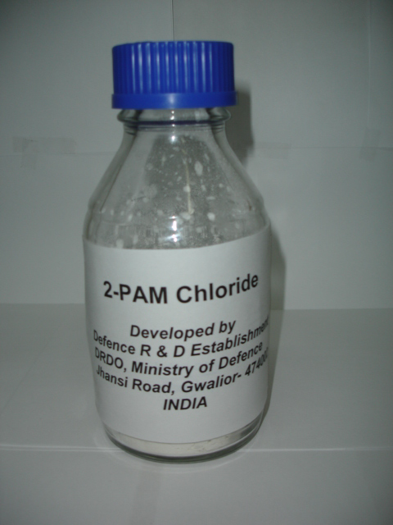
Applications & Use of the Product:
Antidote for Nerve agent, Civil use in Public health departments
Salient features:
- An Efficient, indigenous method for the synthesis of 2-PAM Chloride has been developed
- Three step process has been developed and conditions optimised
- Simple and Cost-effective technology
- Developed an upscalling Process for 1 Kg
- Indian patent filed, granted for 20 years, No: 245272
- 2-PAM chloride is to be filled in cartridges of Auto injectors
Approximate Cost:
Rs ~2,25,000/- Per 1 Kg
Whether technology is transferred?
No, Technology is ready for transfer to the industry.
Present status:
Process developed for 1 Kg Batch

Developed by:
DRDE, Gwalior

