Brief write up on Aluminium Foam Technology
Description of the technology
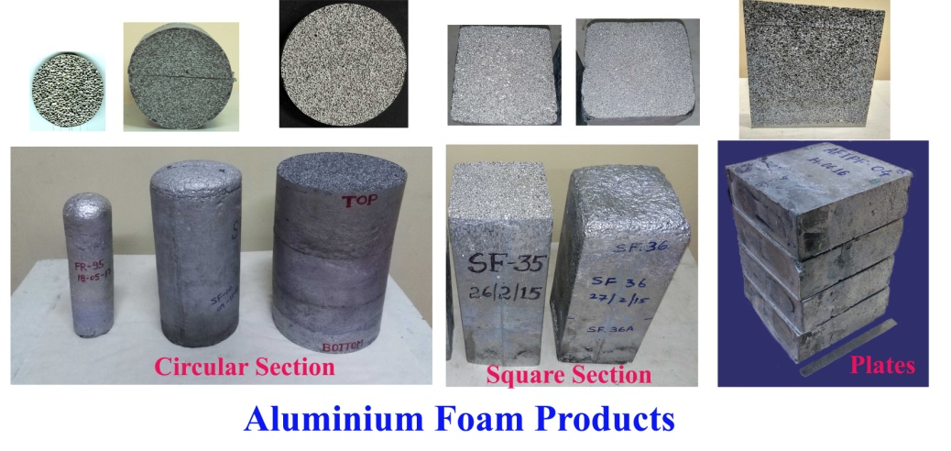
The closed cell Aluminium foams are prepared by in DMRL, Hyderabad by melting aluminium and subsequently creating pores. The technology developed for Aluminium foam making is advantageous over other processes as it is inexpensive, easy to scale up, reproducible and produces uniform cell structure. The product range includes circular section, square section ingots and plates. The sizes demonstrated are 220 mm φ, 500 mm height (cylindrical) and 175x175x200-500 mm (square section) in 8 kg scale. Plates of 300 x 300 x 100 mm having density 0.5 g/cc in 5 kg scale are also available.
Application areas
Closed cell aluminium foams, during deformation are capable of absorbing large quantity of energy at low transmitted stress. Deformation can be uni-axial compression, impact or blast. Additionally, they show high stiffness (when used as sandwich panels), vibration dampening, heat insulation and fire resistant properties. The closed cell structure pulverises when exposed to blast pressures resulting in the high pressure attenuation. Similarly, during impacts, the foam cells bend, collapse and rupture, thereby, the transmitted stress remains low. Such profile of properties makes these foams attractive for many applications in defence and civilian areas. Possible areas include design of crash resistant modules for automobiles and passenger safety, light weight high stiffness structural components, blast protection modules for military MCVs, shock attenuating back up panels for armour modules against high speed ammunitions, impact force absorber modules for safe transport and storage modules of radioactive materials, hazardous chemicals, warheads of missiles and many such uses.
Test results and properties of the foams
Elaborate tests conducted on these foams highlight following properties.
Table 1: Compressive Properties
Density (g/cc) | 0.3 | 0.8
Plateau strength (MPa) | 1.0 | 15
Elastic Modulus (GPa) | 0.2 | 0.8
Energy Absorbed (MJ/m³) | 1 | 10
- High energy absorption under compression at low and nearly constant transmitted stress (see Table for compression properties)
- Foam filled tubes and sandwich plates show high stiffness and improved efficiency of energy absorption in compared to the empty tubes
- High velocity (energy) impacts on the foams show 30 times force reduction in comparison to impacts on rigid surface
- Blast experiments on foams with optimized parameters could reduce incidence contact pressure up to 50 times
Summary
A melt based technology to produce closed cell aluminium foams is available in DMRL. The process is reproducible with respect to the final foam quality and properties. Evaluations have confirmed their ability to absorb blast and impact energy. Various applications pertaining to the safety of military vehicles, blast protecting structures, shock mitigating add-ons can be envisaged. Railways, automobiles and other transportation industries can also use the material to improve safety against accidental impacts. The technology is available for mass production and commercialization.
For further information on the subject, please contact:
Director
Defence Metallurgical Research Laboratory
Kanchanbagh (P.O.)
Hyderabad – 500 058
INDIA. Phone: 040-2434 0681 / 2434 0365, Fax: 2434 0233

