Mechanical Munition Layer-Self Propelled (MML-SP)

Research & Development Establishment (Engineers), Pune, a premier laboratory under Defence R&D Organisation (DRDO) invites Expressions of Interest (EOI) from Indian industries having sufficient experience, expertise and willing to undertake production work of Mechanical Munition Layer-Self Propelled (MML-SP) hereafter called as ‘system’. The industry should be technically & financially competent to manufacture and supply the ‘system’ with requisite quality standards.

BRIEF DESCRIPTION:
Munition laying of anti-tank ND Mk III/IV Munitions (Bar Munitions) is an important activity of Indian army. It slows down or removes possibility of enemy tank movement across Munition strip. To perform this activity R&DE (E) has developed self-propelled and fully automated MML-SP equipment.
The MML-SP is designed for laying Bar Munitions in soil at variable depth & spacing with effective Munition laying rate. It is designed to lay Munitions in plains of Punjab, semi deserts and deserts of Rajasthan at variable inter-Munition spacing. All the operations in the equipment like Munition dispensing, trenching, burying etc. are automatically carried out with electrical and hydraulic actuators. The position of various actuators or Munition is sensed by sensors fitted at various locations. The actuators are operated by Electronic controller automatically based on inputs from operator and sensors. The system has been equipped with GPS based Munition field mapping device which automatically stores location of laid Munition with accuracy up to 50 cm. The system is based on HMV Tatra 8x8 VVN.
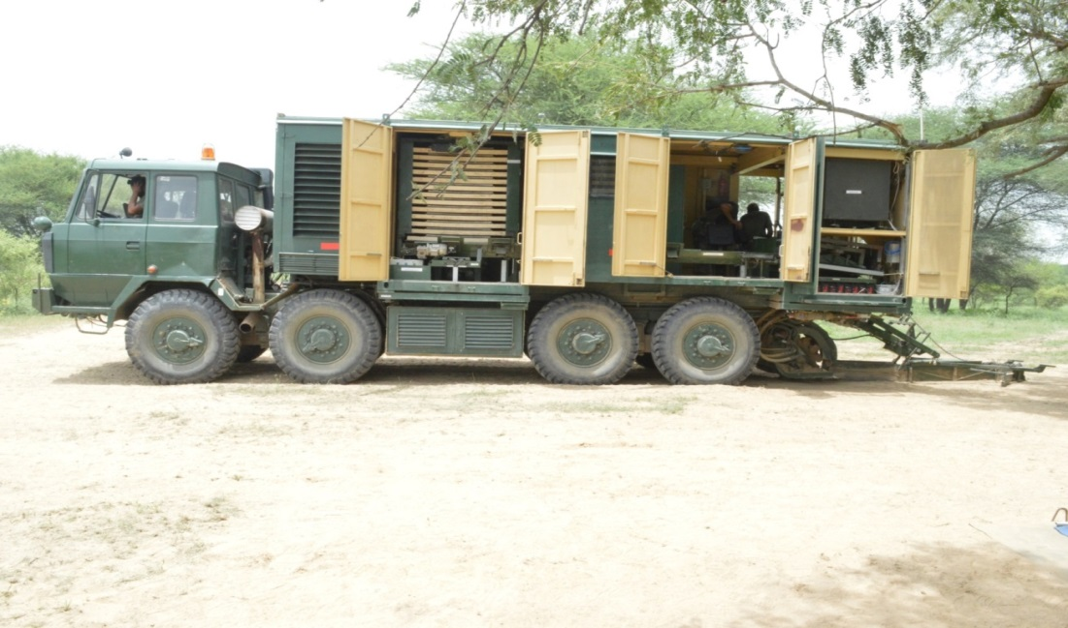
Mechanical Munition Layer-Self Propelled (MML-SP) Prototype

TECHNICAL DETAILS & SALIENT FEATURES:
Mechanical Munition Layer-Self Propelled (MML-SP) is built on TATRA 8x8 VVN chassis. It consists of mechanical, electrical, electronic & hydraulic sub-systems.
Mechanical sub-system includes Base frame with canopy fitted on chassis, Munition storage and dispensing containers (2 Nos.), Trenching system, Burying system, Longitudinal Horizontal conveyor (LHC), Fixed Tilt Tray (FTT) and Movable Tilt Tray (MTT). Electrical and Electronic sub-systems include alternator, Power Distribution Unit (PDU), servo motors, UPS, junction boxes, maintenance panel, drive panel, electronic controller, MMI panel, DGNSS/INS system, GIS, camera unit etc.
Hydraulic system consists of auxiliary engine, hydraulic pumps, hydraulic motor, oil cooling system, direction control valves, hand pump, manifolds, pipes, hoses etc. Salient features are as follows:
- Operational terrain: Plains of Punjab, desert & Semi-deserts of Rajasthan.
- Variable Munition Laying rate, Inter-munition spacing & Depth of trench
- Mode of operation : Fully automated
- Munition field data recording : GPS based automatic data recording
- Operational temperature range: 0-45⁰ C

Interested industries may respond along with their company profile, financial & technical capabilities etc. as per the following format :

(a) Memorandum and Articles of Association (Should be incorporated as per Indian
Companies Act, 1956)
(b) Certificates of registration as a manufacturing unit, if any. (c) Balance Sheet for the preceding three years.
(d) Income Tax returns for the preceding three year period
(e) Details of shareholding/ownership pattern especially foreign partners/ shareholders, foreign employees, directors, etc. The company must adhere to the prevailing Govt. of India policies and regulations on Foreign Direct Investment (FDI).
(f) Annual budget for R&D during last three years.
(g) Numbers and details of IPR or patents etc held by the company. (h) Number of technically or professionally qualified personnel.
(i) Record of past performance (e.g Supply orders executed against Ministry of
Defence orders, public sectors and paramilitary forces, if any.
(j) Availability of adequate infrastructure (List of machines and their production capacities) and technical expertise.
(k) List of Testing and Support equipments
(l) ISO/ ISI certification or any other certification
(m) Relevant clearances from the authorities/ ministries (if any)
(n) Capacity and capability to undertake developmental work and to accept attendant financial and commercial risks.
(o) Capacity/Capability to market the product through the marketing network, sales and service network, reliability to maintain confidentiality.

Eligible industries will be invited to sign Non-Disclosure Agreement with R&DE (Engrs) and for technical discussion, following which they shall be evaluated for giving Transfer of Technology (TOT) on non-exclusive basis. Criteria for choosing industry partner will include manufacturing capability, assurance on quality and capacity of production apart from other terms and conditions.

Interested industry may write to Director, R&DE(Engrs), Pune on the following address –

Director, R&DE(Engrs). DRDO, Min. of Defence, Alandi Road, Dighi,
Pune – 411015
They may also contact on phone – (020) 27044505, (020) 27044526
Email: director@rde.drdo.in , jpsingh@rde.drdo.in,

Or

Director, DIITM,DRDO HQ,
Min. of Defence, DRDO Bhawan, Room No. 447, B Block,
Rajaji Marg, New Delhi - 110011
Phone – 011 23013209
Email: mayank@hqr.drdo.in

