HRIDAYAMRIT : A HERBAL HEART TONIC AND HEALTH BEVERAGE
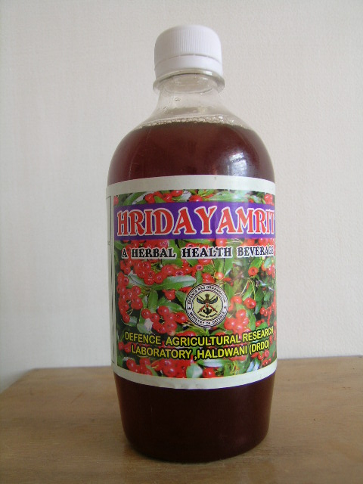

Hridayamrit is a herbal beverage developed from Cartaegus berries which are very nutritious, having flavonoides (2-3 %), Vitamin ‘A’ (289 IU/ 100g), Vitamin B₁₂ (110 ug/100g), Vitamin ‘C’ (57.8mg/100g), Vitamin ‘E’ (289mg/100g) protein (1.6 %), calcium (3.79 mg/100g), magnesium (1.38 mg/100g), potassium (1.39mg/100g). Flavonoids and oligomeric proantho-cyaninidins are the most bioactive constituents present in berries of C. crenulata. Modern scientific research has shown that this shrub has potential application for treatment of hypertension patients. Clinical trials on heart patients with hypertension have shown that total flavanoides of Crataegus reduce cholesterol level and improves cardiac functions. Besides this the beverage is useful in case of insomnia, neurasthenia, anxiety and anorexia.
It is a herbal cardiac tonic useful in case of hypertension, angina, arrhythmia and congestive heart failure. It is an energizer, nerve soothing, refresher health tonic. It helps to reduce the blood cholesterol and lipid to a considerable level. The presence of flavonoids in this beverage helps in cardiotropic and vasodilator action. The regular intake of drink lowers the serum cholesterol and triglycerides.
Salient Features
- A herbal heart tonic in particular and a general herbal beverage for everyone.
- Rich in anti-oxidants.

Current Status
- Ready for TOT

