120mm Fin Stabilised Armour Piercing Discarding Sabot (FSAPDS) Mark-I
Description of the technology:
Fin Stabilised Armour Piercing Discarding Sabot (FSAPDS) is the primary ammunition with any armoured regiment. 120mm Fin Stabilised Armour Piercing Discarding Sabot (FSAPDS) Mark-I is a single piece ammunition with combustible cartridge case for MBT Arjun. The penetrator is made up of high strength high density tungsten alloy material. The projectile is fired at very high muzzle velocity. The sabot is discarded just after the muzzle and the penetrator, stabilised by Tail fin unit, travels to the target. On impact with the target, the enormous kinetic energy forces the penetrator to perforate the tank armour. This is sufficient to permanently damage the essentials of tank and harm the tank crew to achieve ‘Total Kill’.
The ammunition is extremely reliable and safe to use. The ammunition has got excellent first round hit probability. The consistency and accuracy of the ammunition are excellent and meet the stringent acceptance criteria of the Indian Army.
The ammunition utilises indigenous Triple Base Propellant with resin base combustible cartridge case. The shelf life of ammunition has been established to be minimum 10 years.
Application Areas:
It is an anti-tank ammunition, which uses Kinetic Energy to defeat the tank armour. The ammunition can be effectively used against all present tanks in service worldwide. It can effectively engage targets at ranges even beyond 2000 meters.
Certifications and test results:
The ammunition is in service for past 10 years. More than 25,000 rounds have been produced and more than 15,000 rounds have been fired successfully.

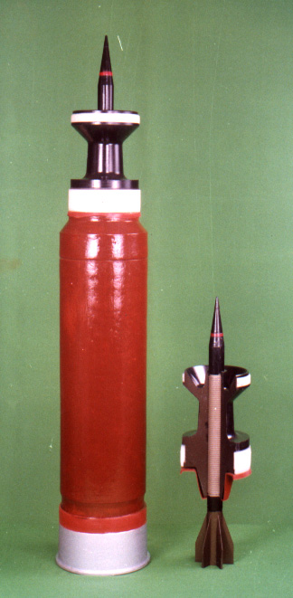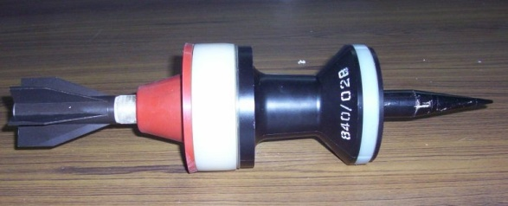
Round 120mm FSAPDS Mk-I with shot FSAPDS Mk-I Shot

