CORDYVIT: A UNIQUE HEALTH SUPPLIMENT

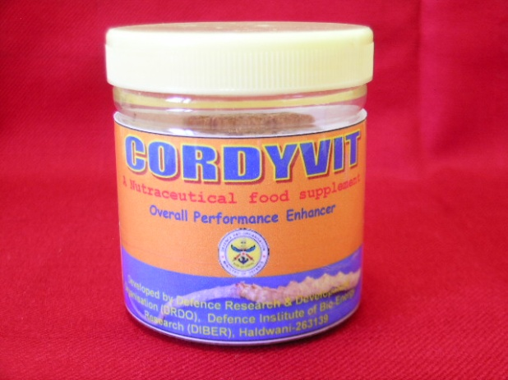

Cordyvit is an unique nutraceutical food supplement formulation developed taking lab cultured mycelium of Cordyceps as base material which is supplemented with mineral mixture, vitamins and antioxidant rich herbs. Cordyceps is highly valued for unique energy rich metabolites which ensure vitality and performance. World over such products have been formulated and an attractive market exists in India as well, this product can potentially fill the void. It is having Cordycepin a compound, which is performance enhancer and has anti-aging properties.
Salient Features
- Overall performance enhancer
- An Anti aging vitalizer which enhances stamina and is helpful in case of hypoxia and joint pains.
Current Status
- Ready for TOT

