Products Ready for Transfer of Technology

[A] DRDO NPT GM qPCR Detect Kit
Application: For Rapid, Reliable and Sensitive Validation of Putative Transgenic Samples (microbes, plants etc.) having npt II Marker Gene.
Key features of the kit:
- Detection Sensitivity: Successful detection of Template dilutions (1.0 ng-1.0 fg of purified gene amplicons).
- Accuracy: No false positive or false negative results.
- Reproducibility
- Rapidity: The optimized two step PCR run time is less than 1.0 h. Further, post PCR handling is NIL.

Patent Filed: Real Time PCR Based Method for Transgene Detection (1632/DEL/2013)
Transgenic

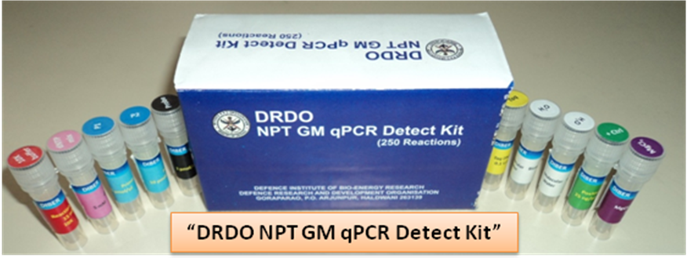

[B] DRDO EasyDetect NPT GM qPCR Kit

Application: for Rapid, Reliable and Sensitive Validation of Putative Transgenic Samples (microbes, plants etc.) having npt II Marker Gene.

Key features of the kit:
- Detection kit with ready-to-use master-mix.
- Detection Sensitivity: Successful detection of Template dilutions (1.0 ng-1.0 fg of purified gene amplicons).
- Accuracy: No false positive or false negative results.
- Reproducibility
  - Rapidity: The optimized two step PCR run time is less than 1.0 h. Further, post PCR handling is NIL.

Patent Filed: Real Time PCR Based Method for Transgene Detection (1632/DEL/2013)
Transgenic

