COMPOSITES SONAR DOME

Research & Development Establishment (Engineers), Pune, a premier laboratory under Defence R&D Organisation invites Expressions of Interest (EOI) from Indian industries having sufficient experience, expertise and willing to undertake fabrication work of “Composite Sonar Dome” hereafter called as ‘system’. The industry should be technically & financially competent to manufacture and supply the ‘system’ with requisite quality standards.

BRIEF DESCRIPTION:
Sonar dome is a protective cover to sonar equipment of surface war ships. The dome is designed to house sonar array, and to maximize the performance of the array by reducing the effects of noise of water turbulence and protecting the array from wave slamming, minor collisions etc. In the design of sonar dome, both structural and acoustic considerations come into play. Typical structural constraints may include the deformation of the structure under steady external flow, accelerations, slamming loads and shock loads. From an acoustic stand point of view, the goal is to maximize the fidelity of incoming sound by ensuring that the self-noise and flow induced noise can be inherently minimized. The current sonar domes in advanced composites bring additional benefits for strength and acoustic performance, extending the ability of the vessel to locate, evade and engage hostile environments. The sonar dome is mounted at the bow of the ship.
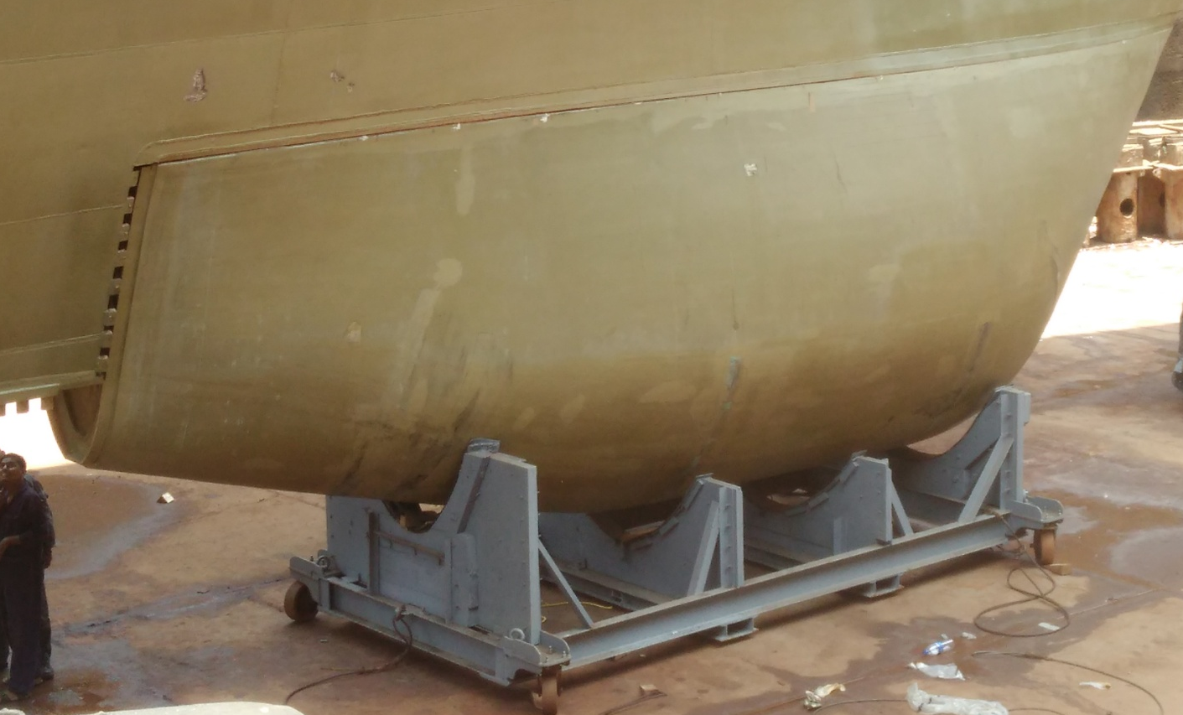
Picture : Realised Dome under the ship
TECHNICAL DETAILS & SALIENT FEATURES:
R&DE(E) has developed design, analysis and manufacturing capabilities of composite sonar domes. A typical dome consists of stiffeners, acoustic window area (acoustically transparent region), baffle plate, and flange with gasket for water tight connection of the dome to ship. Acoustic window area is a composite-rubber sandwich construction. Lifting hooks are provided for handling dome during handling and fitting.
R&DE(E) has established manufacturing processes i.e. Vacuum Assisted Resin Transfer Molding (VARTM) for realization of composite sonar dome. The process require mold for realization of a structure. VARTM is a room temperature curing process. For post curing product has to be heated till 80 degree C.
To realize sonar dome, male mold has to be used which should caters factors like dimensional accuracy, surface finish, ease of lay-up, demolding etc. Mould should suited to process requirement.
In VARTM process, vacuum and resin points are provided for creating vacuum and sending resin into dry fabric, respectively. These points are decided based on guidelines obtained from process modeling and flow simulation studies. In VARTM process, resin is sucked under vacuum and it flows into the dry fabric until it is saturated with resin. To monitor resin flow online in complex regions, a process monitoring system is also available which can be deployed wherever necessary. After resin infusion, job is allowed to cure at room temperature for 24 hr then the job is demolded. Thus the complete design to manufacturing know-how of composite sonar dome is available with R&DE(E) and can be transferred to interested industry partner for commercial use.
This technology is ready with us to transfer to any Indian Industry for supply of domes to Indian Navy only.

Interested industries may respond along with their company profile, financial & technical capabilities etc. as per the following format :

(a) Memorandum and Articles of Association (Should be incorporated as per Indian
Companies Act, 1956)
(b) Certificates of registration as a manufacturing unit, if any. (c) Balance Sheet for the preceding three years.
(d) Income Tax returns for the preceding three year period
(e) Details of shareholding/ownership pattern especially foreign partners/ shareholders, foreign employees, directors, etc. The company must adhere to the prevailing Govt. of India policies and regulations on Foreign Direct Investment (FDI).
(f) Annual budget for R&D during last three years.
(g) Numbers and details of IPR or patents etc held by the company. (h) Number of technically or professionally qualified personnel.
(i) Record of past performance (e.g Supply orders executed against Ministry of
Defence orders, public sectors and paramilitary forces, if any.
(j) Availability of adequate infrastructure (List of machines and their production capacities) and technical expertise.
(k) List of Testing and Support equipments
(l) ISO/ ISI certification or any other certification
(m) Relevant clearances from the authorities/ ministries (if any)
(n) Capacity and capability to undertake developmental work and to accept attendant financial and commercial risks.
(o) Capacity/Capability to market the product through the marketing network, sales and service network, reliability to maintain confidentiality.

Eligible industries will be invited to sign Non-Disclosure Agreement with R&DE (Engrs) and for technical discussion, following which they shall be evaluated for giving Transfer of Technology (TOT) on non-exclusive basis. Criteria for choosing industry partner will include manufacturing capability, assurance on quality and capacity of production apart from other terms and conditions.

Interested industry may write to Director, R&DE(Engrs), Pune on the following address –

Director, R&DE(Engrs). DRDO, Min. of Defence, Alandi Road, Dighi,
Pune – 411015
They may also contact on phone – (020) 27044208, 27044868
Email: director@rde.drdo.in , roymk@rde.drdo.in
Or
Director, DIITM,DRDO HQ,
Min. of Defence, DRDO Bhawan, Room No. 447, B Block,
Rajaji Marg, New Delhi - 110011
Phone – 011 23013209
Email: tot@hqr.drdo.in

