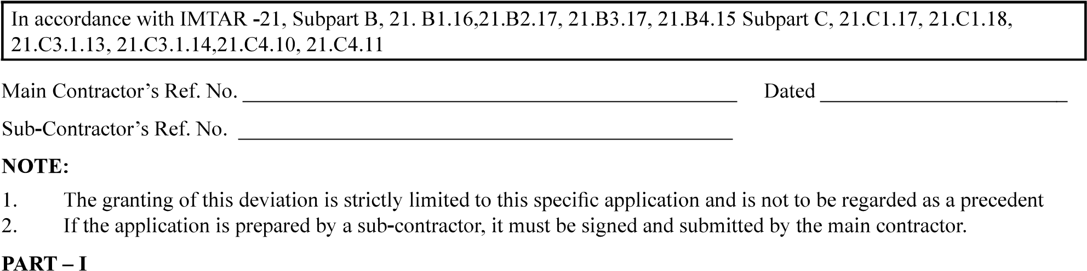

…………………….……

…………………………………………………

…………………………………………..

|  |  |  |
| --- | --- | --- |
|  |  |  |
| 2. |  |  |
| 3. |  |  |
|  |  |  |
| 5. |  |  |
| 6. |  |  |
| 7. |  |  |
| 8. |  |  |
| 9. |  |  |
|  |  |  |
|  |  |  |
|  |  |  |
|  |  |  |
|  |  |  |
|  |  |  |
|  |  |  |

……….

………………………….

………………………………………….. …………………………………

…………………

PART - II : TO BE COMPLETED BY THE TAA

1. REMARKS OF DGAQA



1. REMARKS BY CEMILAC

…………………………

……………………………………

……..

1. NCRB REFERENCE (If Applicable)

………………………

………….







