|  |  |  |  |
| --- | --- | --- | --- |
|  | | | |
|  | | | |
|  | |  | |
|  | |  | |
|  | | | |
|  | | | |
|  | | | |
|  | | | |
|  | | | |
|  | | | |
|  | | | |
|  | | | |
|  | | | |
|  | | | |
|  |  | |  |
|  | | | |
|  | | | |

Instructions for the use of the Air System Statement of Conformity IMTAR Form 52

1. Purpose and scope

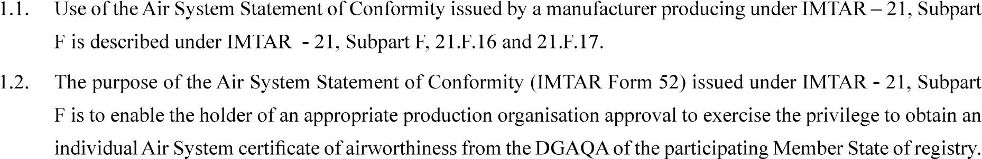

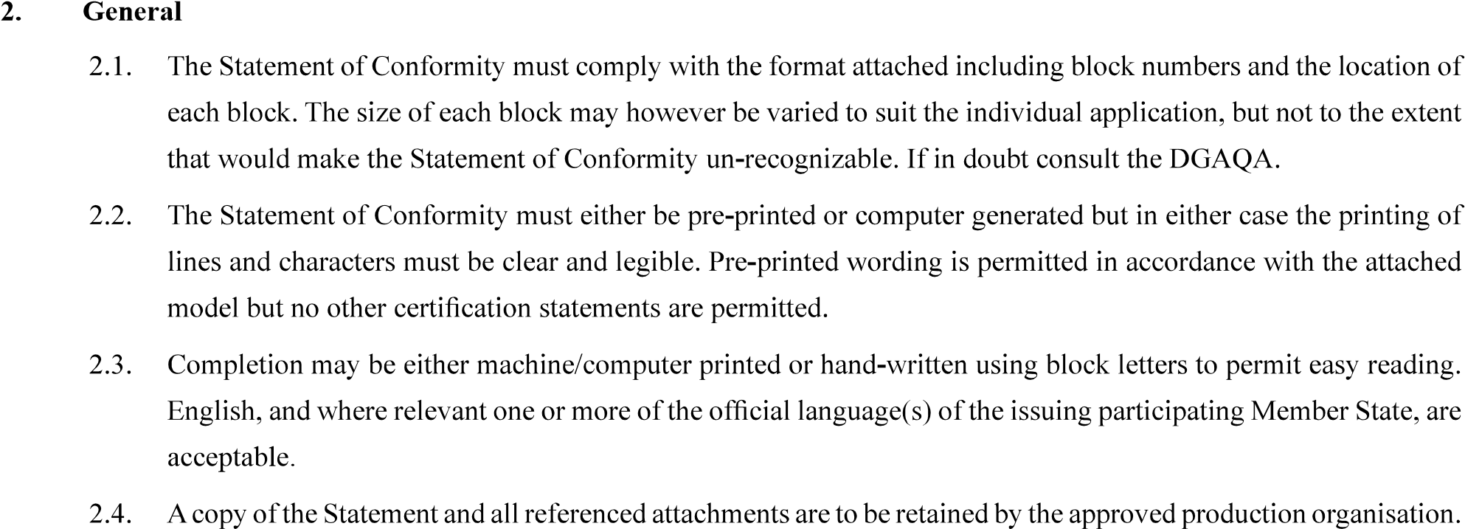

3. Completion of the Statement of Conformity by the originator

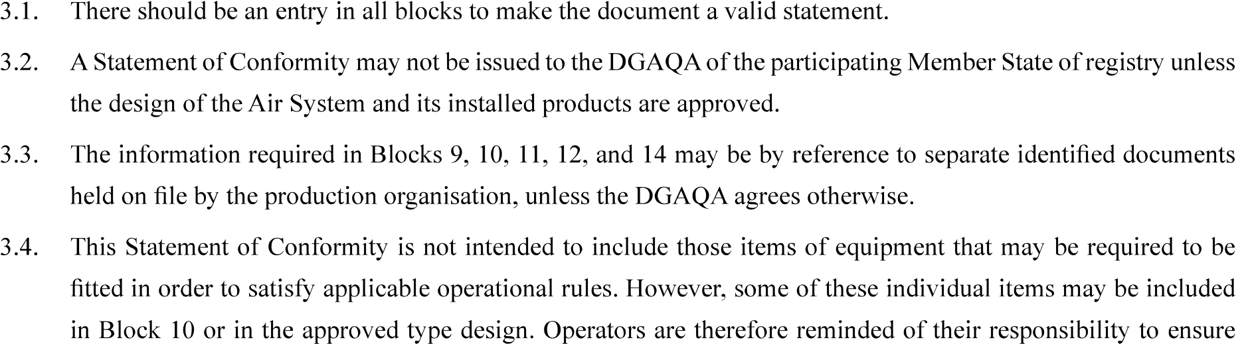

compliance with the applicable operational rules for their own particular operation.



to produce and print a unique number.

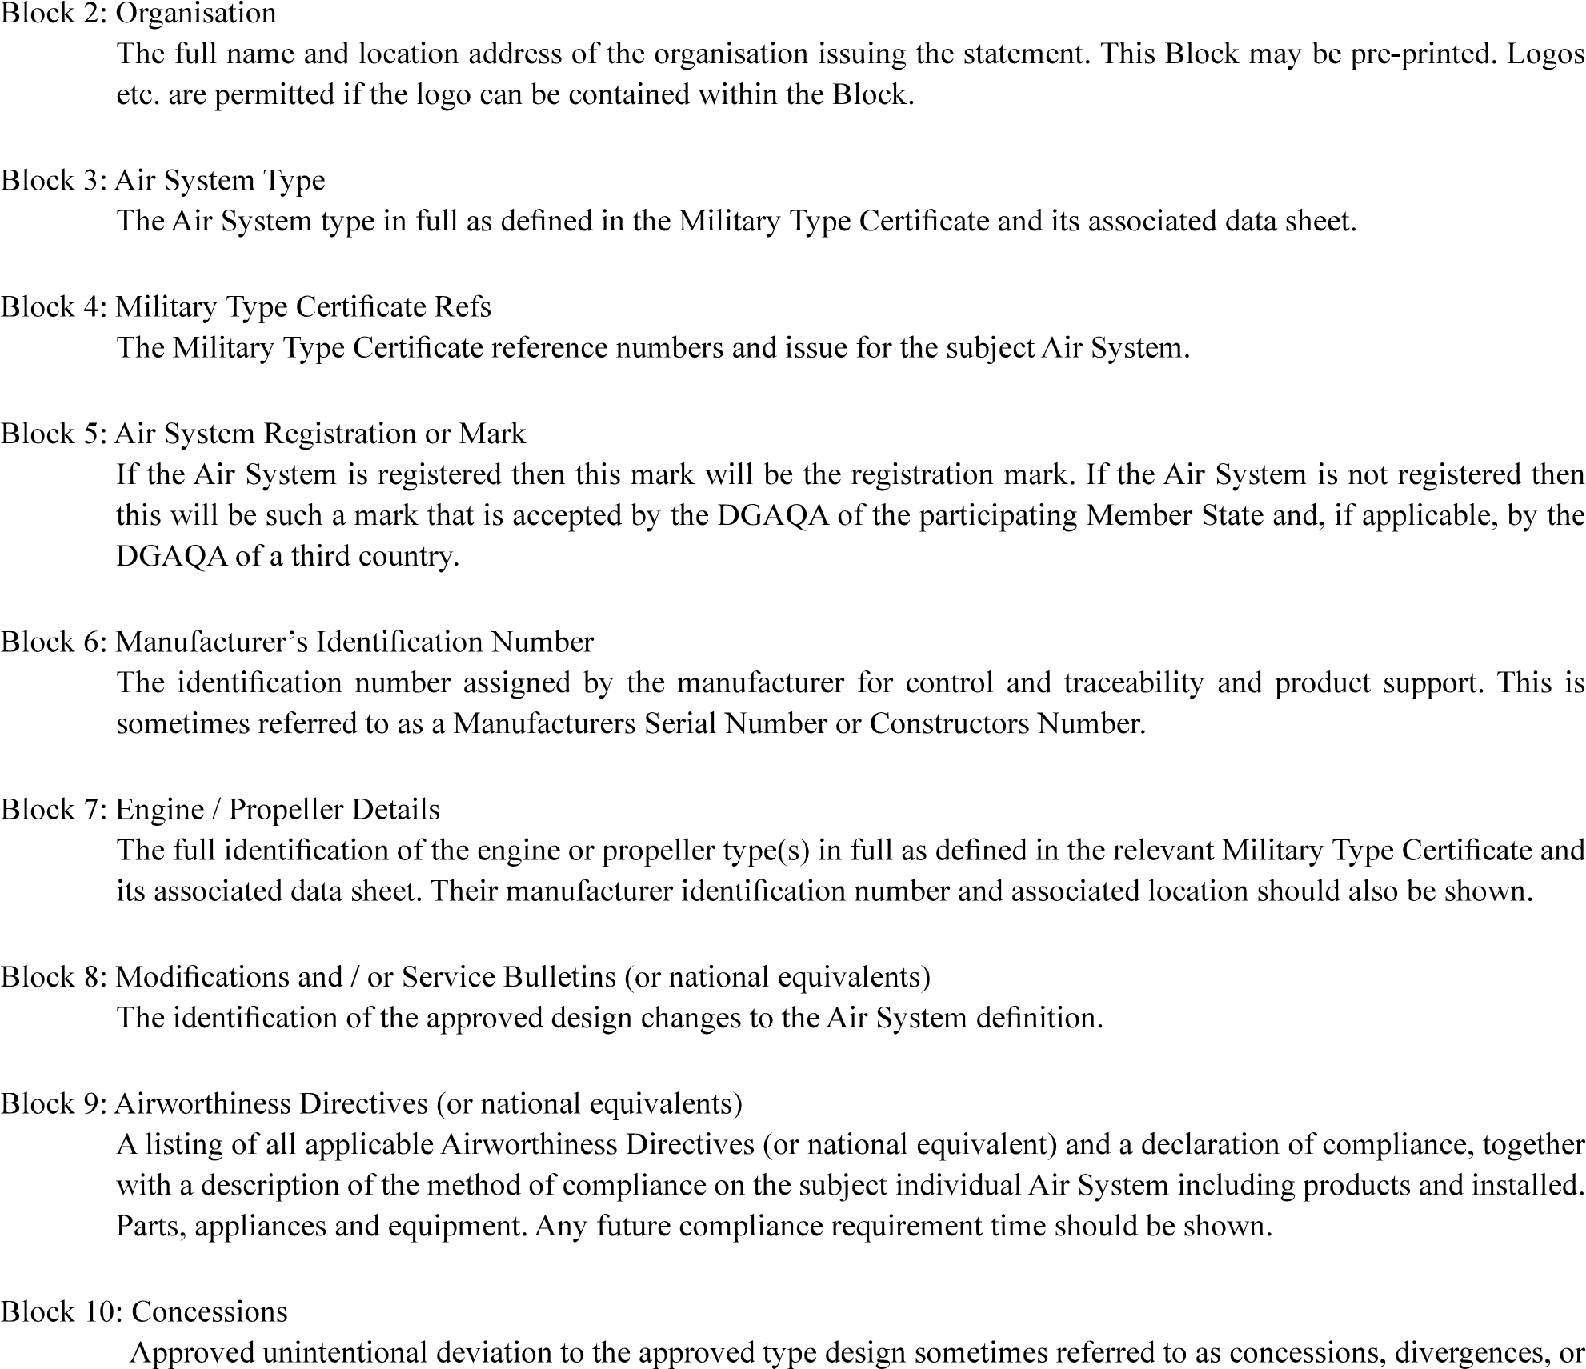

non-conformances.

