Directorate General of Aeronautical Quality Assurance

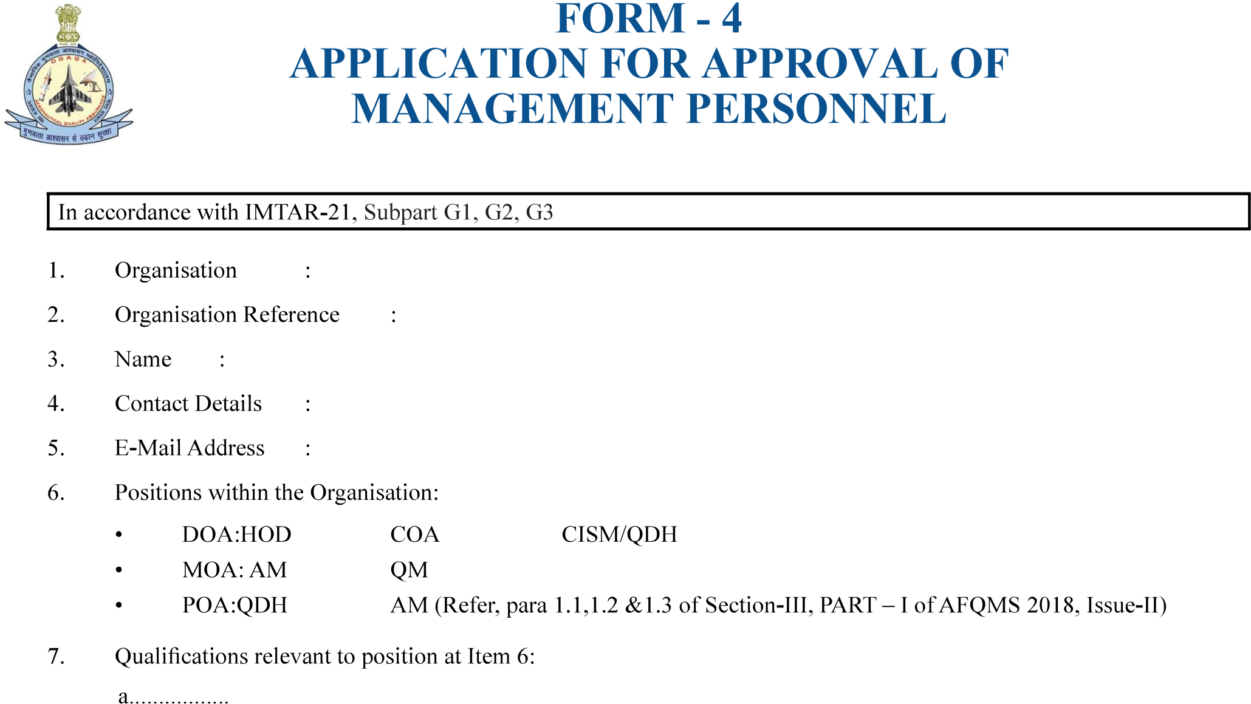

b................

|  |  |
| --- | --- |
| Version : 2.0 | Date: August 2023 |

c................



a..................

b..................

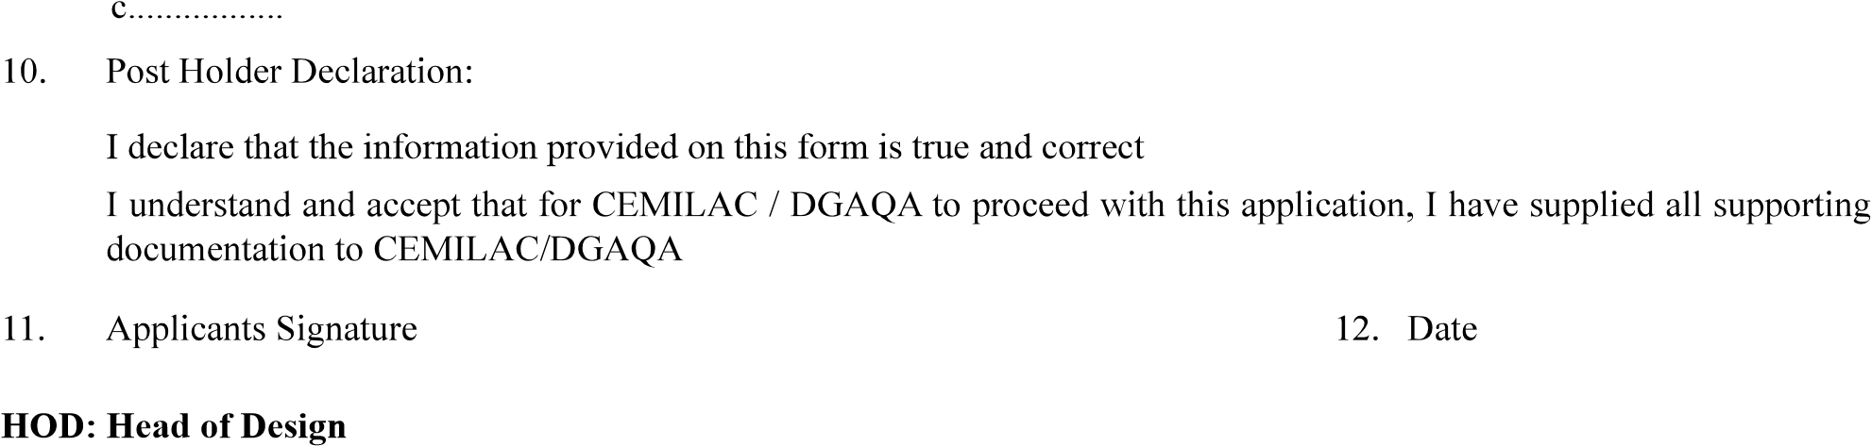

COA: Chief of Airworthiness

CISM: Chief of Independent Support Monitoring / QDH: Quality Department Head

AM : Accountable Manager

QM : Quality Manager

DOA: Design Organisation Approval

POA: Production Organisation Approval

8