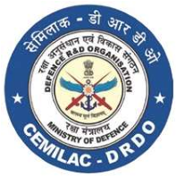

FORM - 36

APPLICATION FOR CONCESSION ON

MODIFICATION / SI/ STI/ SB

PART A

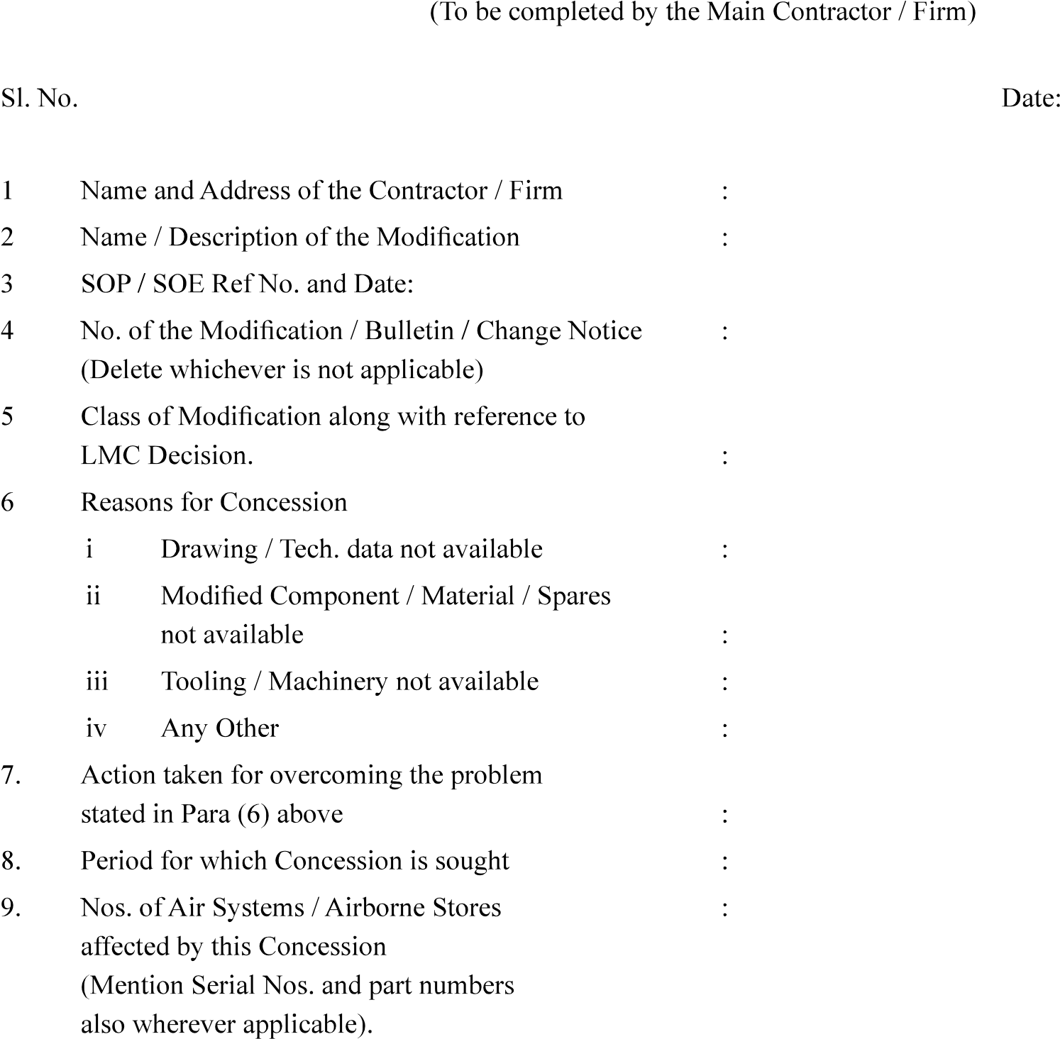

|  |  |
| --- | --- |
| Version : 2.0 | Date: August 2023 |

79

FORM - 36

# APPLICATION FOR CONCESSION ON MODIFICATION / SI/ STI/ SB

## PART - B

## PART - C

## PART - D



|  |  |
| --- | --- |
| Version : 2.0 | Date: August 2023 |

80