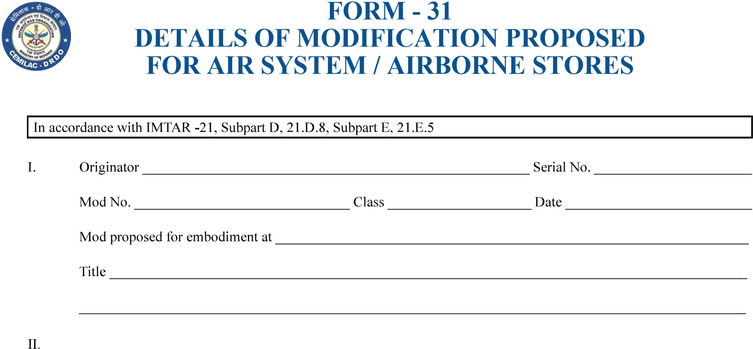

……………………………………………………………………………………………………………

…………………………………………………………………………………………………………………………………………………….

…………………………………………………………………………………………………………………………………………

…………………………………………………………………………………….

……………………………………….

……………………….

………………………………………….

……………………………

…………………………………………………………………………….

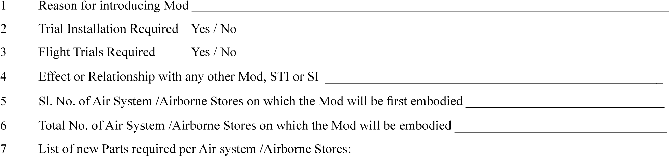

………………………………………………

……………………………………………

………………………………………………………………………………..

|  |  |
| --- | --- |
| Part Number |  |
| Issue |  |
| Nomenclature |  |
|  |  |

…………………………………………………………….

…………………………………………………………………………………………………

|  |  |
| --- | --- |
| Part Number |  |
| Issue |  |
| Nomenclature |  |
|  |  |

|  |  |  |  |  |
| --- | --- | --- | --- | --- |
|  |  | New Pt. No. | |  |
| Issue |  | Issue | |  |
|  |  |  | |  |
|  |  |  | |  |
| Version : 2.0 | | | Date: August 2023 | | |

69

FORM - 31

# DETAILS OF MODIFICATION PROPOSED FOR AIR SYSTEM / AIRBORNE STORES

………………………………………………………..

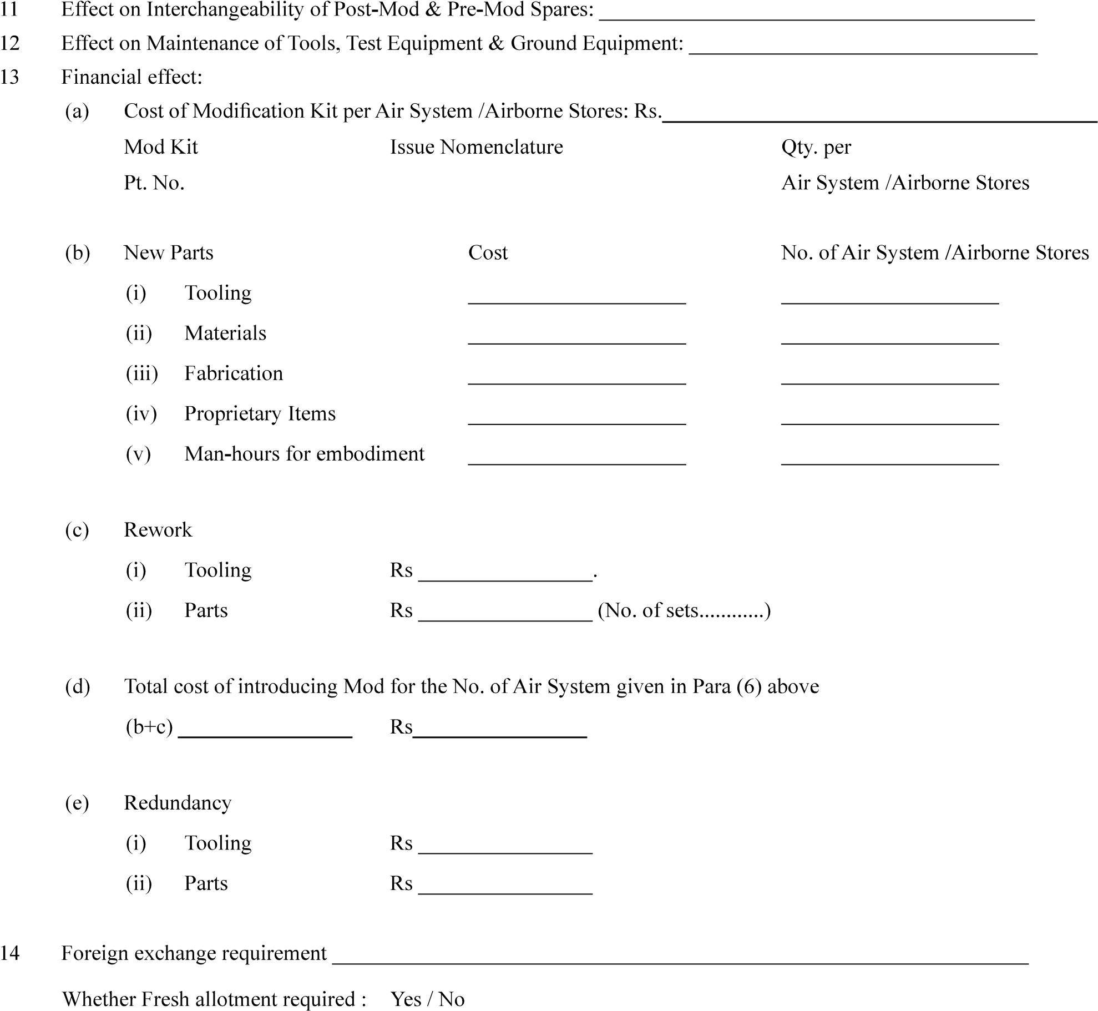

…………………………………………

…………………………….

………………………….

…………………………

……………………………

……………………….

…………………………

………………………

……………………….

………………………………..

…………………………….

………)

…………………….

……………………..

…………………....

…………………..

…………………..

………………….

…………………………………………………………..

………………………………………………...

………………………….

………………………………………………………………………

…………………………….

|  |  |
| --- | --- |
| Version : 2.0 | Date: August 2023 |