

FORM - 23

DECLARATION OF DESIGN AND

PERFORMANCE OF AIRBORNE STORES

DoDP No. ___________________________________________________________ ISSUE No. ___________________________________________________________

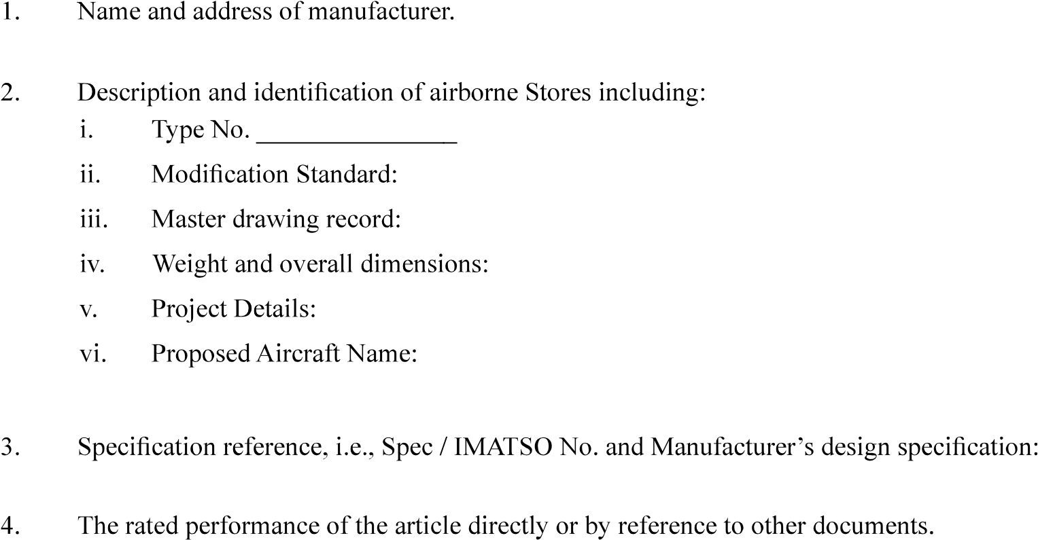

5. Particulars of approvals held for the equipment.

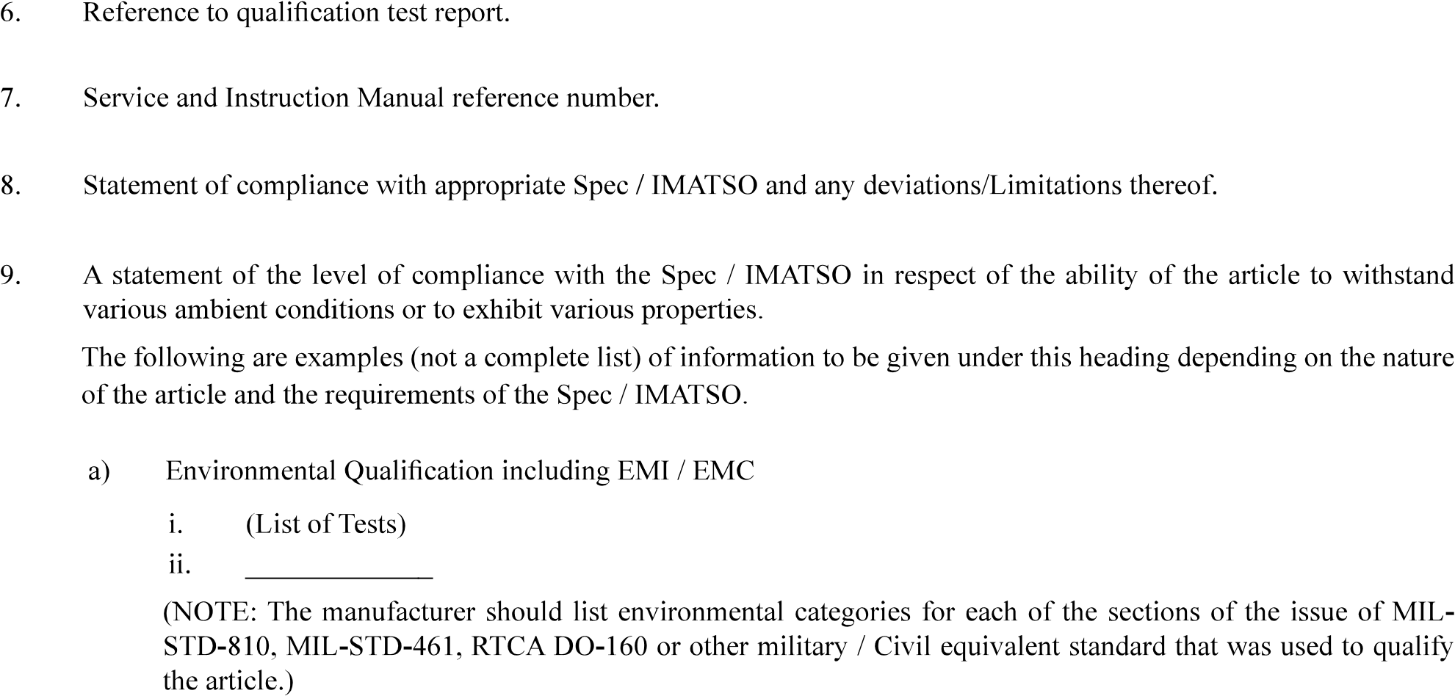

|  |  |
| --- | --- |
| Version : 2.0 | Date: August 2023 |

FORM -23

DECLARATION OF DESIGN AND

# PERFORMANCE OF AIRBORNE STORES

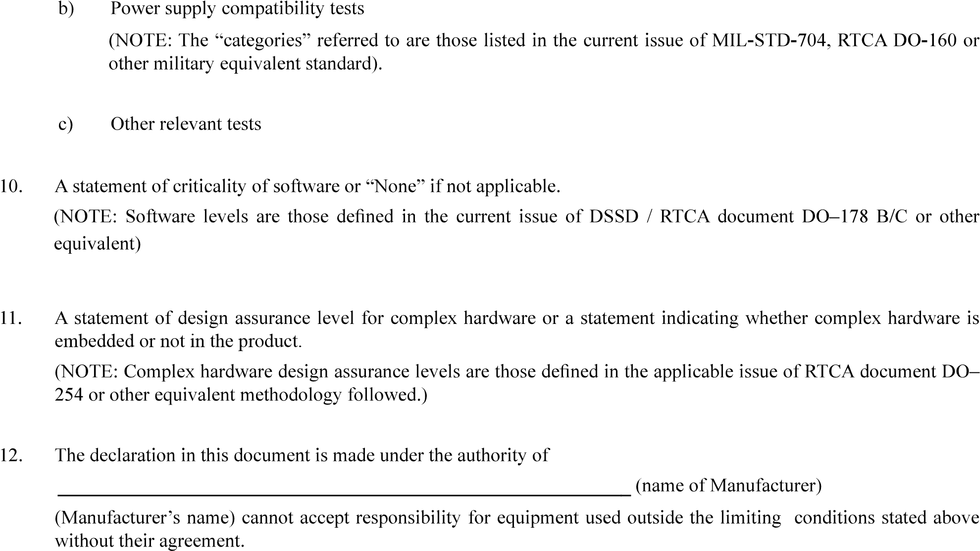

|  |  |
| --- | --- |
| Version : 2.0 | Date: August 2023 |