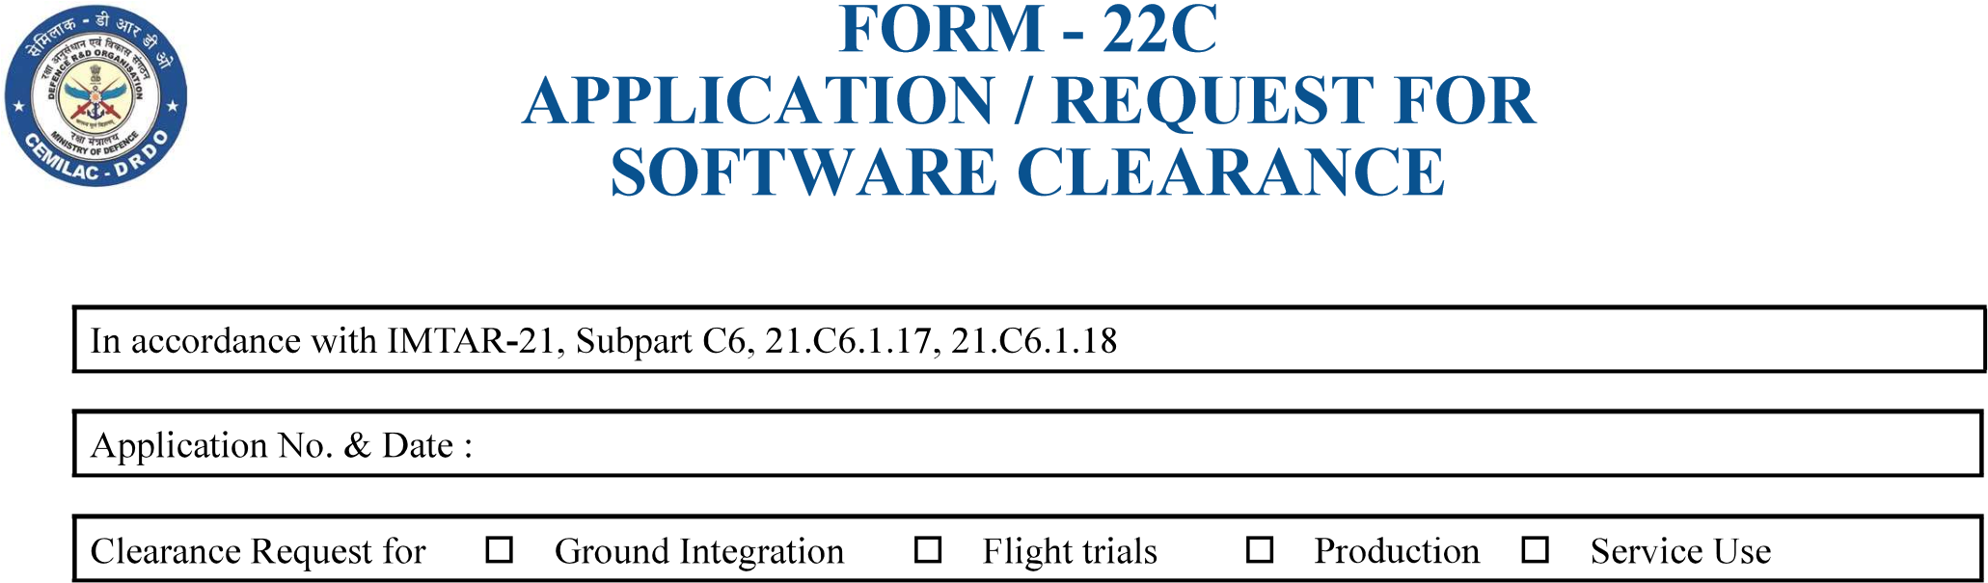

|  |  |  |  |
| --- | --- | --- | --- |
|  |  |  | |
| 2 | Platform |  | |
| 3 |  |  | |
|  |  |  | |
| 5 |  |  | |
| 6 |  |  | |
| 7 |  |  |  |
|  |  |
|  |  |
| 8 |  |  | |
| 9 |  |  | |
|  |  |  | |
|  |  |  | |
|  |  |  | |
|  |  |  | |
|  |  |  | |
|  |  |  | |
|  |  |  | |
|  |  |  | |
|  |  |  | |
|  |  |  | |
| 20 |  |  | |
|  |  |  | |
| 22 |  |  | |
| 23 |  |  | |

|  |  |
| --- | --- |
| Version : 2.0 | Date: August 2023 |