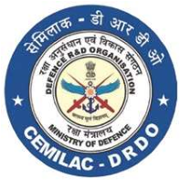

FORM - 21B

DESIGN CRITERIA FORM FOR

CARBON-CARBON AIRCRAFT BRAKE DISCS

|  |  |  |
| --- | --- | --- |
| Reference |  | |
| Applicant’s Reference |  | Date: |

jhjhhu

|  |  |  |  |  |  |  |  |
| --- | --- | --- | --- | --- | --- | --- | --- |
| No. | onent  Name | cation |  |  | Environmental and Temp | Requirements of Metallic  Attachments, | inform-  ation |
|  |
|  |  | Non  critical | Thermal Properties | Kinetic  Application  Pressure,  Torque,  Temperature |  |  |  |

Enclosures:

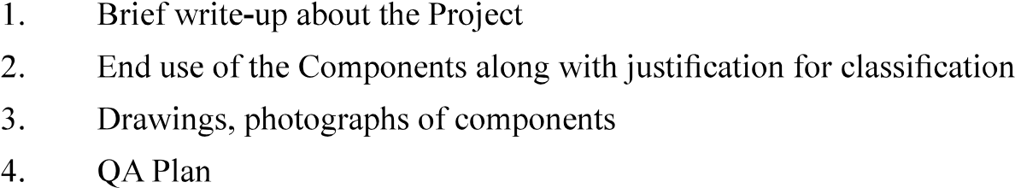

Signature:

Name and Designation:

Name of Organisation (with Seal):

Counter Signed by CEMILAC

|  |  |
| --- | --- |
| Version : 2.0 | Date: August 2023 |