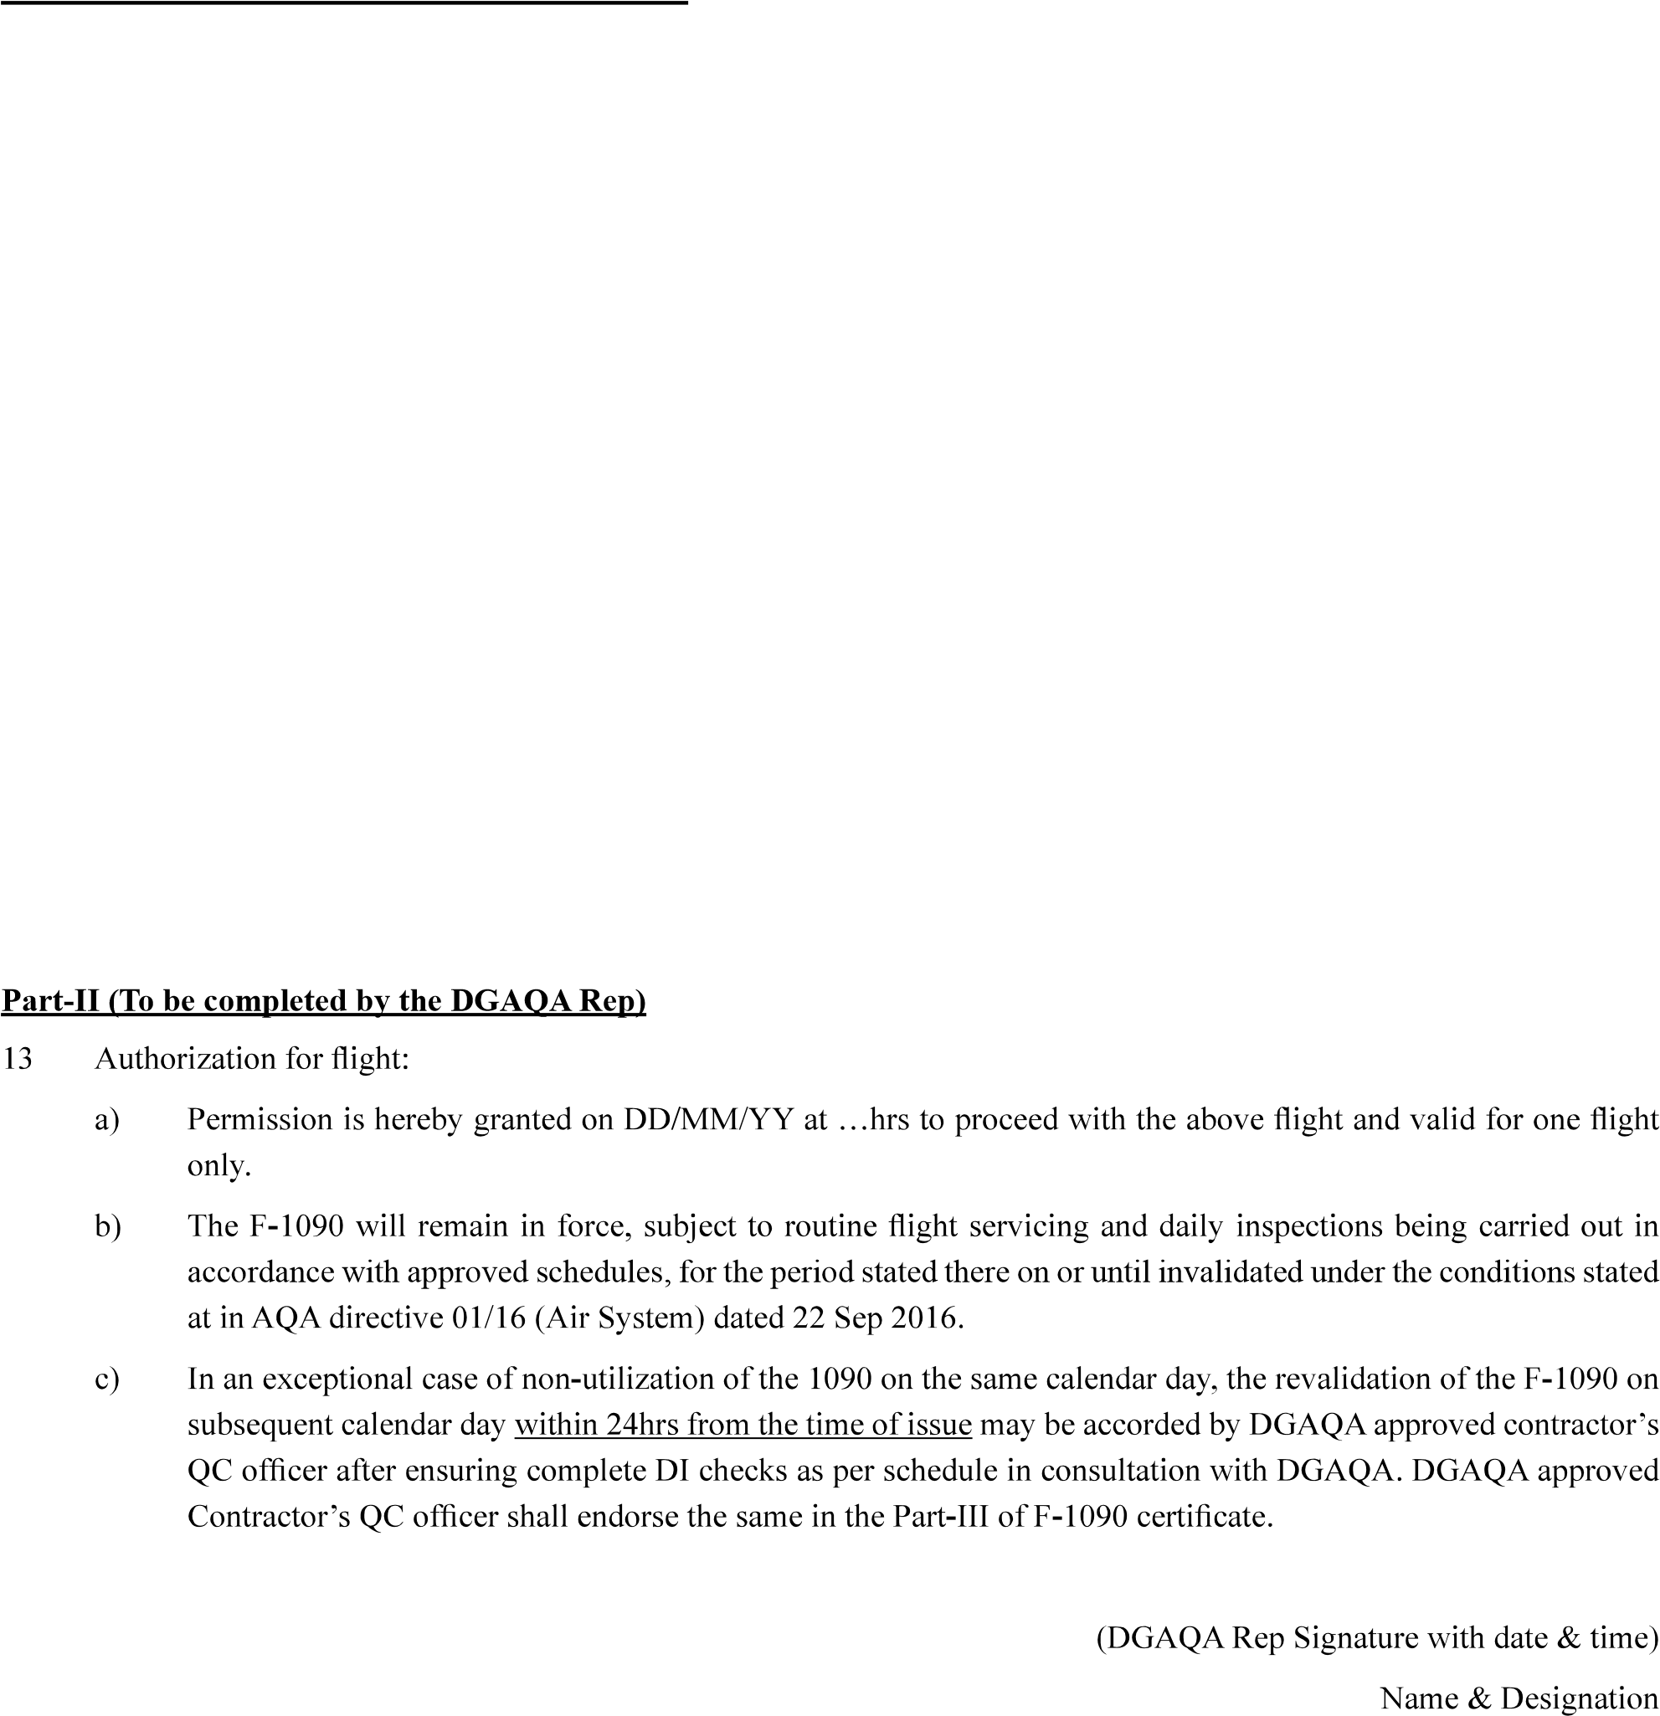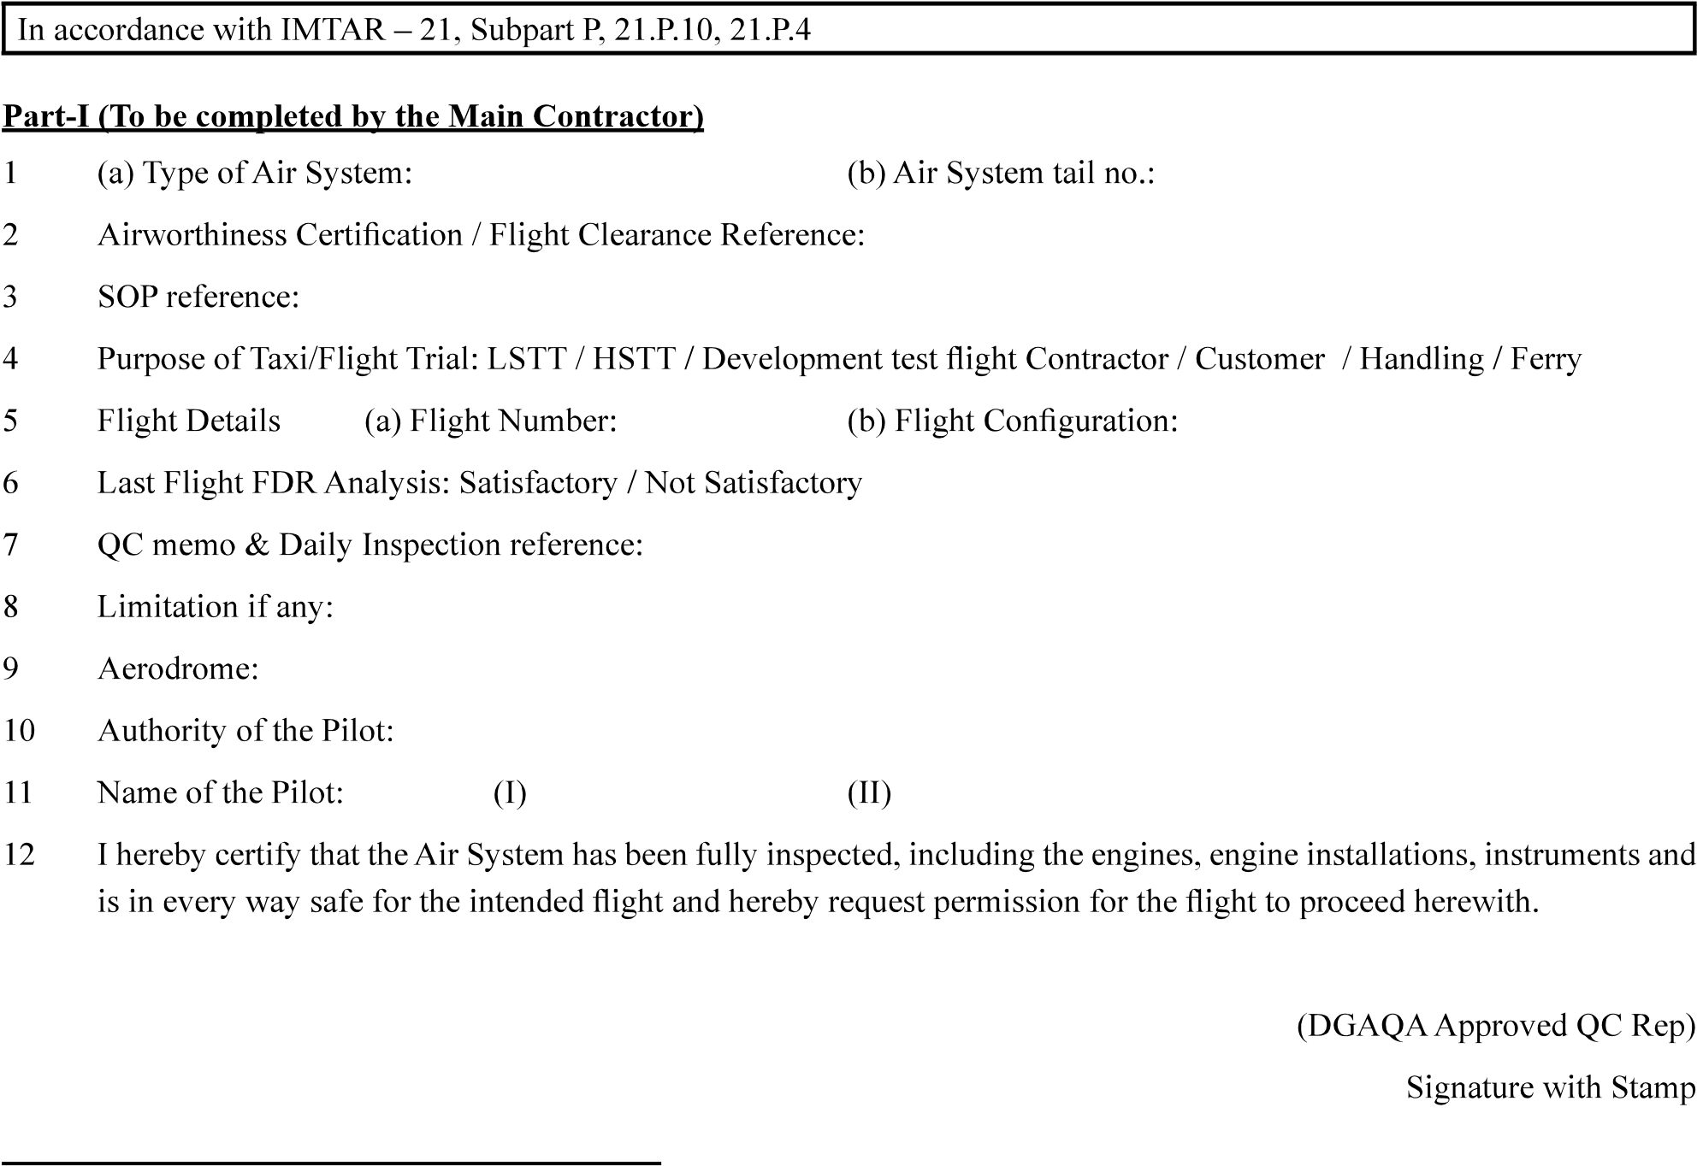

DD/MM/YY

…

………………………………………………

…………………………………………..

……………………….

………………………..

……………………………

………………………………………….………………………………..

……………………………..

…………………………..

……………..

…………………………………………..

………………………………………….

…………………………………..

…………………………….

CERTIFICATE OF SAFETY

FOR FLIGHT

Part-III - Revalidation

Revalidation:

……………………………………..

………………….

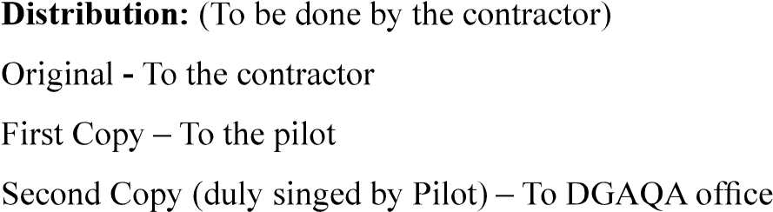II is revalidated.

………………………………………………………

Part - IV

