Template No.

CEMILAC_ACGP_ACP_01

**Issue/Rev No: 01/00**

**Date of Release: 8 Feb 2025**

**AIRWORTHINESS CERTIFICATION PLAN for Air Launched Weapon**

**for**

**Missile**

|  |  |  |  |  |  |  |
| --- | --- | --- | --- | --- | --- | --- |
|  | | | | | | |
| <DESIGN  AGENCY  LOGO> | | **Document No.** |  | | | |
| **Issue No./**  **Rev No. :** | <00X>/ | **Issue Date :** | | <DD/MM/YYYY> |
| **Copy No. :** | 01 of N | **No. of**  **Pages :** | | < total no .of pages > |
| **Document Classification :** | 🞎 Secret 🞎 Confidential  🞎 Restricted 🞎 Unrestricted | | | |
| **Title:** | | | | | **Project/System :** | |
| **AIRWORTHINESS CERTIFICATION PLAN**  **for**  **Air Launched Weapon for Missile** | | | | | < Project/System Name> | |
| **LRU/System Part No.** | |
| <No.> | |
| **Critical Level** | |
| <A/B/C/D/E> | |
|  | **Name & Designation** | | | | **Signature** | |
| Prepared By | <Design Rep Name>, < Designation> <Agency Name> | | | |  | |
| Reviewed By | <Project Leader Name>, <Designation> <Agency Name>  <AWG/QA HOD Name>, <Designation> <Agency Name> | | | |  | |
| Approved By | <Project Leader Name>, <Designation>  <Design Agency>  <Officer_Name>, <Designation>  RCMA <Name> | | | |  | |
| **<Design Firm Name & Address>** | | | | | | |

**Disclaimer:**

This document is a guidance document. Applicable section / table rows may be considered. Any additional details may be added. Any not applicable section/ table rows may be deleted. The template is very general and vary with process to process followed by Development Agency. The document may be fine-tuned with the TAA for finalization.

**Revision Sheet**

|  |  |  |  |  |
| --- | --- | --- | --- | --- |
| **Sl. No.** | **Rev No.** | **Rev Date** | **Changes** | **Remarks** |
|  |  |  |  |  |
|  |  |  |  |  |
|  |  |  |  |  |
|  |  |  |  |  |

**Contents**

1 Introduction 1

1.1 Scope of the document 1

1.2 Reference documents 1

1.2.1 Project Documents 1

1.2.2 Standards/Guidelines 1

1.3 List of Abbreviations 1

1.4 Organizations Involved 1

2 Project Definition 1

2.1 Scope of the Project: 1

2.2 System Requirements 1

2.3 Operational Envelope 2

3 Specification of Missile 2

3.1 Missile Operation 2

4 Design and Development 3

4.1 Development of Hardware 3

4.2 Development of Software 3

4.3 System/sub-system Criticality Classification: 3

4.4 Integration of Missile Sections 4

5 Instrumentation of Missile 4

6 Missile Integration to Platform 4

7 Certification 4

7.1 Certification process 4

7.1.1 Material 6

7.1.2 Airframe Structure 7

7.1.3 Aerodynamics 8

7.1.4 Avionics System: 9

7.1.5 Software Certification 9

7.1.6 Cooling System 11

7.1.7 Propulsion system 11

7.1.8 Warhead 12

7.1.9 Bought out Item 13

7.1.10 Human Machine Interface 13

7.2 Test and Validation 13

7.2.1 Ground Tests 13

7.2.2 Dummy Drop 13

7.2.3 Carriage Flight Trials / Captive Flight Trials (CFT) 14

7.2.4 Release Flight Trials 14

7.2.5 Integration on **Platform** 14

7.3 Documents to be generated: 14

7.4 Design Modifications 15

8 Project Time Line 16

9 Challenges 16

10 Clearance 16

**Table of Figures**

Figure 1

Figure 2

Figure 3

Figure 4

**List of Tables**

Table 1

Table 2

Table 3

Table 4

# Introduction

Brief introduction of the project to be given along with platform of integration.

## Scope of the document

Scope of the document to be mentioned here.

## Reference documents

### Project Documents

|  |  |  |
| --- | --- | --- |
| **S. No.** | **Document Number/Date** | **Document Name** |
|  |  |  |

### Standards/Guidelines

|  |  |  |
| --- | --- | --- |
| **S.No.** | **Document Number/ Date** | **Document Name** |
|  |  |  |

## List of Abbreviations

|  |  |
| --- | --- |
| **Abbreviation** | **Expansion** |
|  |  |

## Organizations Involved

Mention the details of Nodal agency for the project development and role and responsibility of various agencies involved shall be provided.

|  |  |  |
| --- | --- | --- |
| **Sl. No.** | **Organization/ Team** | **Responsibilities** |
|  |  |  |

# Project Definition

## Scope of the Project:

Scope of the project to be brought out here. The details about the development of missile/ launcher/ other platform related LRU’S etc., to be described here.

## System Requirements

PSQR reference, project requirements and their means of compliance shall be elaborated as per the table below.

|  |  |  |  |  |
| --- | --- | --- | --- | --- |
| **S. No** | **PSQR Para** | **Performance Parameters** | **PSQR Statement** | **Testing Method/Remarks** |
|  |  |  |  |  |

## Operational Envelope

The operational envelope of missile shall be brought out as described below:

**Carriage conditions:** The carriage conditions of the missile w.r.t altitude, G limits, Max. speed etc., shall be brought out here.

**Release Conditions:** The release conditions of the missile w.r.t altitude, G limits, Max. speed, Bank limits, pitch limits etc., shall be brought out here.

# Specification of Missile

The brief specifications of missile to be listed as shown below. The list is not exclusive; you can bring out all the other specifications.

|  |  |  |
| --- | --- | --- |
| **Sl. No.** | **Parameter** | **Value** |
|  | Length |  |
|  | Diameter |  |
|  | weight |  |
|  | Type of propulsion system |  |
|  | Modes of Operations |  |
|  | Type of guidance |  |
|  | Range |  |
|  | Altitude of operation |  |
|  | Launch platform |  |
|  | Launcher |  |
|  | Time of Flight |  |
|  | Type of Warhead |  |
|  | Kill Probability |  |
|  | Other parameters |  |

## Missile Operation

Missile operation sequence to be explained with figure

The sequence should contain the information like Pre-Launch Phase, Auto-Launch sequence, Release, Boost Phase, Mid-course Phase, Target search & selection, Terminal Phase etc., as per relevance of mission sequence.

It shall also bring out the activities listed below:

1. Activities in the hanger before integration to Aircraft
2. Missile preparation on the ground prior to mission
3. Integration of missile with launcher on aircraft on the ground
4. NOGO Requirement
5. Realignment Requirements

# Design and Development

Configuration of the missile (section wise) to be explained with Figure

## Development of Hardware

The development of new technologies for Project and adaptation of existing systems from other projects to be tabulated below as per configuration of missile/launcher/platform LRUs.

|  |  |  |  |
| --- | --- | --- | --- |
| **S. No.** | **Sub-systems** | **New Development/ Adaptation/BoI** | **Remarks** |
| 1. Missile Sub-systems | | | |
|  |  |  |  |
| 1. Launcher Sub-systems | | | |
|  |  |  |  |
| 1. Platform LRUs | | | |
|  |  |  |  |

## Development of Software

The development of software for Project and adaptation of existing software from other projects to be tabulated below as per configuration of missile/launcher/platform software intensive sub-systems.

|  |  |  |  |
| --- | --- | --- | --- |
| **S. No.** | **Sub-systems** | **New Development/ Adaptation/BoI** | **Remarks** |
| 1. Missile Sub-systems | | | |
|  |  |  |  |
| 1. Launcher Sub-systems | | | |
|  |  |  |  |
| 1. Platform LRUs | | | |
|  |  |  |  |

## System/sub-system Criticality Classification:

The criticality of systems/subsystems/LRUs and material of Weapon System has to be categorised based on the Failure Mode Effect and Criticality Analysis (FMECA) / Failure Tree Analysis (FTA) studies. The classification shall be as Safety Critical (C1), Mission Critical (C2) and Non Critical (C3).

## Integration of Missile Sections

Missile is to be realized as per the approved drawings and to be integrated as per the approved Mechanical & Electrical Integration documents with the integration of subsystems and assembly of sections. The relevant phase checks shall be carried at section and integrated missile level as per the approved Checkout document. The routing of wires and cables shall be carried out as per the approved drawings.

# Instrumentation of Missile

A suitable telemetry system free from electromagnetic interference, hazards to be used for recording, transmitting the instrumented data during flight trials. The instrumentation plan will be approved by RCMA (Missiles). Project shall release analysis report after each trials.

# Missile Integration to Platform

Platform integration details to be explained and clearance activities and the readiness details to be provided. The amount of testing and checks to be carried before integration to the platform has to be elaborated.

The prerequisite for the integration clearance/SEO are provided below:

1. Stress analysis w.r.t structural integration
2. Store Separation Studies (Theoretical and CFD studies)
3. Functional check document (Ground and Flight)
4. EMI/EMC Qualitative Test Plan Document
5. Electrical load analysis

# Certification

## Certification process

The certification process shall be as per ALM Subpart-B3 of IMAP 23 shall be elaborated in detail.



The airworthiness certification process of different domain of weapon system is enumerated below for compliance:

### Material

Material certification to be followed as per the following format:

|  |  |  |  |  |  |  |  |  |  |
| --- | --- | --- | --- | --- | --- | --- | --- | --- | --- |
| **PROFORMA FOR DESIGN CRITERIA**  **Project : ____________ Material Grade : _____________**  **Name of Inspection Agency : ____________ Heat Treatment Condition : _______**  **Size (mm) : _____________** | | | | | | | | | |
| **Sl. No.** | **Component** | **Classification** | **Stress Conditions** | | | **Environmental Conditions** | **Temperature Conditions** | **Weld ability requirements\*** | **Any other information** |
| **Primary** | **Secondary** | **Static/ Dynamic loading conditions** |
|  |  |  | Eg: Fatigue, YS, UTS | Eg: Fatigue, YS, UTS |  |  |  | * Type of welding * No. of joints * Component details which are to be welded * Material type * WPS & PQR Status-approved or not? * Vendor details |  |
| **Signature**  **Name & Designation**  **Name of Organization (with Seal)**  **Enclosures:**   1. Brief write-up about the Project 2. End use of the Components along with justification for classification 3. Drawings/Photographs of components 4. QA Plan 5. Application for Type Approval 6. Details of Supplier, if already identified | | | | | | | | | |

### Airframe Structure

The certification procedure for airframe structure is as shown in below Fig.



### Aerodynamics

The certification procedure for aerodynamics is as shown in below Fig.

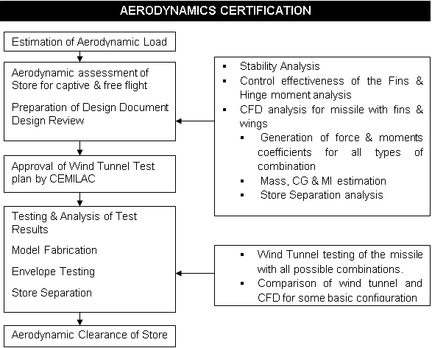

### Avionics System:

The certification procedure for avionics is as shown in below Fig.

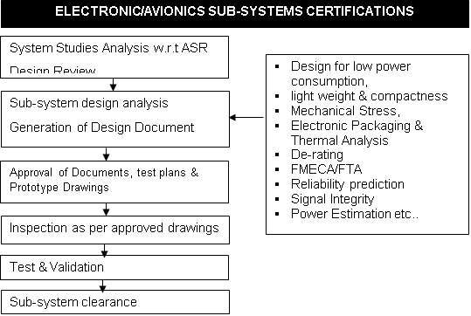

Figure 6 Figure Avionics System Certification

### Software Certification

Phases of Clearances and Certification Plan for each phase:

|  |  |
| --- | --- |
| **Phase** | **Activities to be carried out** |
| CFT and Dummy drop trials | * Preparation of certification plan * Approval of SRD, ICD * Approval of High level test cases * Requirement Based testing (LRU-wise) * Baselining of the software with version description document * IV&V recommendation * Missile integration tests * Aircraft integration Tests |
| Mission launch without warhead | * Preparation of certification plan * Approval of SRD, ICD * Requirement Review * Design Review * Code Walkthrough * Approval of the test rigs and software * Approval of Test plan and High level test cases * Requirement Based testing (LRU-wise) * Baselining of the software with version description document * IV&V recommendation * Missile integration tests * Aircraft integration Tests * Change management with SCR and SCN forms |
| Mission launch with warhead | * Preparation of certification plan * Approval of SRD, ICD * Requirement Review * Design Review * Code Walkthrough * Static and Dynamic analysis * Algorithm validation * Approval of the test rigs and software * Approval of Test plan and High level test cases * Requirement Based testing (LRU-wise) * Software Verification report consisting of results from all the analyses and testing. * Baselining of the software with version description document * IV&V recommendation * Missile integration tests * Aircraft integration Tests * Change management with SCR and SCN forms |
| Production | * Consolidation of all the changes and incorporation into corresponding artefacts * Reconciliation of the limitations and known issues * Closure of defect investigations and Request for Actions. * Conformance to standards * User acceptance trial reports * Final configuration of the software * User documentation (User manual, installation manual, troubleshooting / diagnostics manual etc) |

### Cooling System

The certification procedure for cooling system is as shown in below Fig.

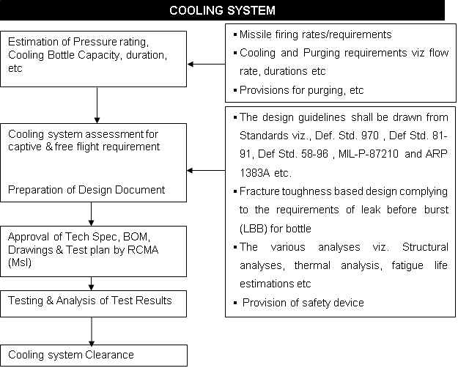

### Propulsion system

The certification procedure for propulsion is as shown in below Fig.

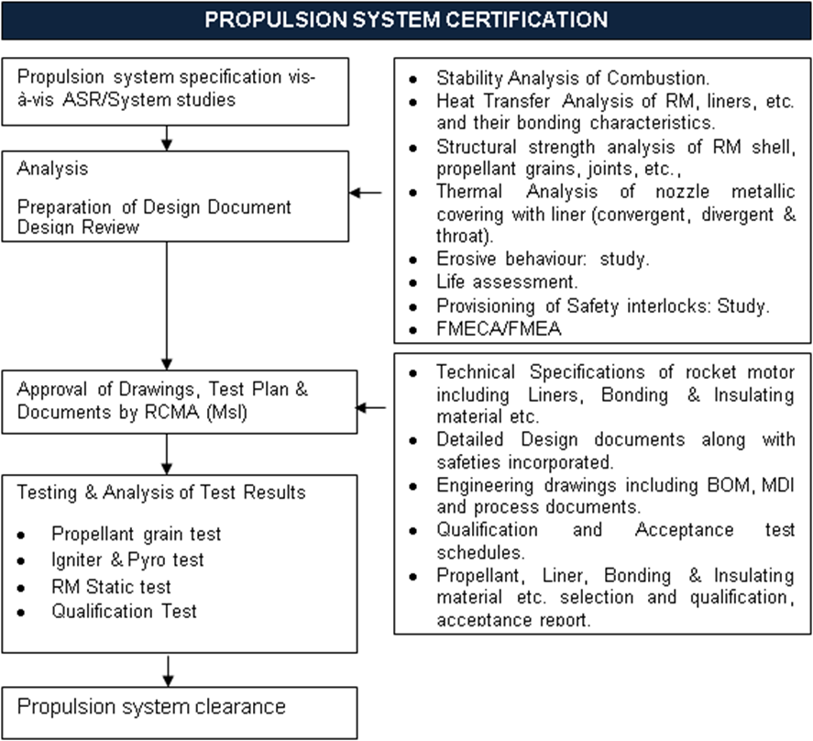

### Warhead

The certification procedure for warhead is as shown in below Fig.



### Bought out Item

The Bought out Item (BOI) Performa as per Form 40A of IMAP 23 to be submitted for imported equipment for issue of clearance by RCMA.

### Human Machine Interface

HMI design development details, their integration aspects, simulation details, test rig details and means of compliance to be explained.

## Test and Validation

Acceptable means of compliance of the weapon w.r.t testing (QT/SOFT/LQT/AT), analysis and review shall be described here. Test report generation and their acceptance criteria to be defined.

### Ground Tests

The following weapon/section level tests shall be carried out successfully before commencement of developmental flight trials as per the approved test procedure document.

1. Ground Resonance Test (GRT)
2. Structural (Missile sections & Full Missile), Vibration & Shock Tests
3. Pit Drop Test
4. Aircraft Electrical System compliance i.a.w. Mil-Std 704-F
5. Booster Separation Test
6. Rocket Motor (Booster & Sustainer) Ground Tests
7. Warhead Performance Evaluation
8. Integration of Missile & Fire Control System with Helicopter
9. Altimeter Performance Evaluation
10. Seeker Performance Evaluation (Sorties during different weather Conditions)
11. Phase Checks of Missile
12. Hardware In-Loop Simulation (HILS) Tests
13. RCS Measurement of Missile
14. Counter Measures test (RF/IR)
15. Missile Handling equipment
16. Operational and Service Life Testing
17. Training aids development and assessment

The above mentioned tests and test conditions to be elaborated, the list is not exclusive. Add all the other applicable tests as well.

### Dummy Drop

**Static Firing on Ground:**

The trial plan is given below:

|  |  |  |  |  |
| --- | --- | --- | --- | --- |
| **Test No.** | **Mission Objective** | **Config.** | **Flight Profile**  **(Alt,Speed, etc.)** | **Remarks** |
|  |  |  |  |  |

Table 7 Dummy drop trial Plan

### Carriage Flight Trials / Captive Flight Trials (CFT)

Bring out the reason to carry out Carriage/Captive flight trials

|  |  |  |  |  |  |
| --- | --- | --- | --- | --- | --- |
| **S. No.** | **Flight No.** | **Mission Objective** | **Config.** | **Flight Profile**  **(Alt, Speed, etc.)** | **Remarks** |
| Carriage Trials | | | | | |
|  |  |  |  |  |  |

### Release Flight Trials

Objectives for RFT to be brought out.

|  |  |  |  |  |  |
| --- | --- | --- | --- | --- | --- |
| **S/N** | **Mission Objective** | **Configuration of Missile and LH/RH** | **Release Conditions(H/c, Alt, Speed, sideslip etc)** | **Target Type (Fixed/Simulated/Moving)** | **Remarks** |
|  |  |  |  |  |  |

**Note: The parameters listed in the table are not exclusive, you can include other parameters as per PSQR**

### Integration on **Platform**

The aspects of integration on platform and its clearance aspects can be described.

## Documents to be generated:

The documents to be generated at Missile level and subsystem level are listed in following Tables:

Missile Level:

|  |  |  |
| --- | --- | --- |
| **Sl. No** | **Documents required** | **Remarks** |
|  | Technical Specification | Docs to be approved by RCMA |
|  | List of equipment and their hardware/software versions |
|  | List of drawings |
|  | Wire harness document |
|  | Mechanical & Electrical Integration document |
|  | Phase Check/Checkout Test document |
| 1. ; | Qualification Test Procedure (QTP) |
|  | Daily Inspection (DI) Procedure |
|  | ENTEST Specification Document |
|  | System safety analysis | For review, scrutiny, and reference for issue of clearance. |
|  | HILS test Plan and Report |
|  | Mission Studies |
|  | Safe Separation, Emergency Jettison |
|  | Failure Mode Studies |
|  | Qualification test report | Test reports to be coordinated by MSQAA/RDAQA |
|  | Phase Checks report |

Subsystem Level:

|  |  |  |
| --- | --- | --- |
| **Sl. No** | **Document required** | **Remarks** |
|  | Technical specification | Docs to be approved by RCMA |
|  | BOM |
|  | MDI/Drawings |
|  | Integration Processes Document |
|  | SOFT/LQT/Qualification test schedule along with Functional Test Procedure | Docs to be approved by RCMA. |
|  | Design Analysis   1. PDR/CDR 2. Mechanical Stress Analysis 3. Electronic Packaging (Dynamic & Thermal Analysis) 4. De-rating 5. FMECA / FTA 6. Reliability analysis | For review, scrutiny, and reference for issue of clearance. |
|  | ESS report | Test reports to be coordinated by MSQAA/RDAQA |
| COTS screening report |
| Qualification test report |

## Design Modifications

During qualification test/flight evaluation if any Defect/Snag is observed a detailed investigation has to be carried out as described in the IMAP 23 involving RCMA, R&QA, MSQAA and Designer. For any design modification or software modification Engineering Change Notice (ECN) or Software Change Notice (SCN) to be issued.

# Project Time Line

The brief timeline of project is to be given.

# Challenges

1. Store Separation & Carriage Flight Trial (CFT) - Likely Issues:
2. MFCS Integration with Sea King Helicopter - Likely Issues:
3. Control Flight Trial - Likely Issues:
4. Development of Float Body for Targets - Likely Issues:
5. Control & Guidance Flight Trial (w/o Warhead) - Likely Issues:
6. Full Configuration Flight Trial (with Warhead) - Likely Issues
7. Additional Tests/ Mil-Std Compliance:

# Clearance

After completion of development, flight evaluation and Qualification, project to finalize the Compliance Document with respect to PSQR. RCMA (Missiles) accords the operational clearance for service use.