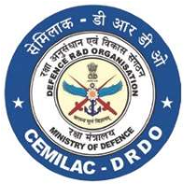
FORM - 80
DESIGN ORGANISATION APPROVAL
CERTIFICATE
[
CEMILAC, MINISTRY OF DEFENCE, GOVT. OF INDIA
]
DESIGN ORGANISATION APPROVAL CERTIFICATE
DESIGN ORGANISATION APPROVAL NUMBER (DOAN):

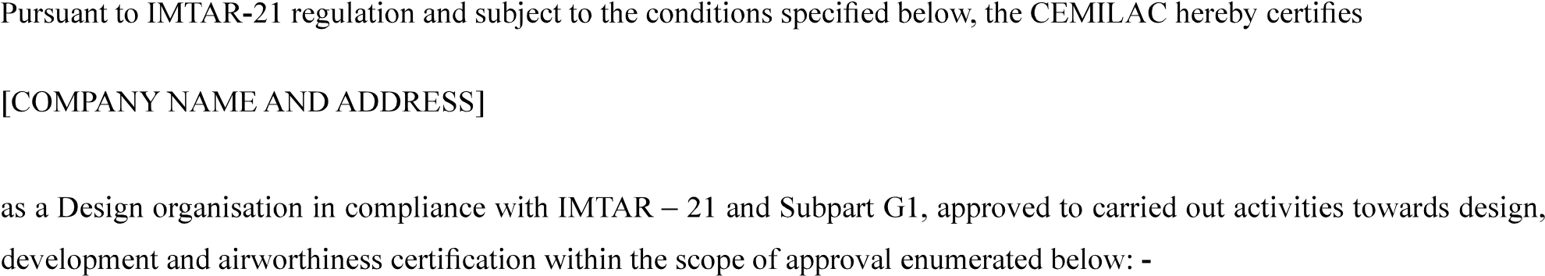
<COMPANY NAME AND ADDRESS>

SCOPE OF APPROVAL:
- Class:
- Activities:
VALIDITY:
PRIVILEGES:

Sl.  No. | Name of the Privilege | Applicable guidelines for operation

FORM - 80
DESIGN ORGANISATION APPROVAL
CERTIFICATE

CONDITIONS:
………………………………..
…………………

LIMITATIONS:
Date of Original Issue:
Date of Preceding Revision:
Date of this revision:
Revision No.:
Signed:______________________________
Chief Executive (A) CEMILAC:

