Version : 2.0 | Date: August 2023
Directorate General of Aeronautical Quality Assurance
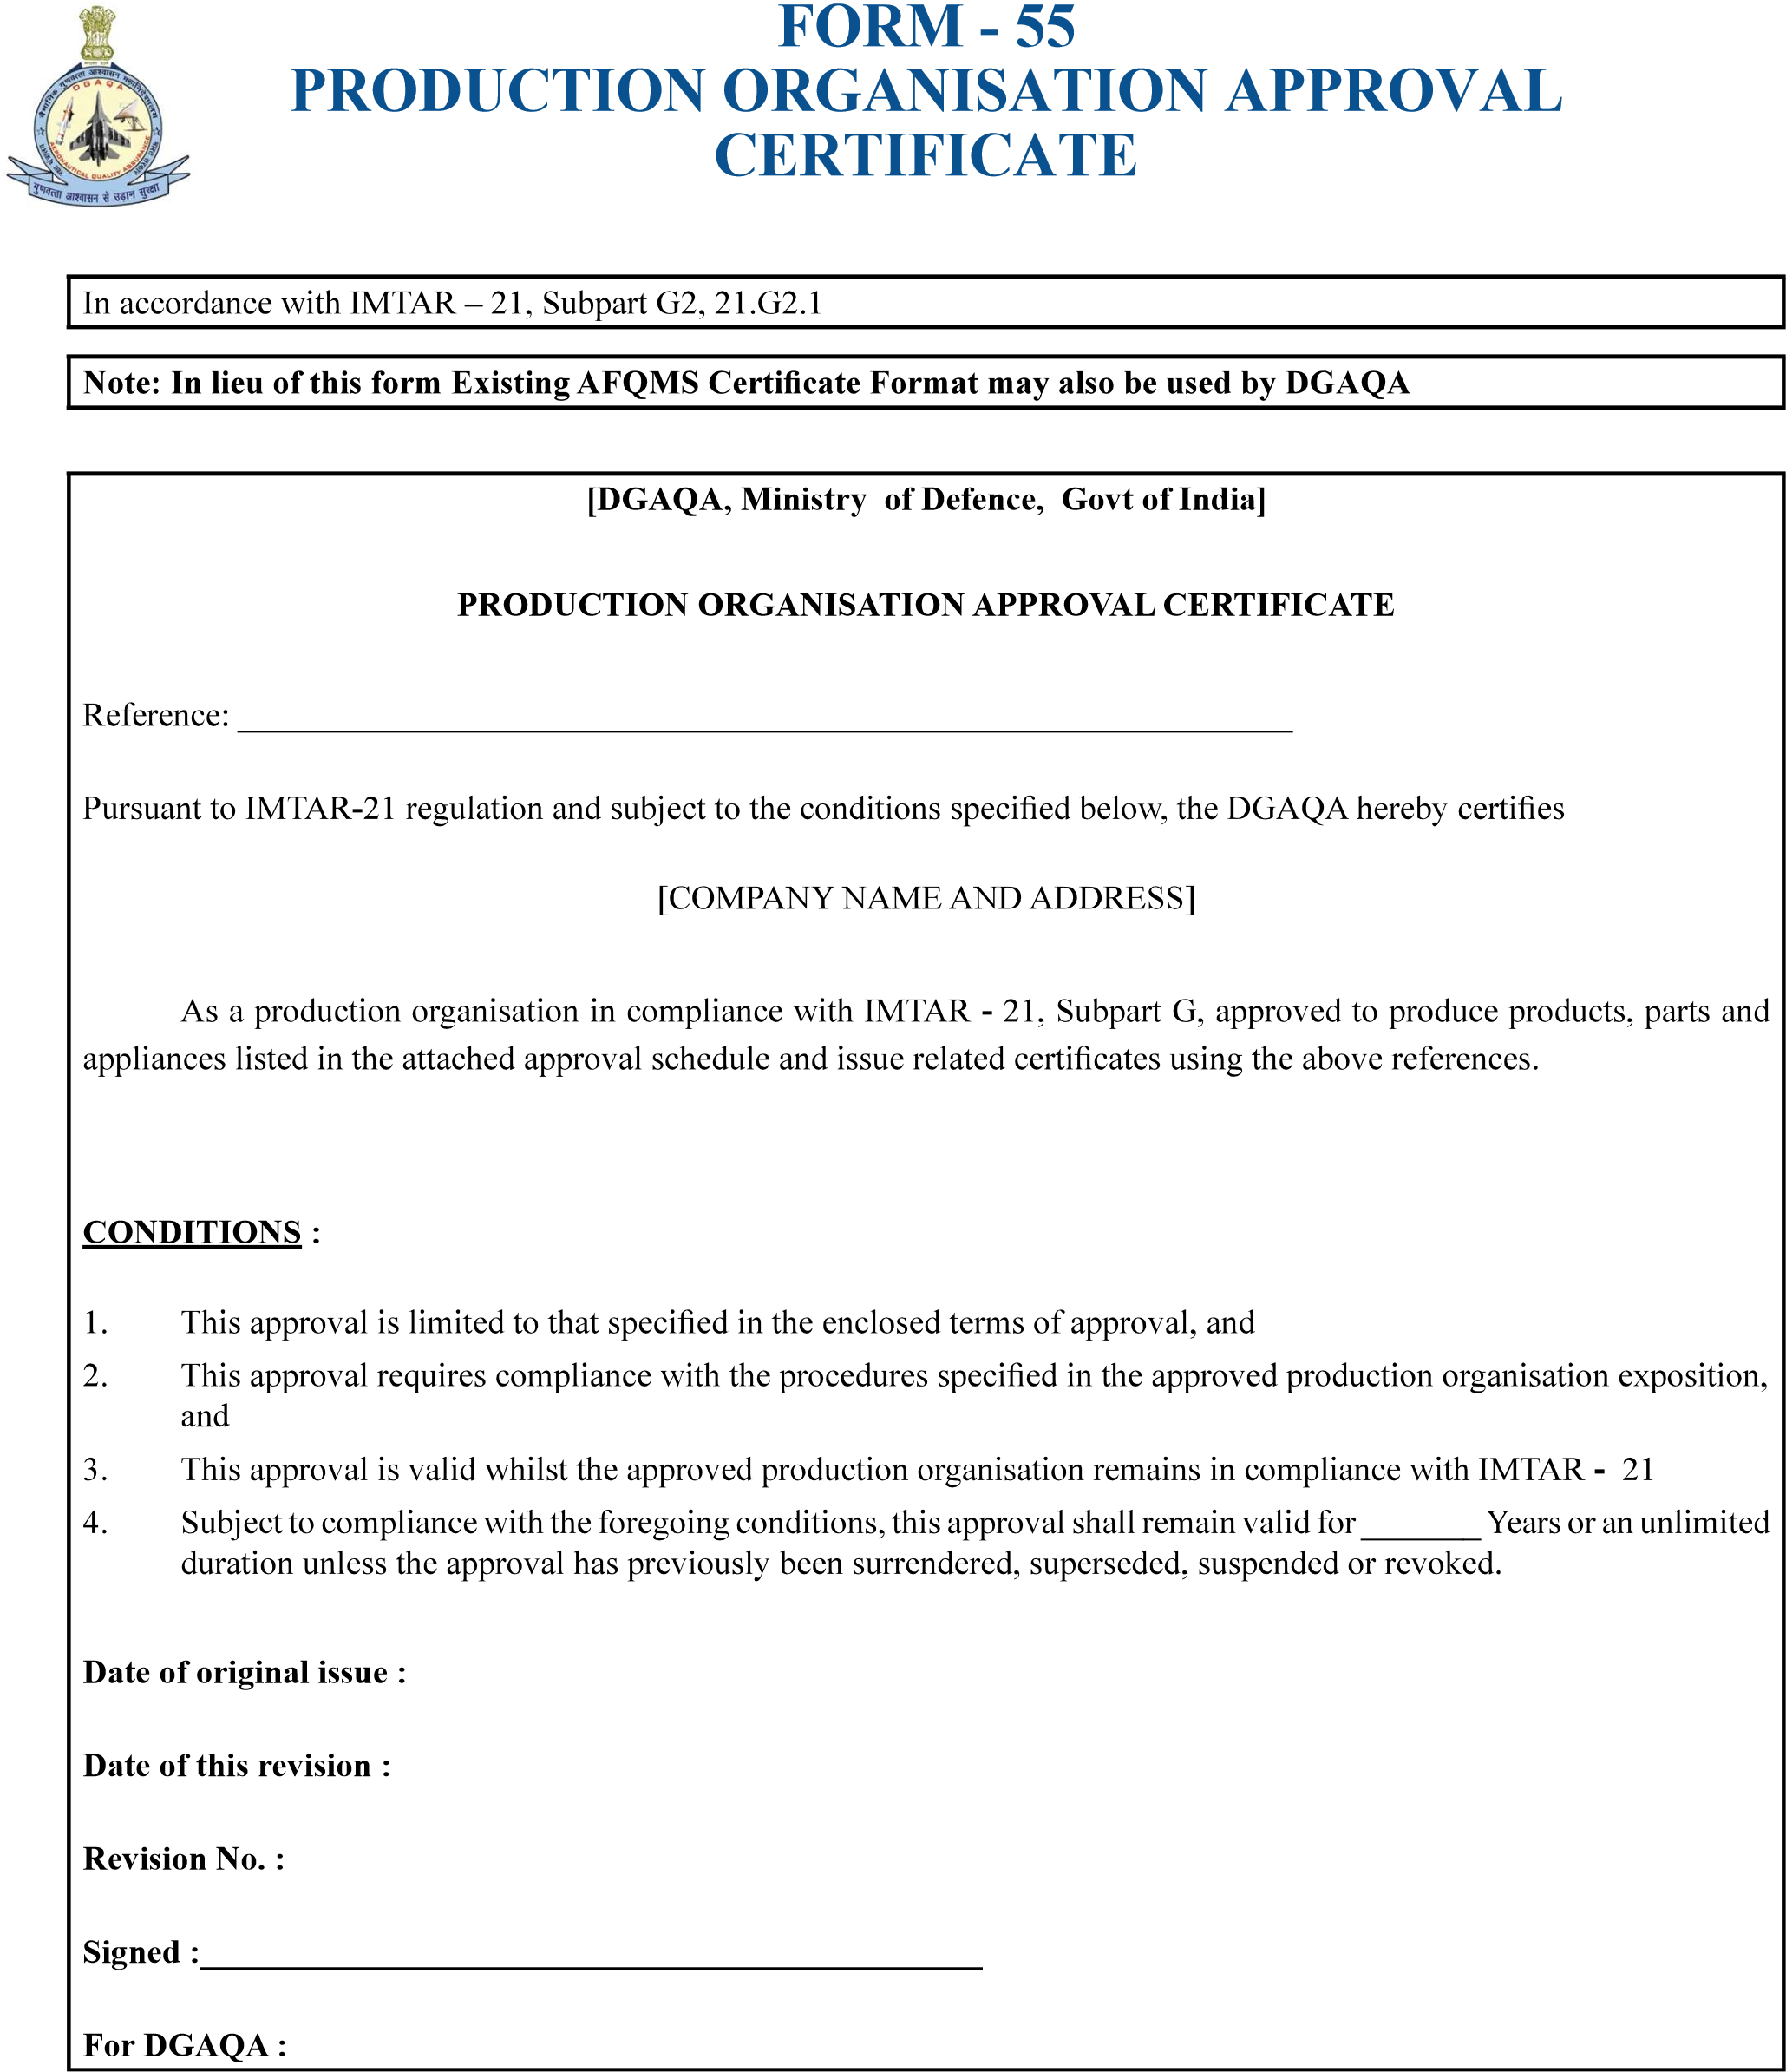
…………………………………………
………………………………
………………………….
……………………………..
………………………………………………………………………………………………………………
……………………………………………………………..
Version : 2.0 | Date: August 2023
Directorate General of Aeronautical Quality Assurance
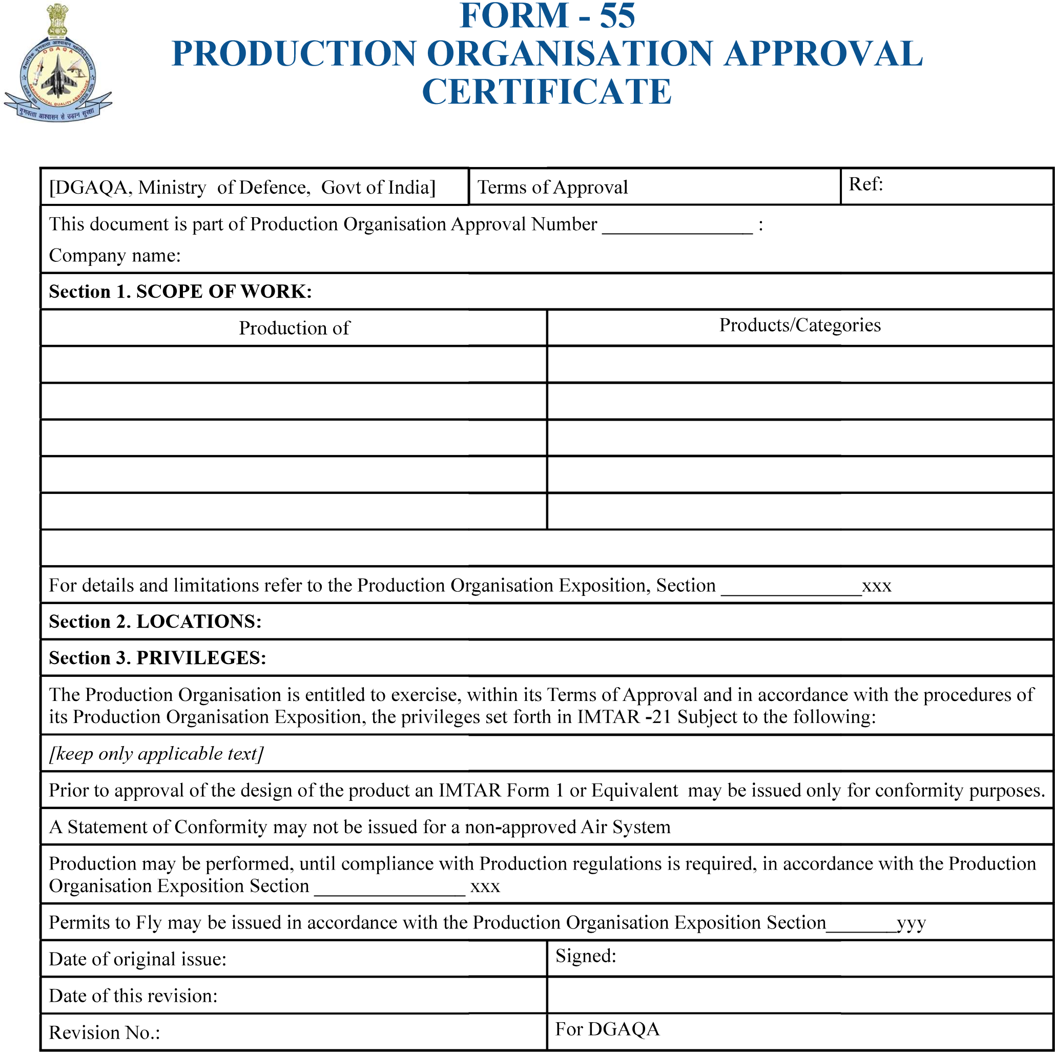
…………………………….

……XXX……

…………..
………………………………………………

…………

