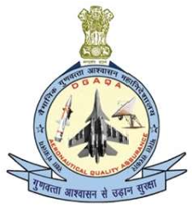
Directorate General of Aeronautical Quality Assurance
FORM - 51
APPLICATION FOR SIGNIFICANT
CHANGES OR VARIATION OF SCOPE AND TERMS OF PRODUCTION ORGANISATION APPROVAL

Note: This Form is made Optional / Not Mandatory

DIRECTORATE GENERAL OF AERONAUTICAL QUALITY
ASSURANCE (DGAQA)
GOVERNMENT OF INDIA, MINISTRY OF DEFENCE ‘H’ BLOCK, NEW DELHI-110011
 | Name and address of the Approval holder
2. | Approval reference number
3. | are requested
5.
6. | nominee
 | …………………………. | …………………………………………….

Directorate General of Aeronautical Quality Assurance
FORM - 51
APPLICATION FOR SIGNIFICANT
CHANGES OR VARIATION OF SCOPE AND TERMS
OF PRODUCTION ORGANISATION APPROVAL

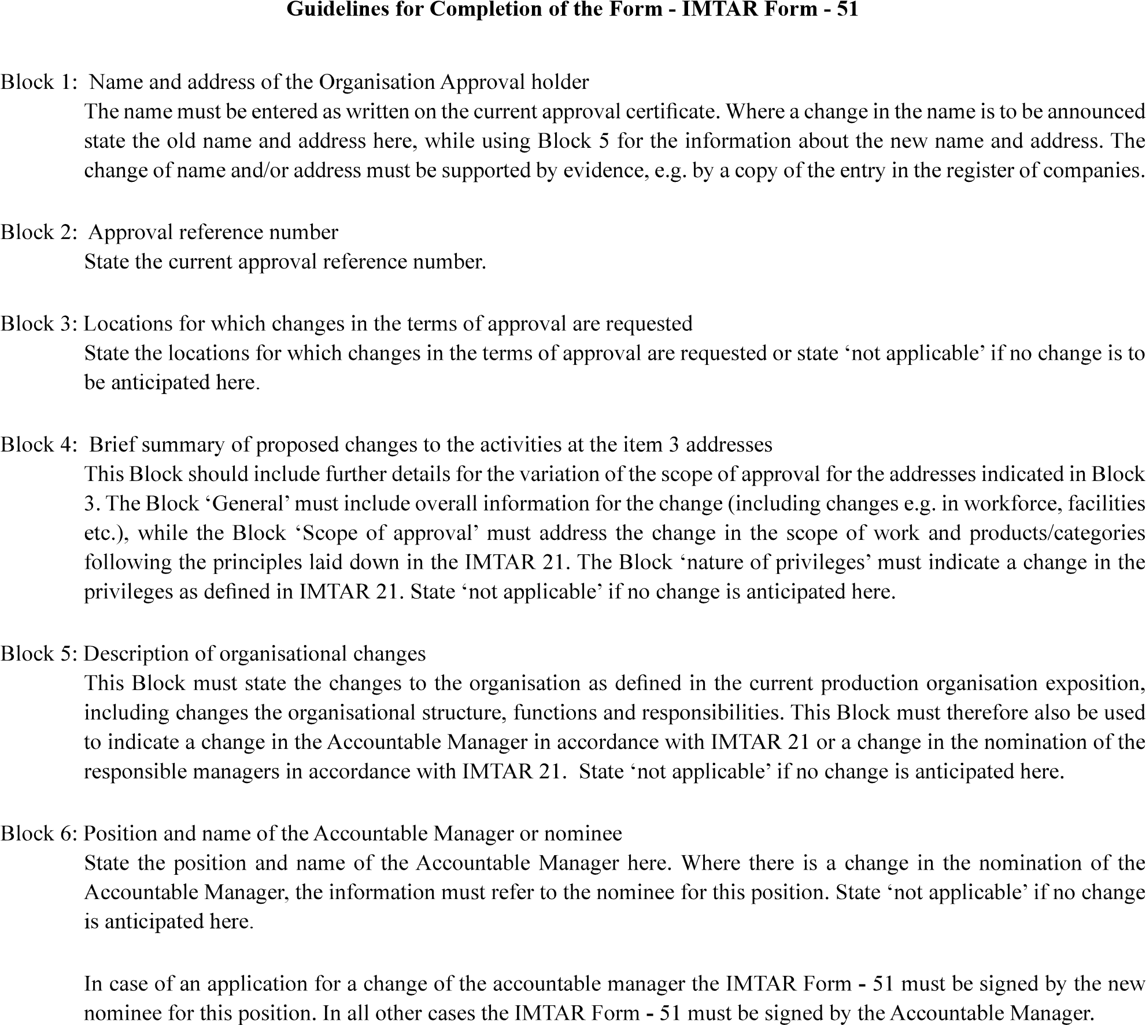
Version : 2.0 | Date: August 2023

Version : 2.0 | Date: August 2023

