
FORM - 40A APPLICATION FOR CLEARANCE OF AIRBORNE STORES IMPORTED FROM FOREIGN COUNTRY
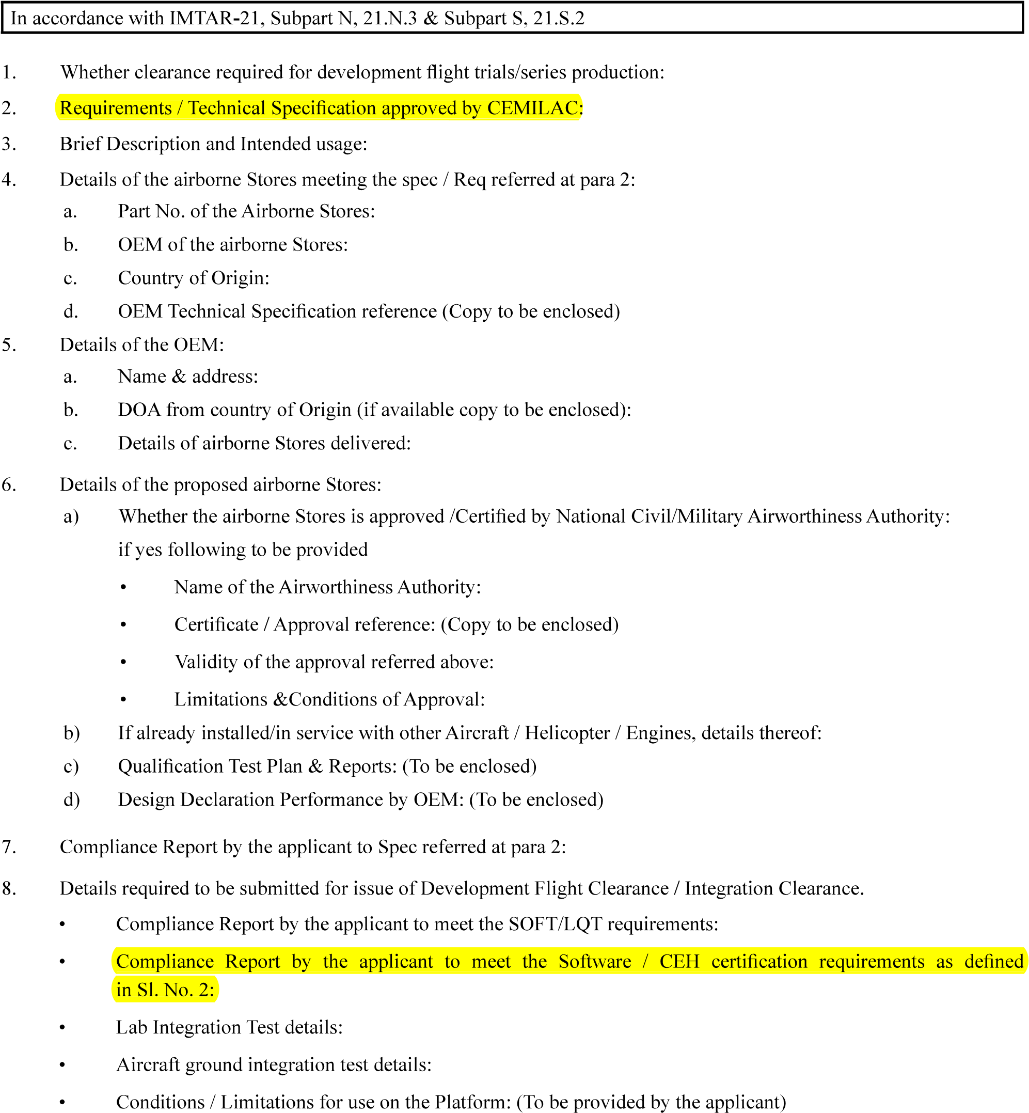
………………………………..
……………………………….
……………………………
…………………………….
……………………………………
……………………………………………………………..
…………………………………..
……………………………………
Version : 2.0 | Date: August 2023
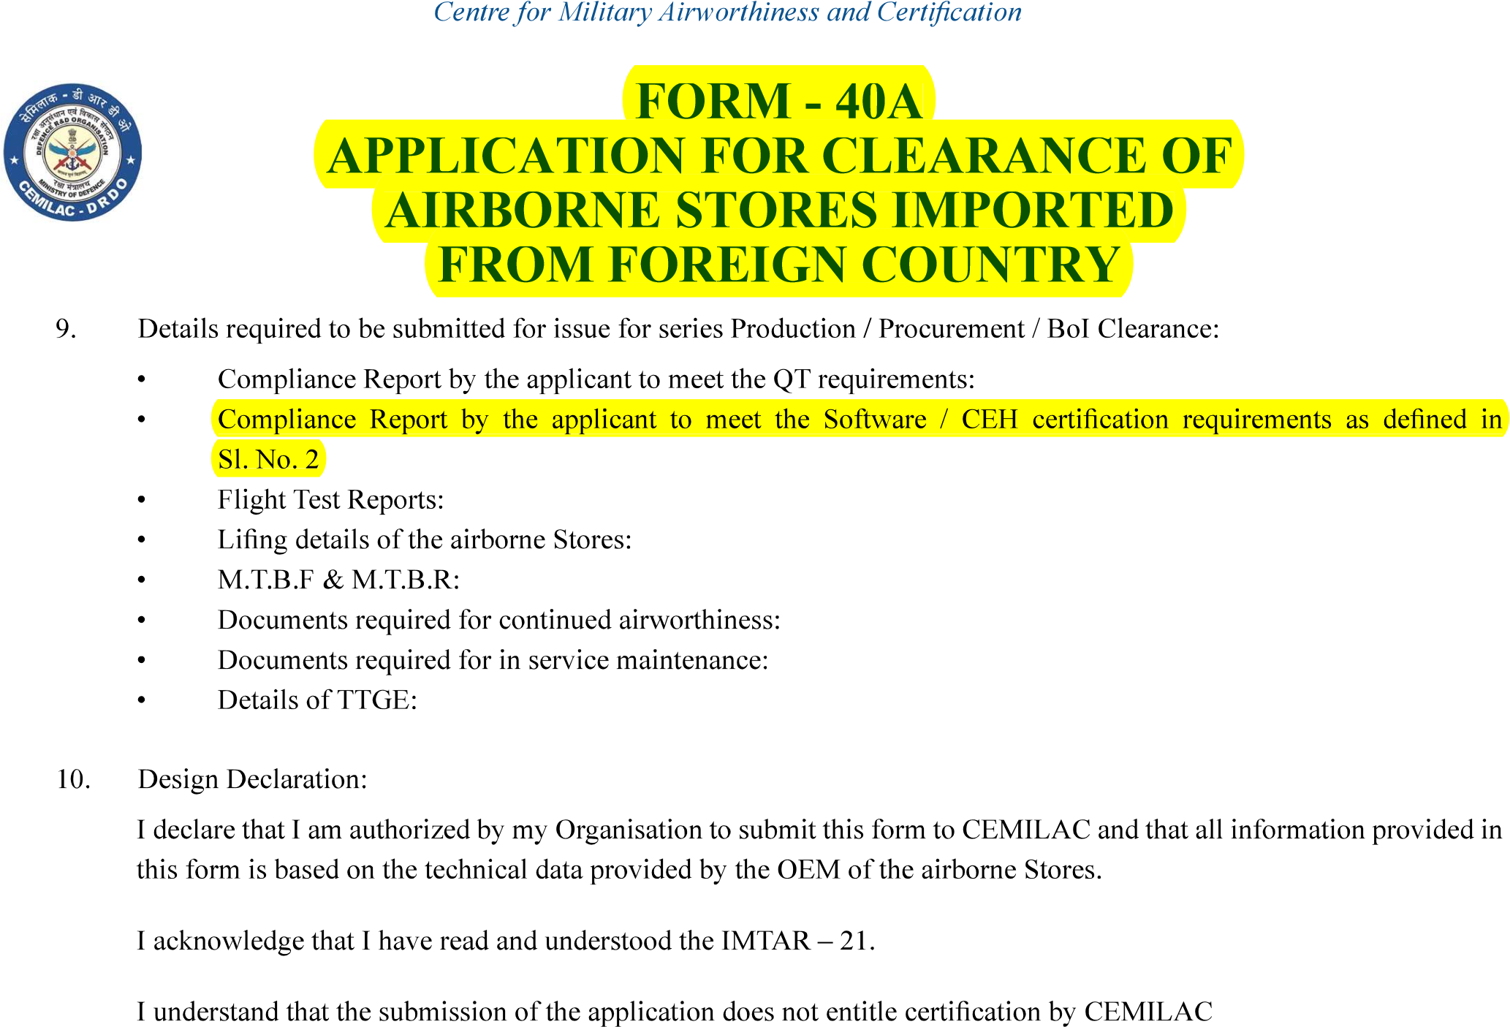
……………………

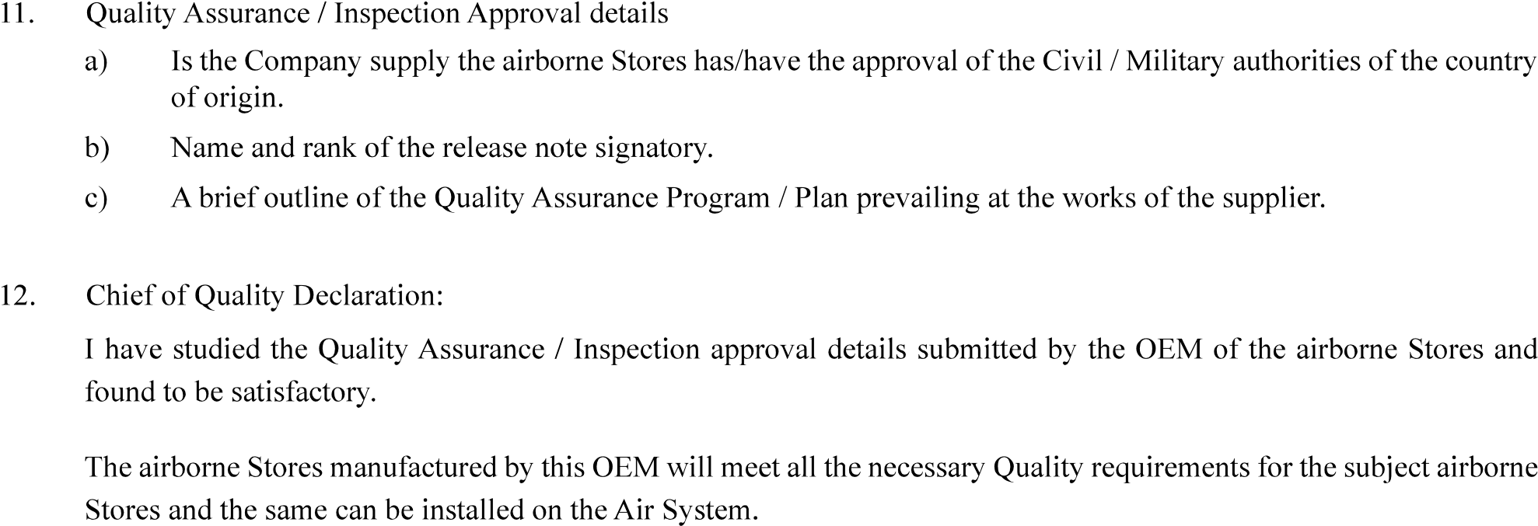
……………………….
…………………………………….
……………
Name

Version : 2.0 | Date: August 2023

