Directorate General of Aeronautical Quality Assurance
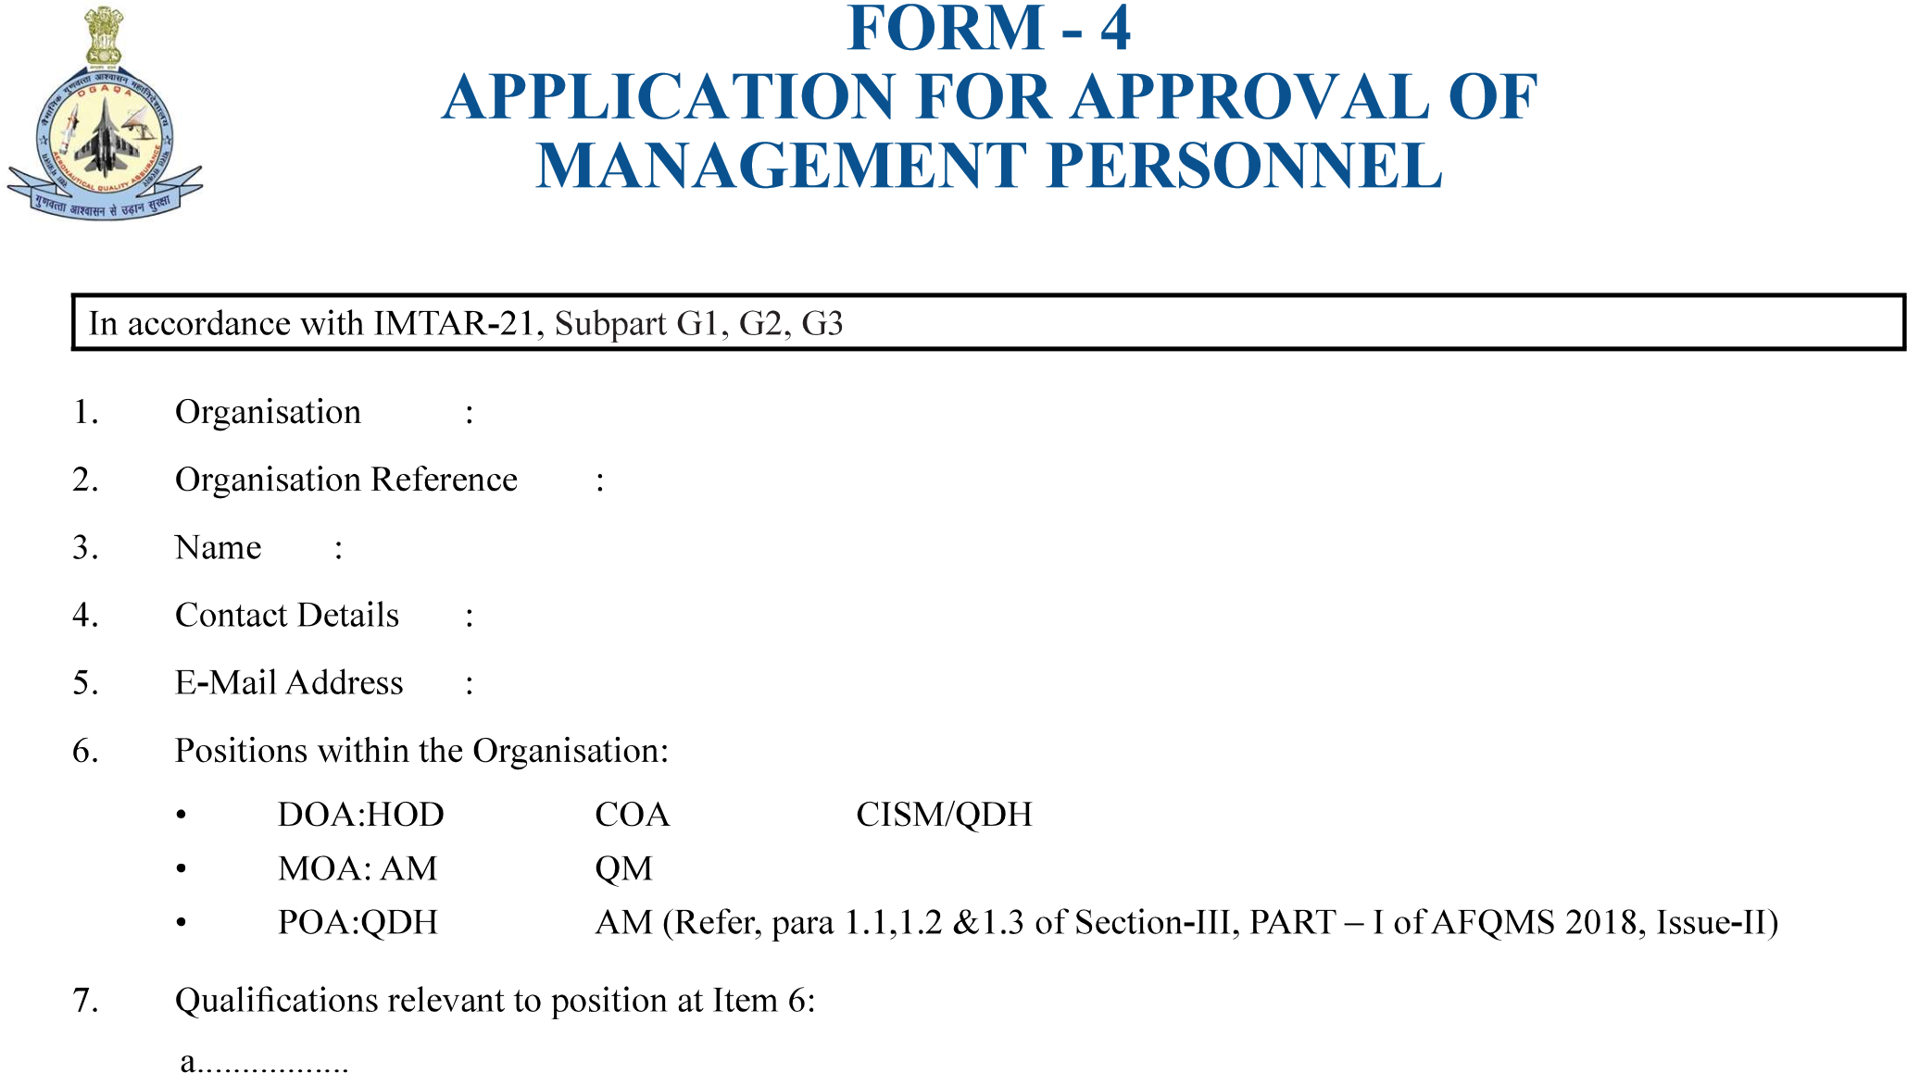

b................
Version : 2.0 | Date: August 2023
c................
a..................
b..................
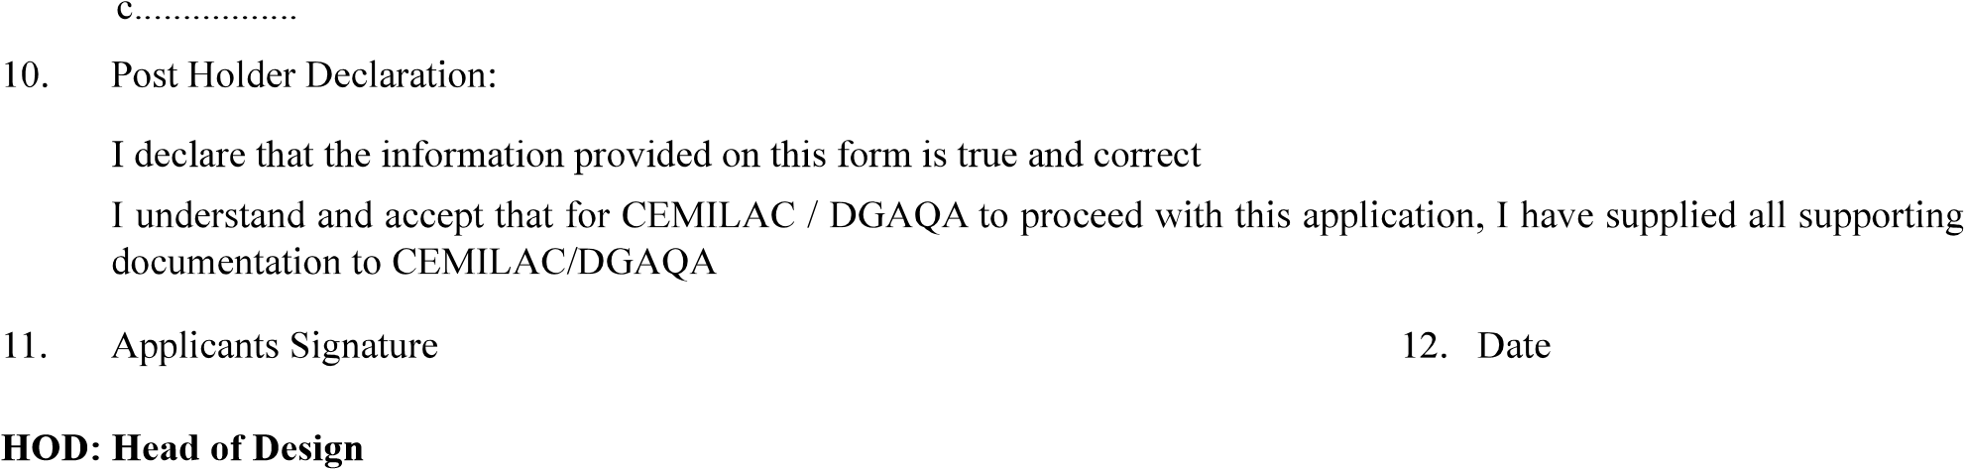

COA: Chief of Airworthiness
CISM: Chief of Independent Support Monitoring / QDH: Quality Department Head
AM : Accountable Manager
QM : Quality Manager
DOA: Design Organisation Approval
POA: Production Organisation Approval
8

