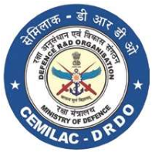
FORM - 36
APPLICATION FOR CONCESSION ON
MODIFICATION / SI/ STI/ SB
PART A
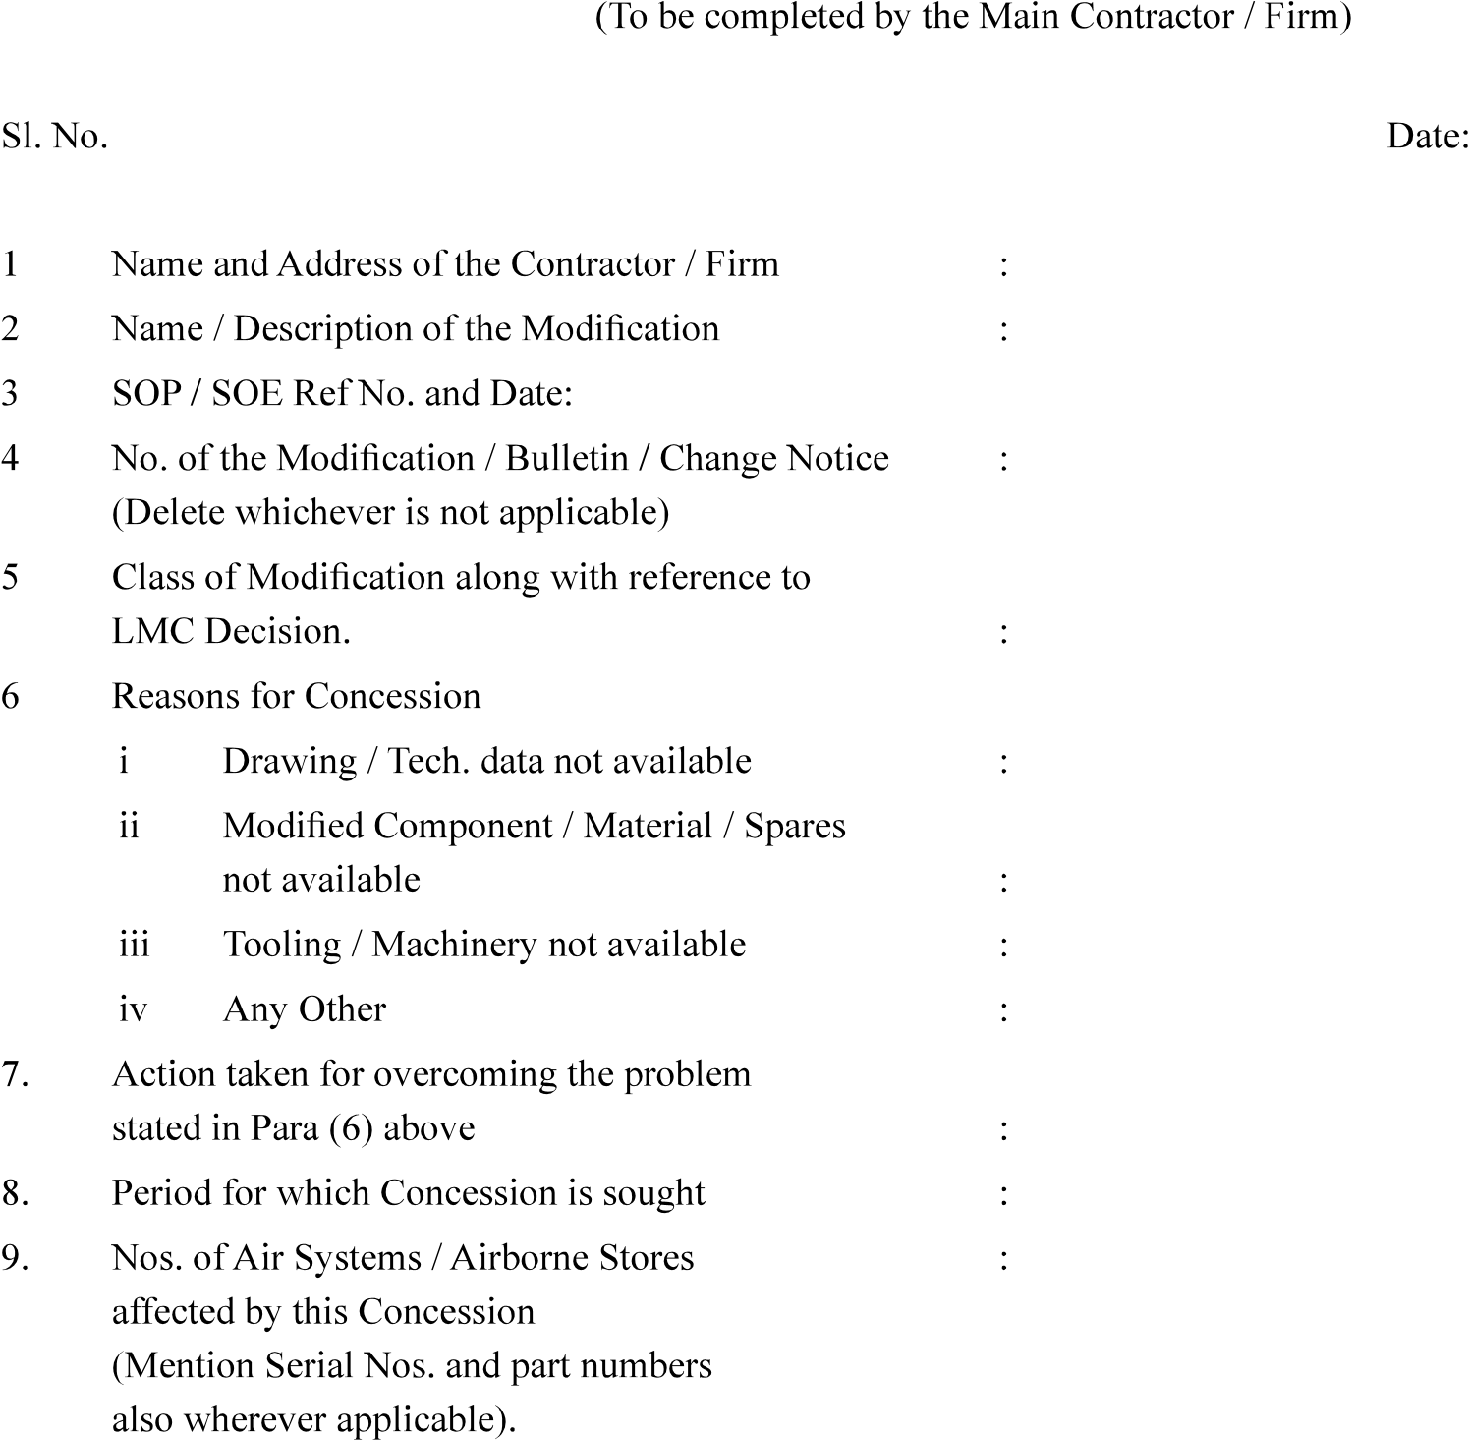

Version : 2.0 | Date: August 2023
79
FORM - 36

APPLICATION FOR CONCESSION ON MODIFICATION / SI/ STI/ SB

PART - B

PART - C

PART - D

Version : 2.0 | Date: August 2023
80

