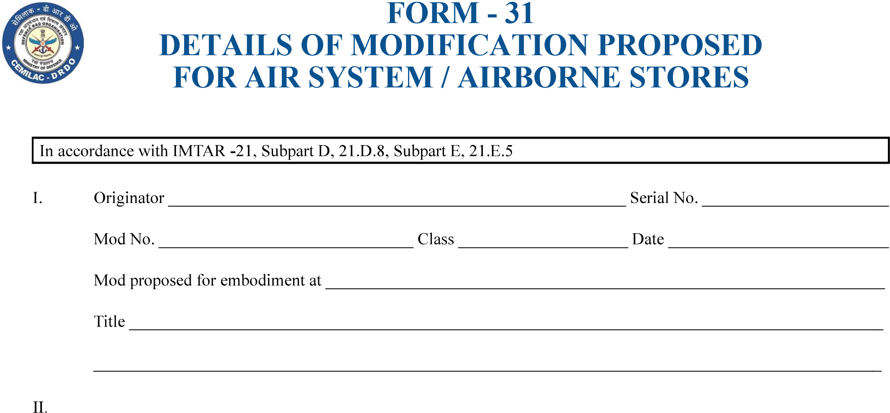
……………………………………………………………………………………………………………
…………………………………………………………………………………………………………………………………………………….
…………………………………………………………………………………………………………………………………………
…………………………………………………………………………………….
……………………………………….
……………………….
………………………………………….
……………………………
…………………………………………………………………………….
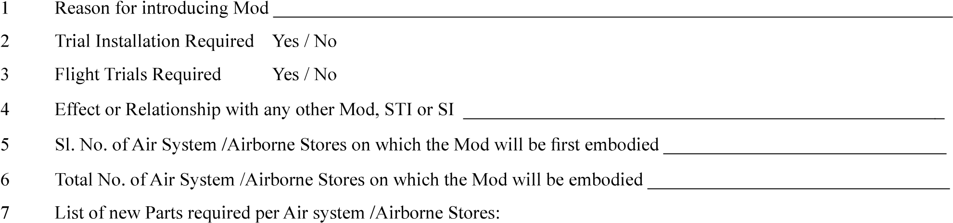
………………………………………………
……………………………………………
………………………………………………………………………………..
Part Number
Issue
Nomenclature
…………………………………………………………….
…………………………………………………………………………………………………
Part Number
Issue
Nomenclature

 |  | New Pt. No.
Issue |  | Issue
Version : 2.0 |  |  | Date: August 2023
69


FORM - 31

DETAILS OF MODIFICATION PROPOSED FOR AIR SYSTEM / AIRBORNE STORES
………………………………………………………..
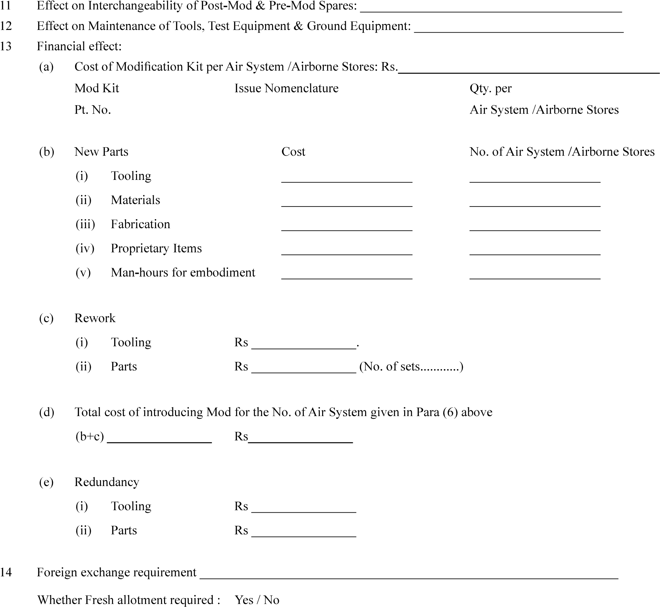
…………………………………………
…………………………….
………………………….
…………………………
……………………………
……………………….
…………………………
………………………
……………………….
………………………………..
…………………………….
………)
…………………….
……………………..
…………………....
…………………..
…………………..
………………….
…………………………………………………………..
………………………………………………...
………………………….
………………………………………………………………………
…………………………….

Version : 2.0 | Date: August 2023

