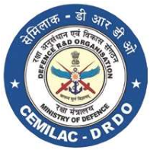
…………………………………………………
FORM -30D
APPLICATION FOR RENEWAL OF
RMTC/MTC FOR AIR SYSTEM
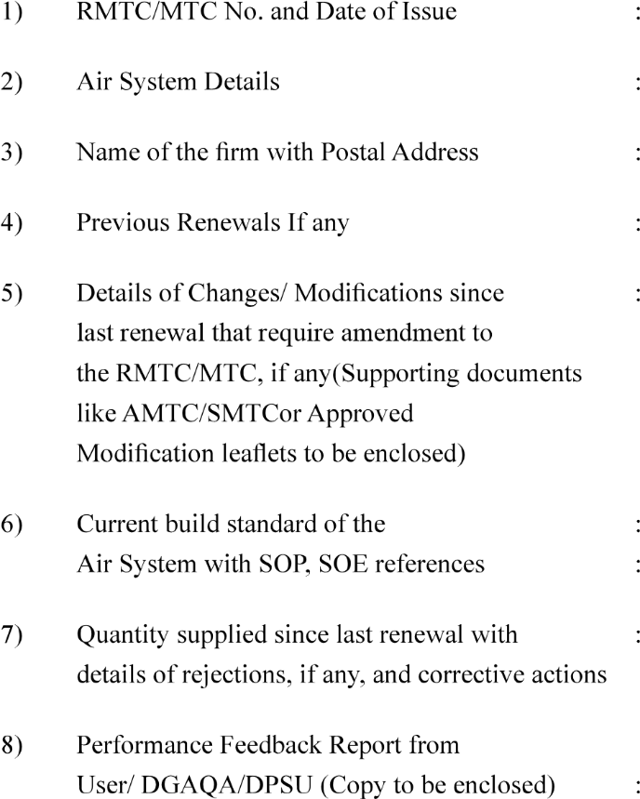
……………………………………….
……………………………….
………………………………………….
…………………………………………………
…………………………………….
…………………………………………………
…………………………………………..
…………………………………………………

(Signature of Head of the Design)
Version : 2.0 | Date: August 2023

