FORM - 30C

TYPE RECORD FOR AIR SYSTEM

Sl. No. |  |  | Contents of Type Record |  | Details, Reference | Record (as Appendix-A onwards with Page numbers)
2 |  | a | Nomenclature
 |  | b | Part Number
3
 |  |  | 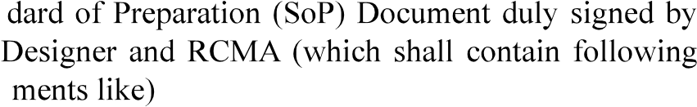
 |  |  | level.
 |  | c | Process document
5
6
7
8
9 |  |  | 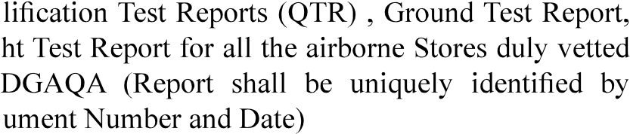
 | Version : 2.0 |  |  | Date: August 2023
66
FORM - 30C
TYPE RECORD FOR AIR SYSTEM
Sl. No. | Contents of Type Record | Details, Reference | Record (as Appendix-A onwards with Page numbers)
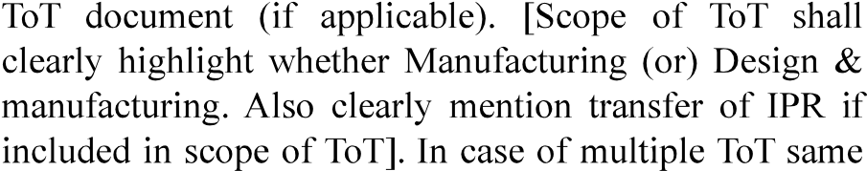
shall be indicated.
 | applicable

Signature of Head of Design

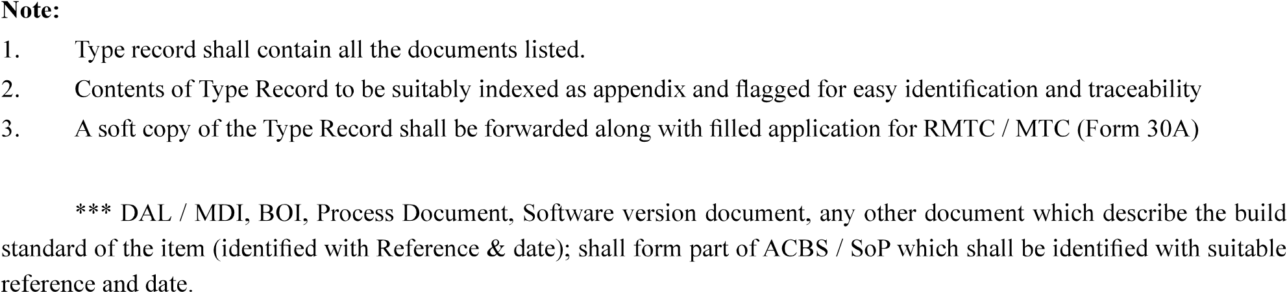
Version : 2.0 | Date: August 2023
67

