…………………………
………………………………………………………………………………………………………………………………………………………………
…………………….
………………
……………….
…...
……….
………………….

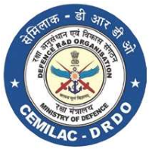
FORM - 30B TYPE CERTIFICATE DATA SHEET
Contents

…………………………………..
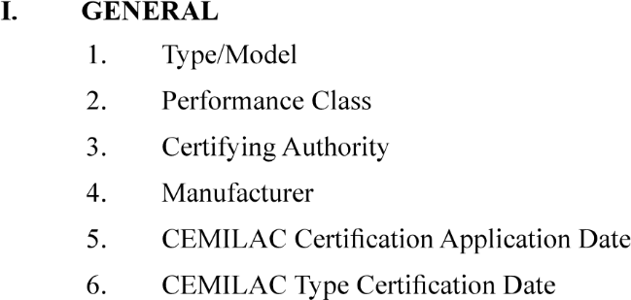
……………………………………
………………………………………
…………………………………………………………..

……………………………………………………….

……………………………………………………………
- CERTIFICATION BASIS

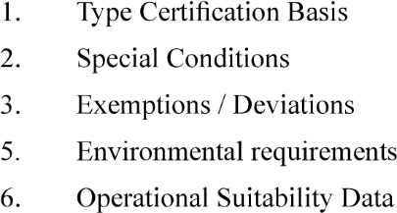
………………………………
……………………………………………………
…………………………………….
……………………………………………………………..
………………………………………………………..
- TECHNICAL CHARACTERISTICS AND OPERATIONAL LIMITATIONS
- OPERATING AND SERVICE INSTRUCTIONS

- OPERATIONAL SUITABILITY DATA (OSD)

- CERTIFICATE OF CONFORMITY AS PER FORM NO. 52 (By the Quality Head of the Organisation duly endorsed by DGAQA as Applicable)

