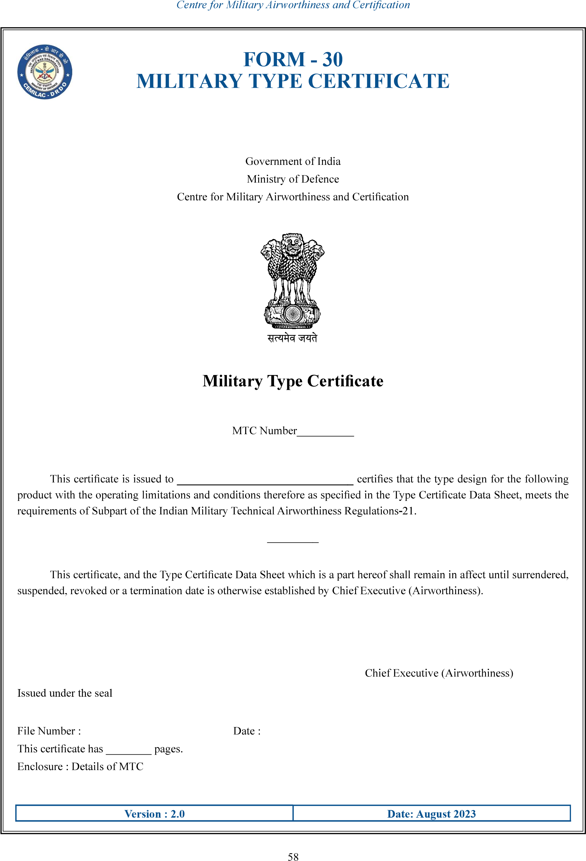
……..
….
………………….
…………………
……………………………..
………………..
……………………………………
……………

……….…………………
FORM - 30
MILITARY TYPE CERTIFICATE
 | Details of the TC Holder
 | Address
 | Air System Details
Version : 2.0 |  | Date: August 2023

59

