Directorate General of Aeronautical Quality Assurance
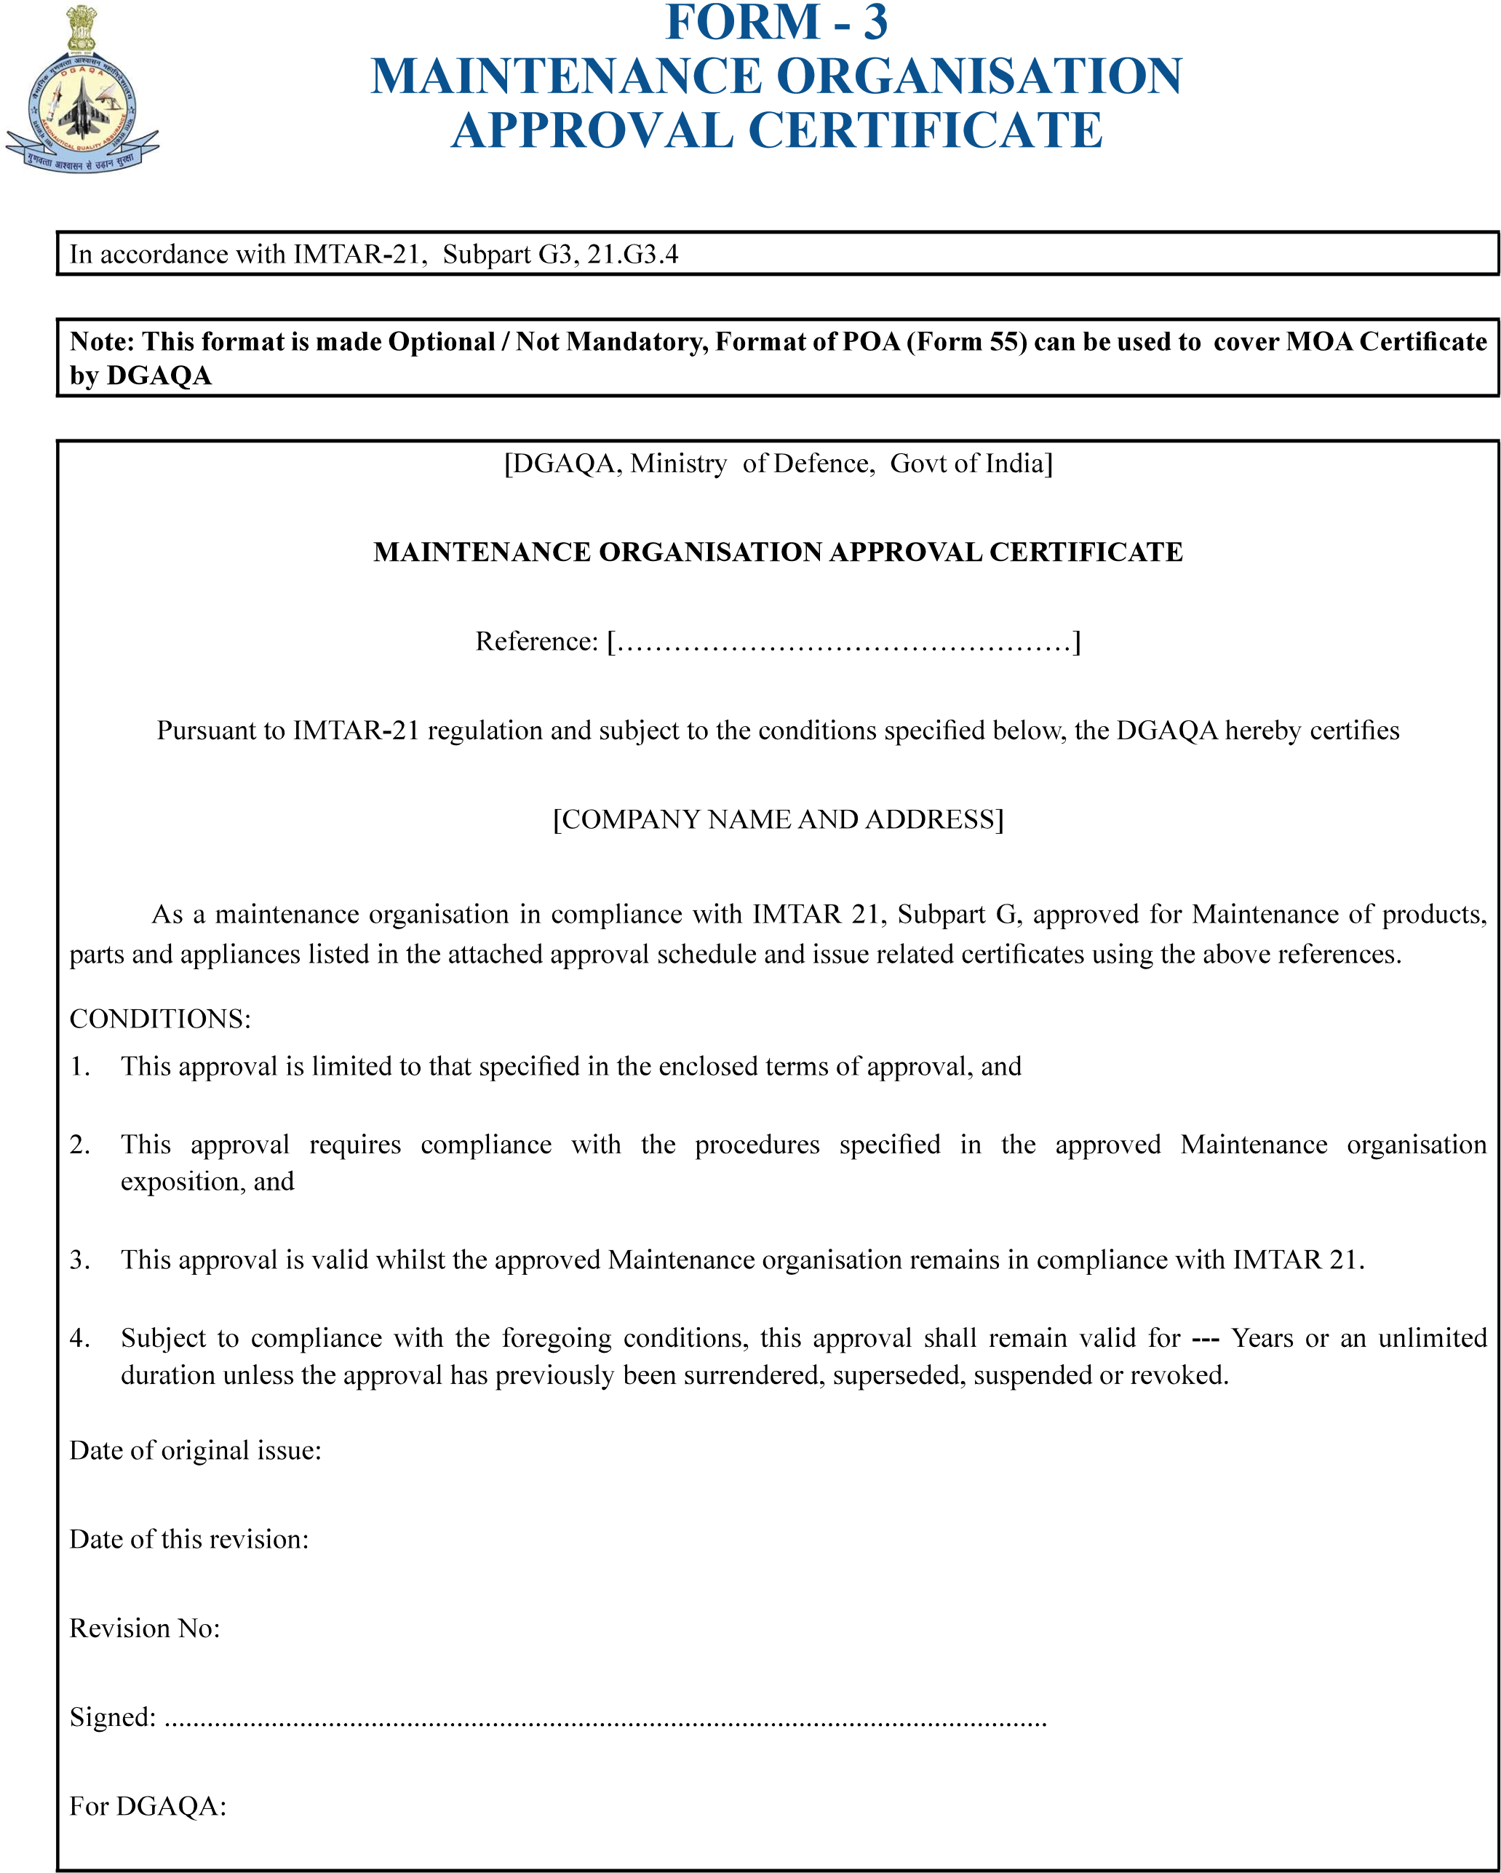
……………………………………………………………………………………………….
COMPANY NAME AND ADDRESS
…………………………………………………………
Version : 2.0 | Date: August 2023
6
Directorate General of Aeronautical Quality Assurance
FORM - 3

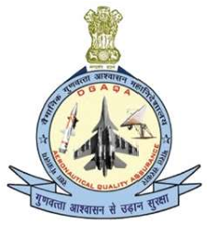
MAINTENANCE ORGANISATION APPROVAL CERTIFICATE
 | Terms of Approval |  |  | Ref:……….……………………………
This document is part of Maintaiance organisation Approval Number […………………………];
Compaay Name :
SCOPE OF WORK
LOCATIONS
PRIVILEGES
[keep only applicable text]
 | XXX
Flight Clearance may be issued in accordance with the Maintenance Organisation exposition Section…yyy……….
Revision No.
Version : 2.0 |  | Date: August 2023
7

