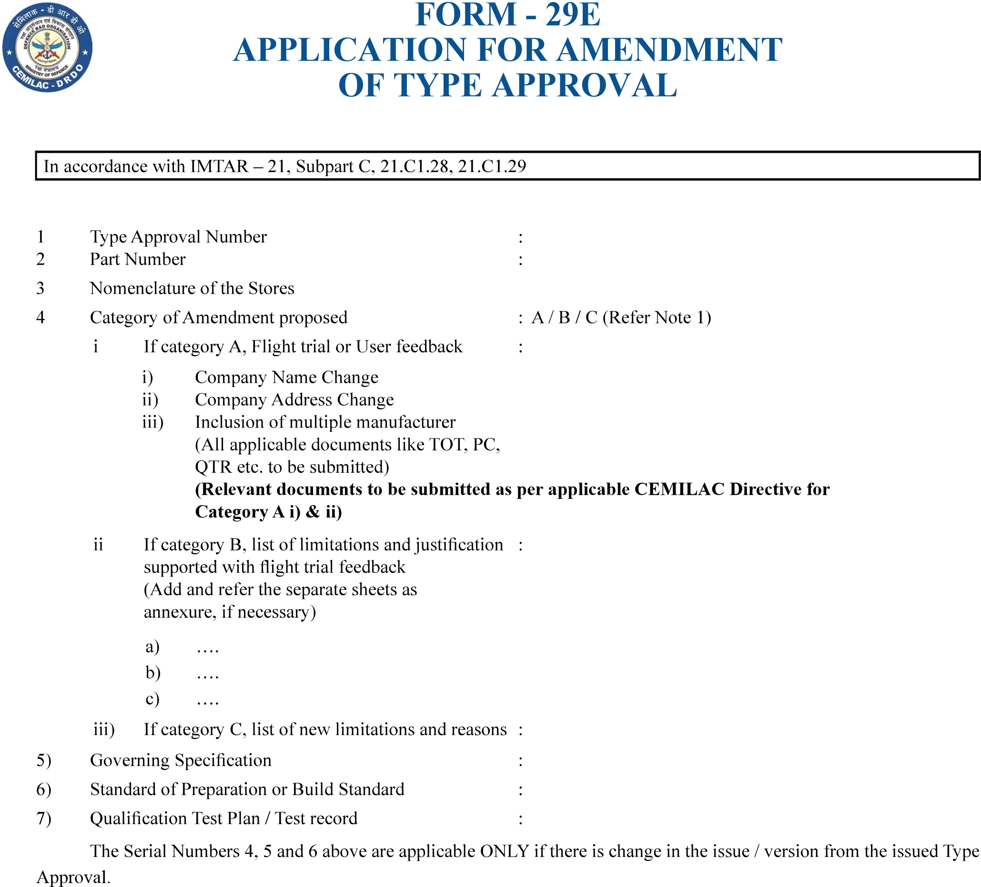
……………………………………..
……………………………….
…………………………………
…………………………………..
………………………………..
…………………………..
…………………………
………………………………
(Head of the Design)
………………………………………………………………
Recommendations of Regional Director
(SIGNATURE OF RD WITH SEAL)
Version : 2.0 | Date: August 2023
56
FORM - 29E

APPLICATION FOR AMENDMENT

OF TYPE APPROVAL
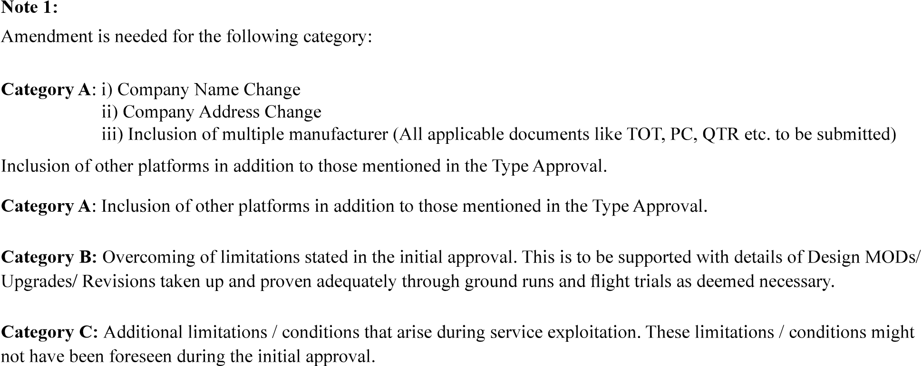
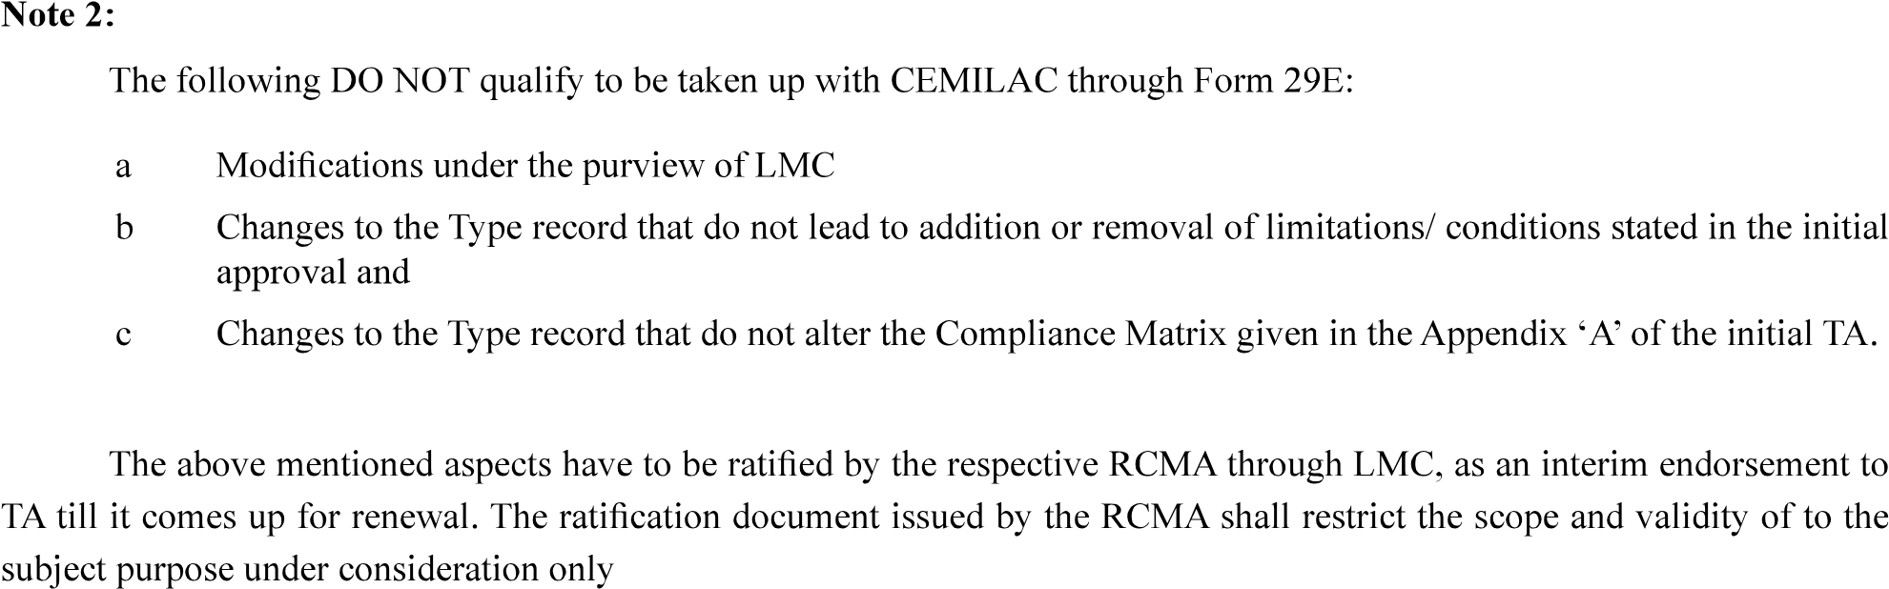
Version : 2.0 | Date: August 2023
57

