
FORM - 29C
TYPE RECORD FOR AIRBORNE STORES
Sl. No. | Contents of Type Record |  | Details, Reference | Record (as Appendix-A onwards with Page numbers)
2 | a Nomenclature b Part Number
3 | 
 | 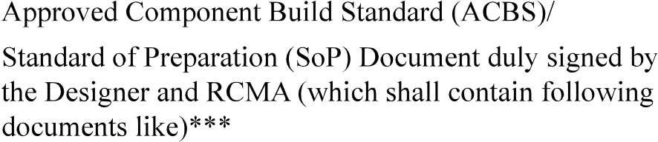
 | c Process document
 | 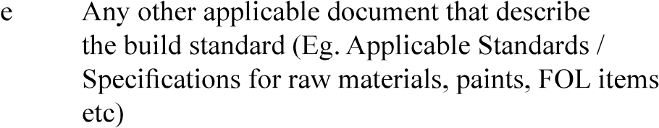
5 | 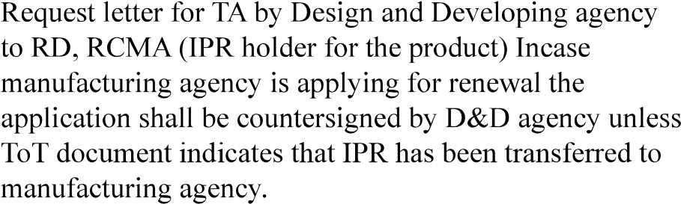
6
7
8 | 
9
Version : 2.0 |  | Date: August 2023

FORM - 29C

TYPE RECORD FOR AIRBORNE STORES
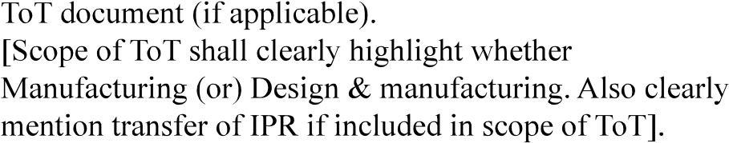
In case of multiple ToT same shall be indicated .
amendments issued

Signature of Head of Design

Signature of the Main Contractor (If applicable) (Note 1)

Recommendations of Regional Director
(SIGNATURE OF RD WITH SEAL)
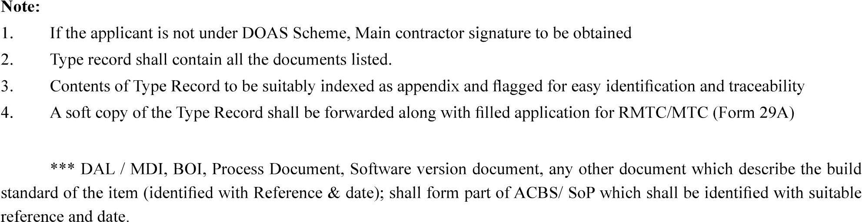
Version : 2.0 | Date: August 2023

