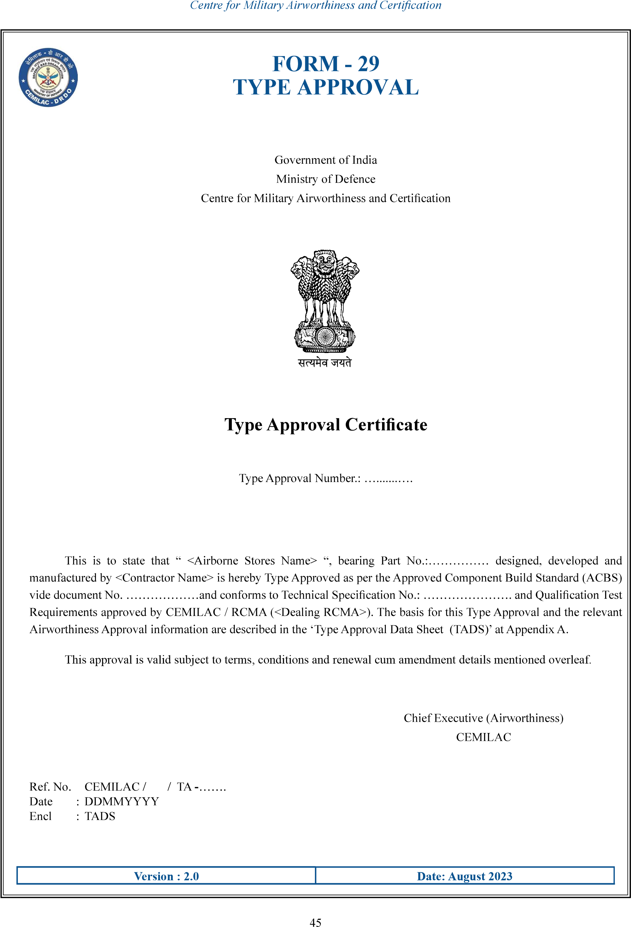
<Dealing RCMA>
………..
<Contractor name>

Chief executive (Airworthiness)
CEMILAC
......................
……………..
….……
“<Airborne stores name>”
……………………….
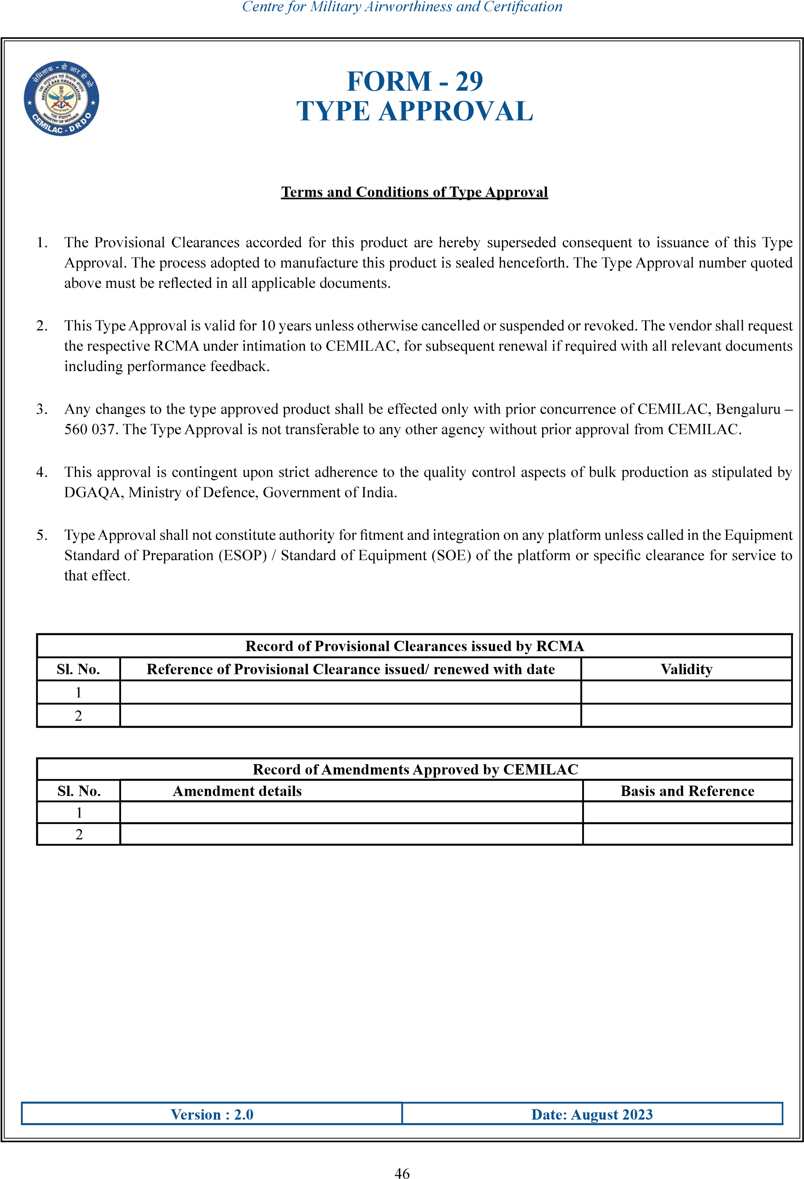

ghvjo
vjgjgj

