1. | Applicant’s Reference
1.1 | Your Reference:
2. | Applicant Address and Contact Data
2.1 | Applicant Data
2.2 | Name and  Address
2.3 | Contact Person
2.3 |  |  | Position Title
2.3 |  |  | Phone
2.3 |  |  | Email
3. Aircraft / UAS / ALM/Engine
3.1 Registration Mark: |  | 3.2 Manufacturer |  | 3.3 |  | Type and  Model | 3.4 | Serial No. |  | 3.5 Hou | rs / Cycles
Aircraft
Engine
UAS
ALM
4. Type Design and Other Information
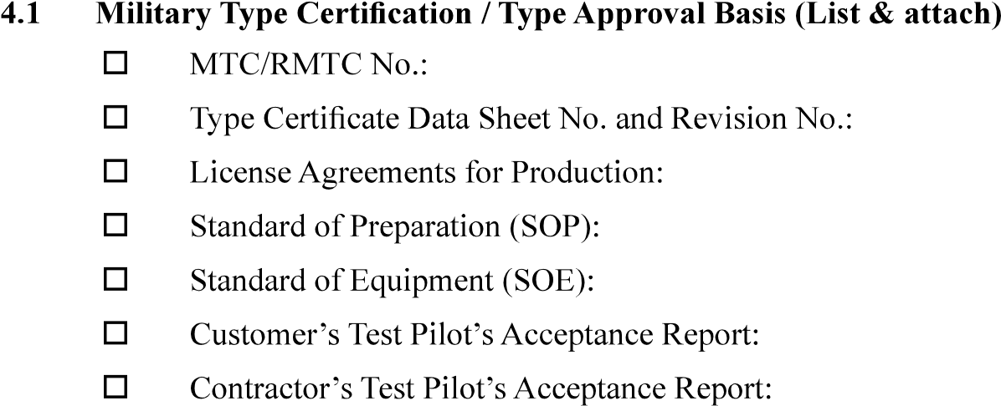
4.2.1 SI/ STI/ UON/ Repair / Production  Deviation | 4.2.2. Description | 4.2.3 Approval /  Installation Status | 4.2.4 ICA Supplements /  Remarks
No. | 4.3.2 Description | 4.3.3 Issuing Authority | 4.3.4 Compliance Status /  Comments

4.4 | Mass and Balance for Air System:
4.5 | Conformity documentation (provide all applicable – follow the note in the guidance section)  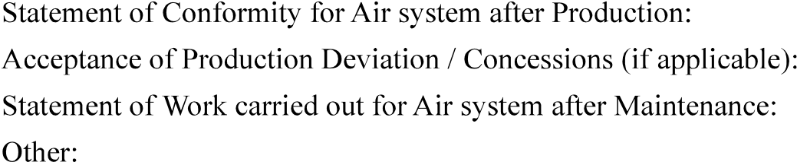
4.6 | Manuals and Instructions for Continuing Airworthiness (ICA)  