Directorate General of Aeronautical Quality Assurance
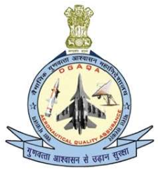
FORM - 25
SIGNALING OUT CERTIFICATE
FOR AN AIR SYSTEM
To
SIGNALING OUT AIR SYSTEM _____________ (TYPE), TAIL NUMBER (_____________)
After _______________________ (Mfg / Upgrade / Servicing / Overhaul)d
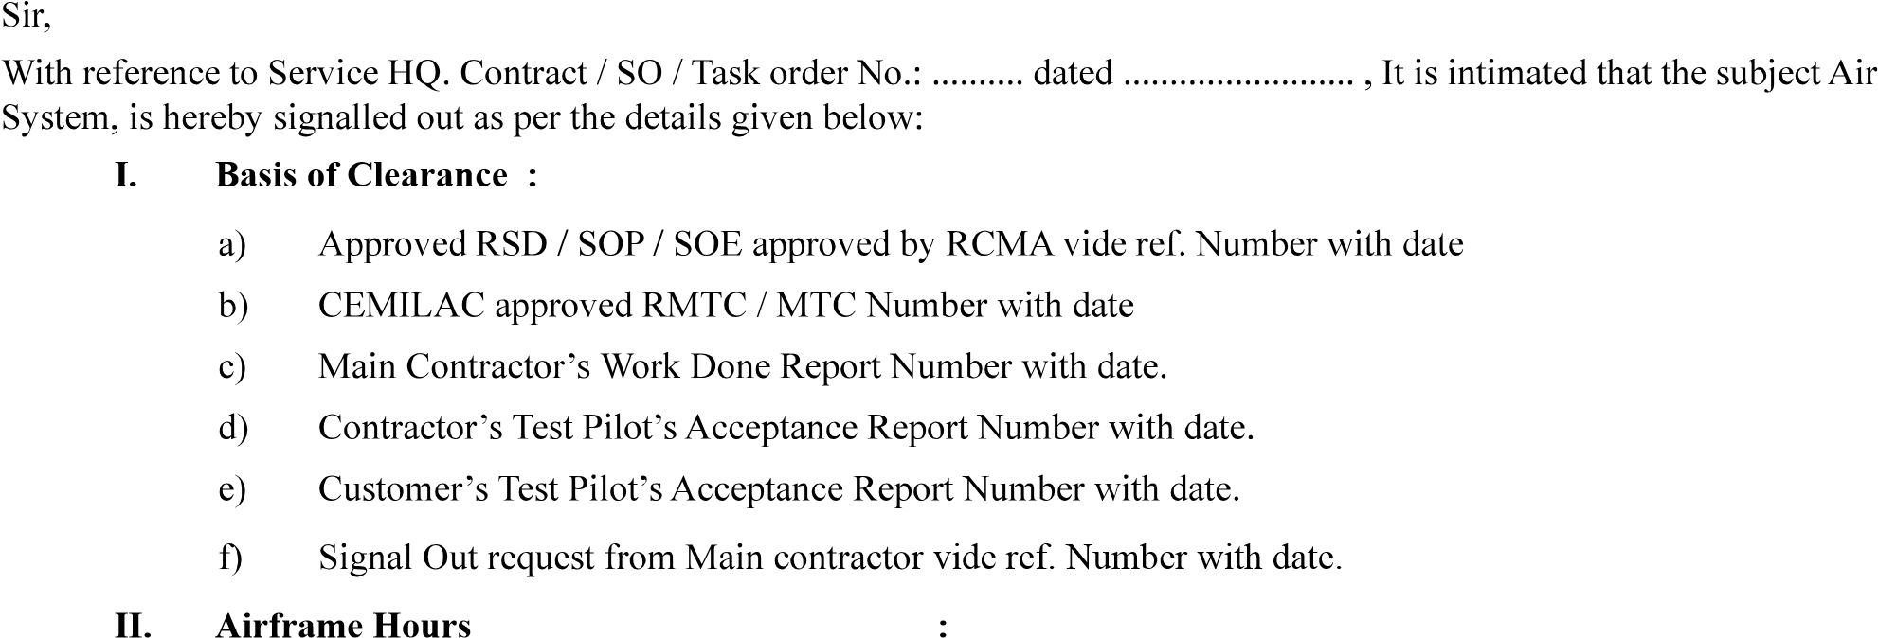
……
………………..

III. Engine Number with completed Hours :
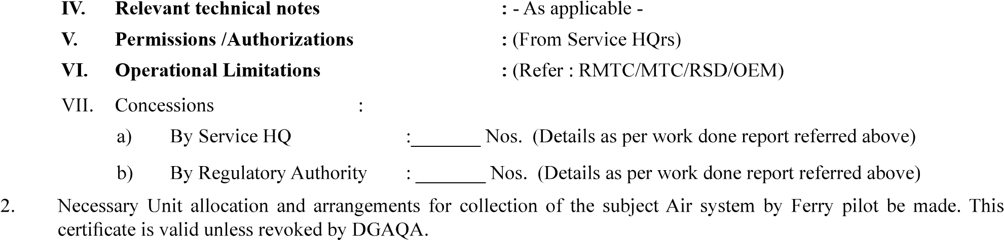VI. Operational Limitations

Distributions:

