
FORM - 23
DECLARATION OF DESIGN AND
PERFORMANCE OF AIRBORNE STORES
DoDP No. ___________________________________________________________ ISSUE No. ___________________________________________________________

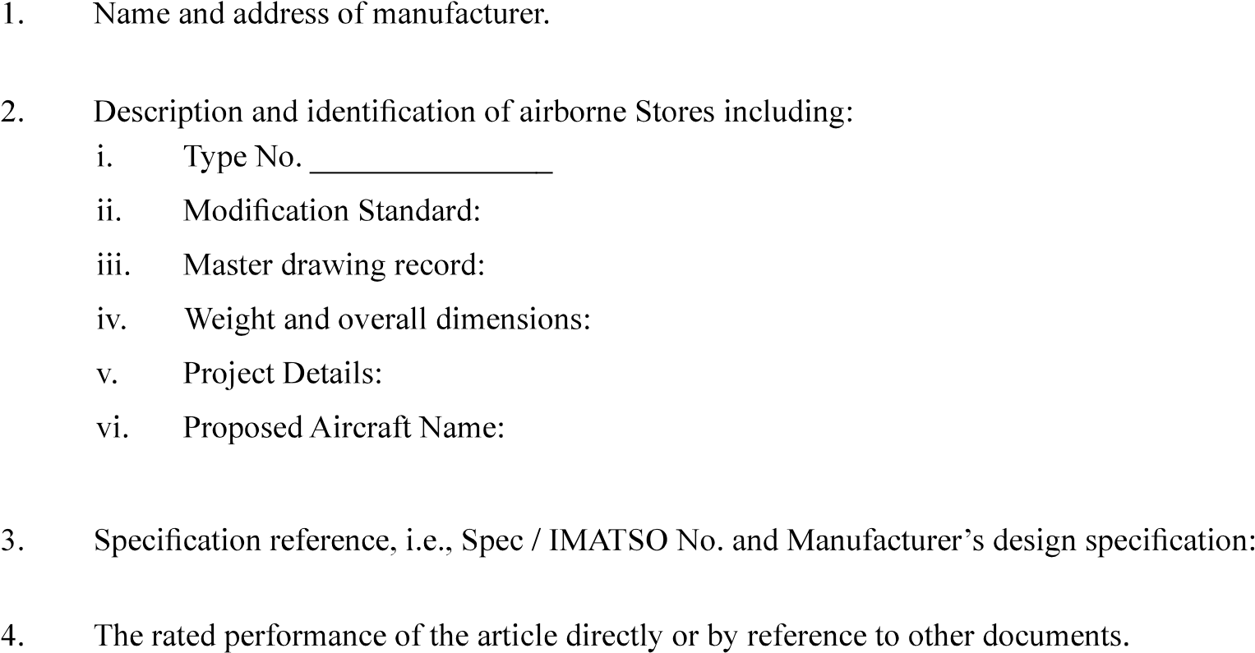

5. Particulars of approvals held for the equipment.

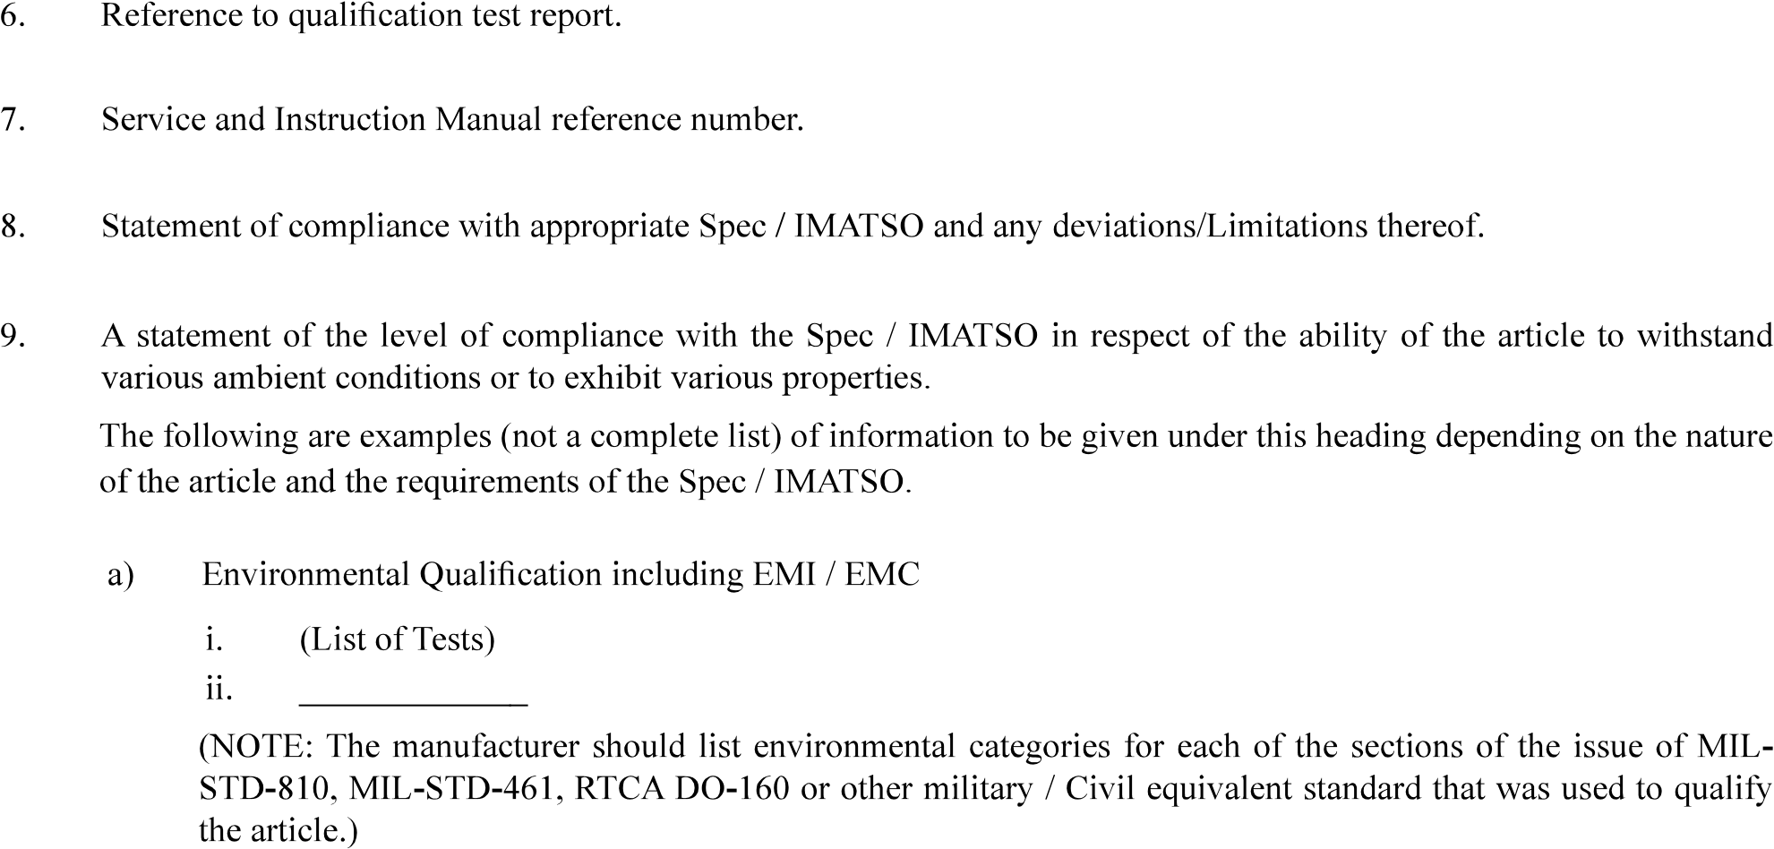

Version : 2.0 | Date: August 2023
FORM -23
DECLARATION OF DESIGN AND

PERFORMANCE OF AIRBORNE STORES
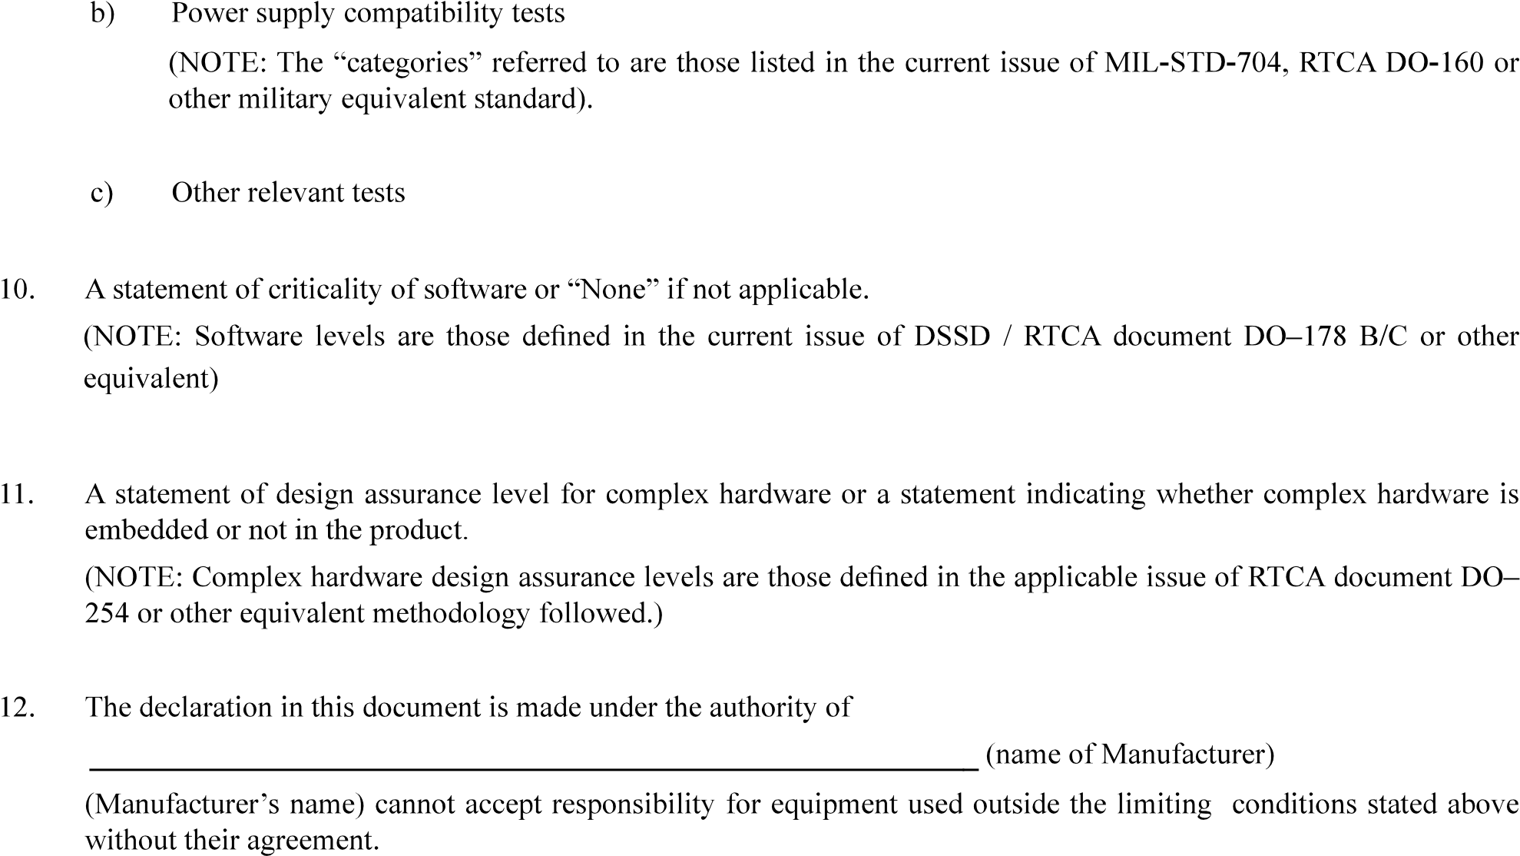

Version : 2.0 | Date: August 2023

