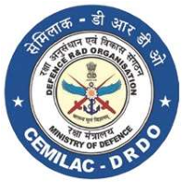
FORM - 22A
SOFTWARE CHANGE REQUEST (SCR)

Platform
