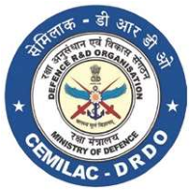
FORM - 21E DESIGN CRITERIA FORM/ INPUT DATA SHEET FOR NON METALLIC MATERIALS AND COMPONENTS, PAINTS AND COATINGS
Project : Material Name of Inspection Agency : Manufacturing Process Route :
Name of the Developing/ Manufacturing Agency: Supply Condition :
Nominal dimension of the component (if applicable):

Reference
Applicant’s Reference |  | Date
Version : 2.0 | Date: August 2023

 | Reference No.
2. | Nomenclature of the Product
3.
5.
6.
7.
8.
9
Enclosures
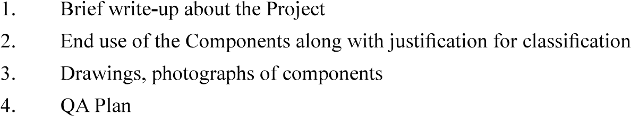
Signature
Name & Designation
Name of Organisation (with Seal)

Countersigned by CEMILAC

