
FORM - 21D
DESIGN CRITERIA FORM FOR POLYMER /
METAL MATRIX COMPOSITE BRAKE PADS
Reference
Applicant’s Reference |  | Date:
Project : Material Name of Inspection Agency : Manufacturing Process Route :
Name of the Developing/ Manufacturing Agency: Supply Condition :
Nominal dimension of the component (if applicable):
 | Reference No.
2. | Part No. | Part name
3.
5.
6.
 | Parameter
7.
8.
9.

Enclosures:
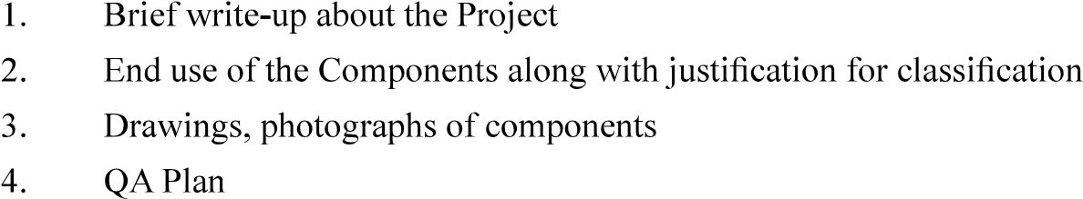 Signature
Name & Designation
Name of Organisation (with Seal)
Countersigned by CEMILAC

