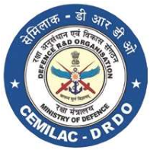
FORM - 21C
DESIGN CRITERIA FORM FOR
COMPOSITES/ CERAMIC COMPONENTS
Reference
Applicant’s Reference |  | Date:
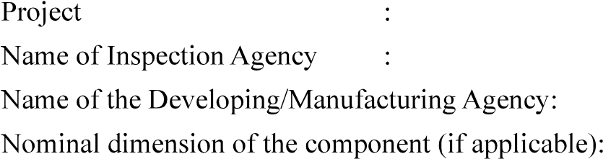
Signature:
Name and Designation:
Name of Organisation (with Seal):

Enclosures:

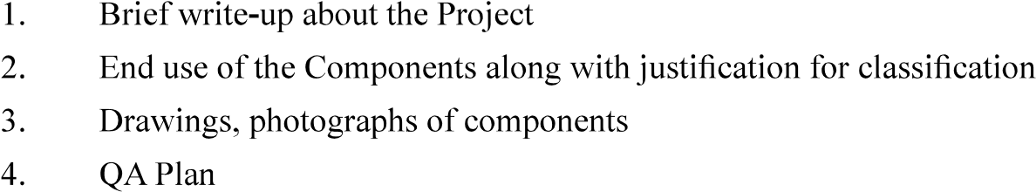

No. | onent  Name |  | Requirements | Environmental | Temperature | Requirements | information
 |  | critical | 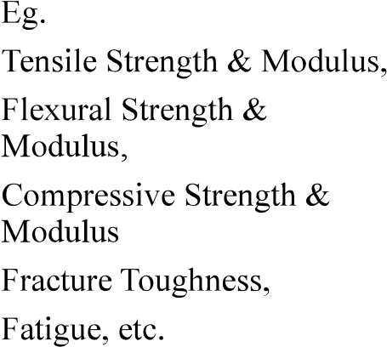 |  |  | 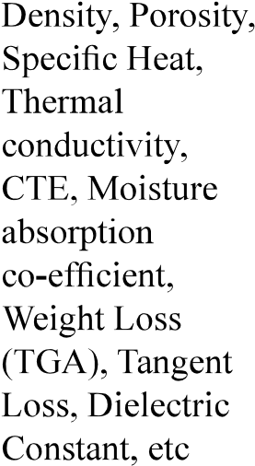

Counter Signed by CEMILAC

