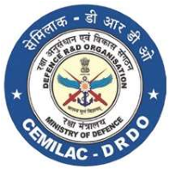
FORM - 21B
DESIGN CRITERIA FORM FOR
CARBON-CARBON AIRCRAFT BRAKE DISCS
Reference
Applicant’s Reference |  | Date:

jhjhhu
No. | onent  Name | cation |  |  | Environmental and Temp | Requirements of Metallic  Attachments, | inform-  ation
 |  | Non  critical | 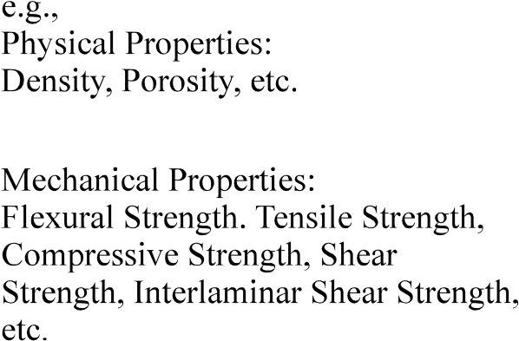  Thermal Properties  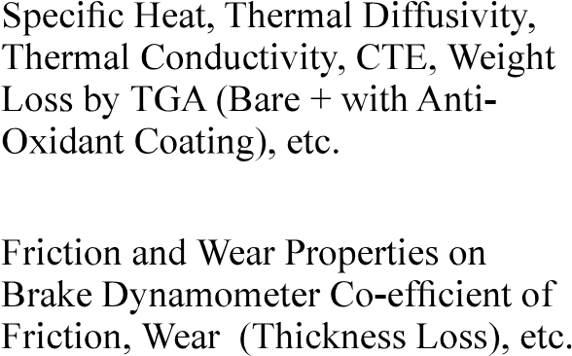 | Kinetic  Application  Pressure,  Torque,  Temperature
Enclosures:
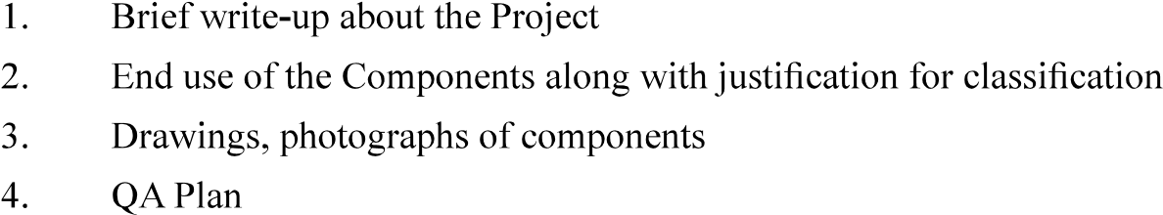
Signature:
Name and Designation:
Name of Organisation (with Seal):

Counter Signed by CEMILAC
Version : 2.0 | Date: August 2023

