Reference
Applicant’s Reference |  | Date:

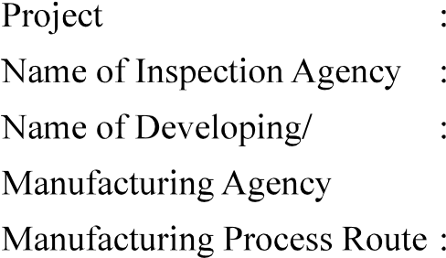
No. | onent | cation |  |  |  | Environmental | Temperature | requirements* | information
No. | onent | cation |  |  | conditions
 |  | Non  critical |  |  |  |  |  | No. of joints,  details which are to be welded, Material  approved or
Enclosures:

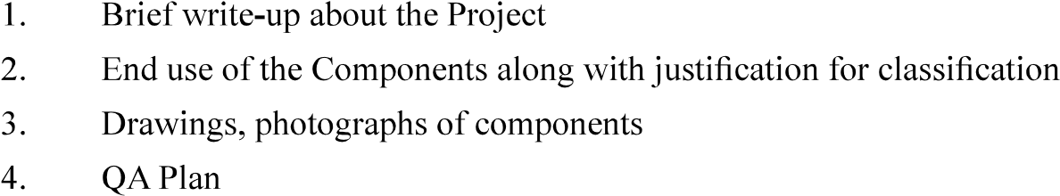
Signature:
Name and Designation:
Name of Organisation (with Seal):

Counter Signed by CEMILAC
Version : 2.0 | Date: August 2023

