Directorate General of Aeronautical Quality Assurance
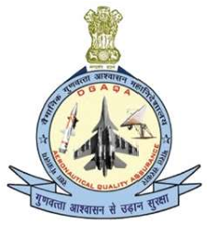
FORM - 2
APPLICATION FOR MAINTENANCE
ORGANISATION APPROVAL
Note: This Form to be provided along with Form F1001, Appendix A of AFQMS 2018, Issue-II
DIRECTORATE GENERAL OF AERONAUTICAL QUALITY
ASSURANCE (DGAQA), GOVERNMENT OF INDIA, MINISTRY OF DEFENCE, ‘H’ BLOCK, NEW DELHI-110011
Version : 2.0 | Date: August 2023
2
Directorate General of Aeronautical Quality Assurance
FORM - 2

APPLICATION FOR MAINTENANCE ORGANISATION APPROVAL
Guidelines for Completion of the IMTAR Form 2
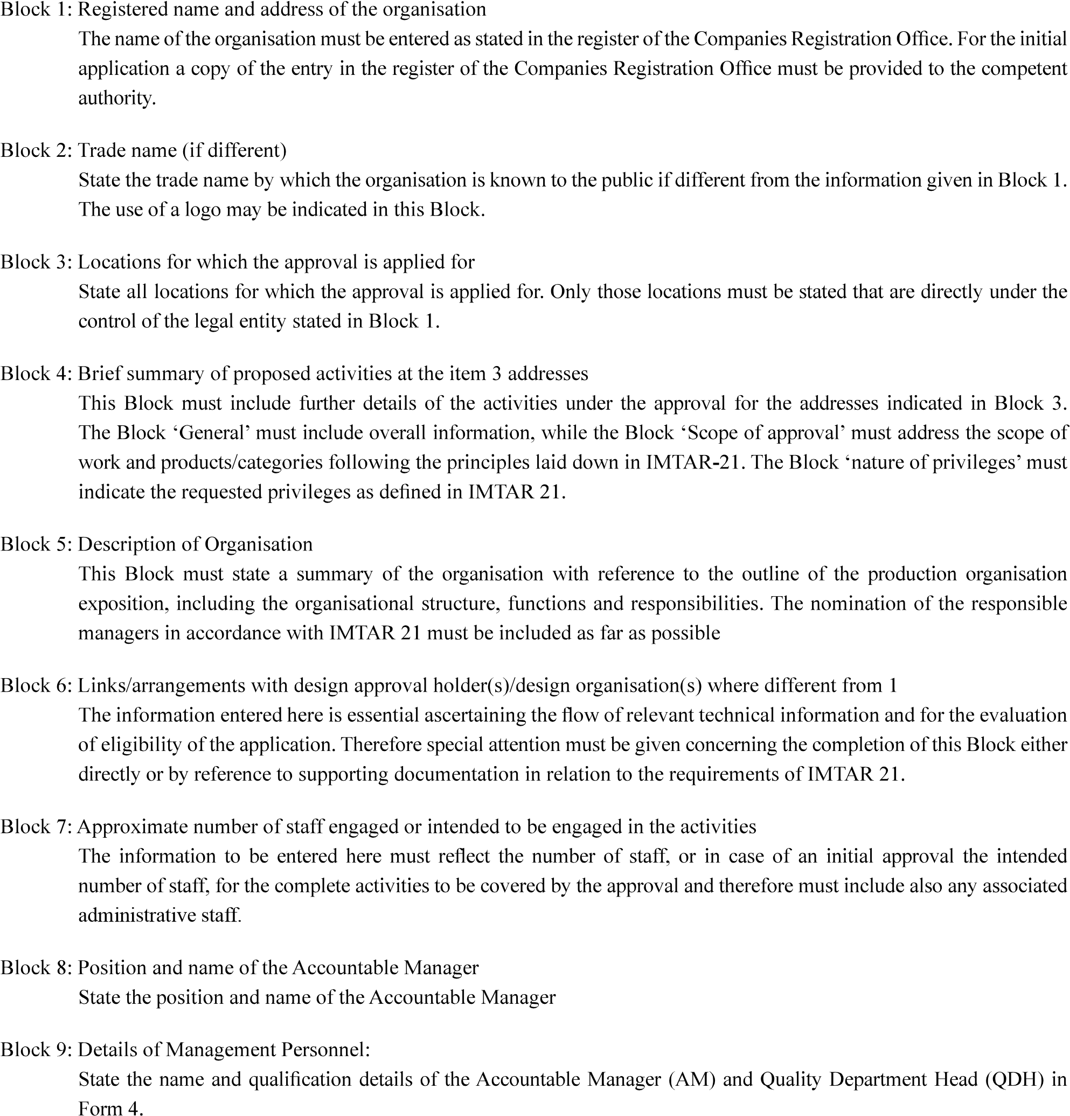
Version : 2.0 | Date: August 2023
3

