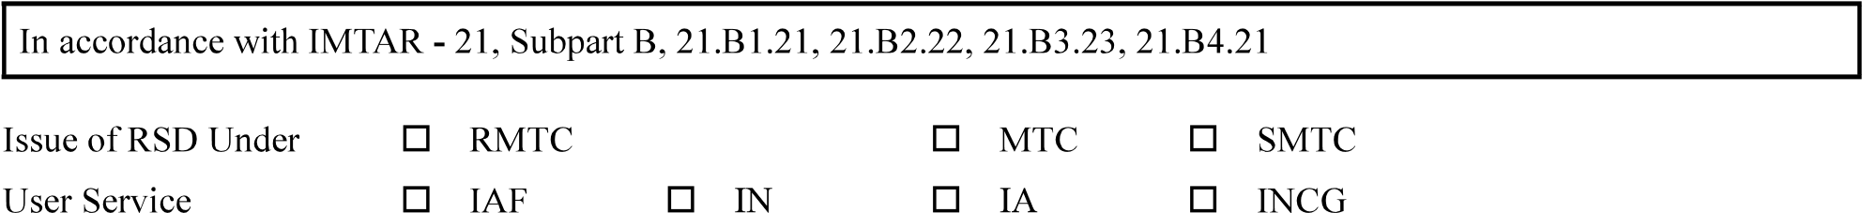
1. | Reference
1.1 | Applicant’s Reference |  |  |  | Date:
2. Applicant’s Information
2.1 Applicant Company Data
2.1.1 Name and Address |  | Applicant Number
 |  | PIN
2.1.2 Contact Person |  | Title |  | Mr Ms
 |  | Name
2.2 Address for Communication
2.2.1 Address
communication
 |  | PIN
2.3 Organisation Approval Details
2.3.1 DOA Details

3. Air System Description
3.1.1 Air System Type
Number / Part
Number
3.1.2 Air System
Nomenclature
3.2 CEMILAC Project
Code
3.3 Brief about the
Project
3.4 Proposed IMTAR
Sub-part
3.5 RMTC / MTC
Number

4. | Air systems Requirements Details
4.1 | Staff Requirements | If applicable
4.2 | Airworthiness  Criteria
4.3 | Air system  Requirement
 | Basis
4.5 | Airworthiness
5.1 | Standard of  Preparation
5.2 | Standard of  Equipment
6.1 | TCB Compliance
6.2 | Limitations List
 | Data Sheet (TCDS)
7. | Release to Service Details
7.1 | User Acceptance  Letter
7.2 | List of Technical and Flight Publications | Add as enclosure
7.3 | RSD Document  Reference

Place
Important Note: CEMILAC does not accept applications without signature. Please make sure that the application is

Note: This application along with the required documents shall be forwarded to dealing RCMA / CEMILAC for further process.
Acknowledgement of Receipt of Application
1. | Applicant’s Reference
2. | Address
2. | Address | PIN
3. | Air System Title

in due course of time

