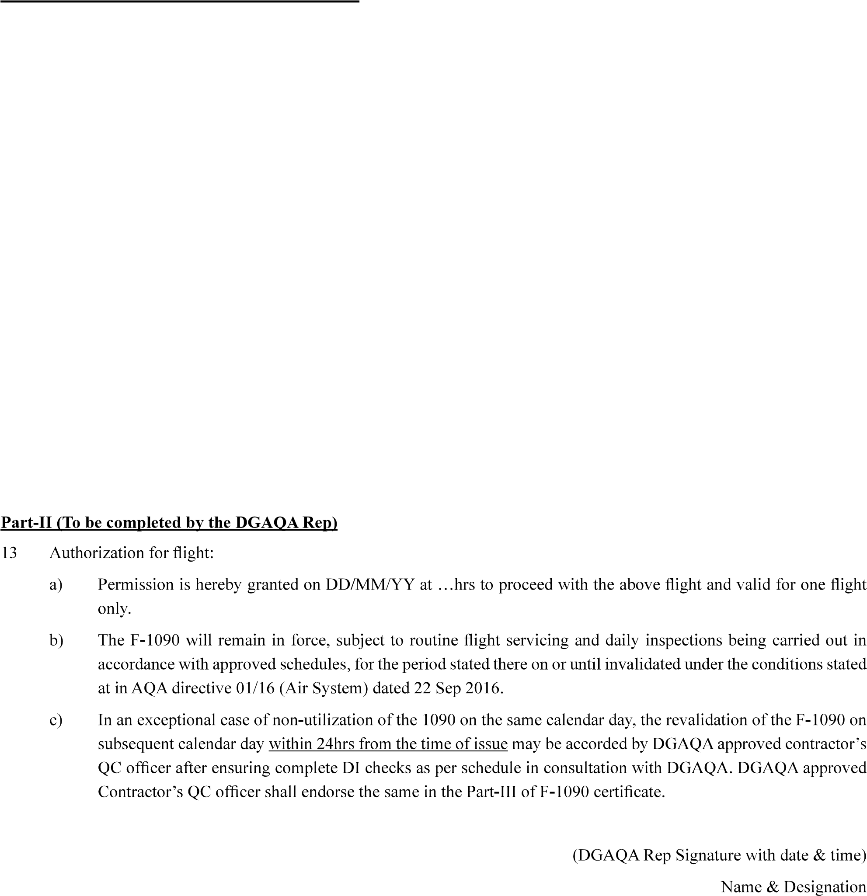
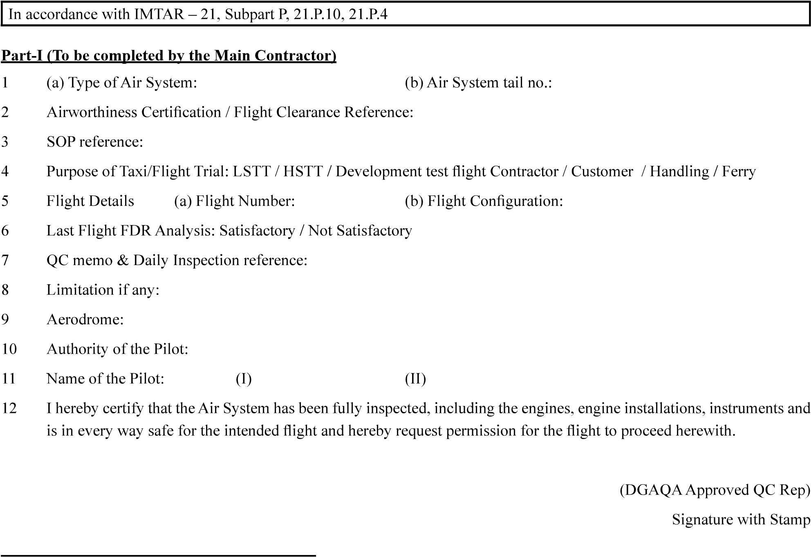
DD/MM/YY
…
………………………………………………
…………………………………………..
……………………….
………………………..
……………………………
………………………………………….………………………………..
……………………………..
…………………………..
……………..
…………………………………………..
………………………………………….
…………………………………..
…………………………….
CERTIFICATE OF SAFETY
FOR FLIGHT
Part-III - Revalidation
Revalidation:
……………………………………..
………………….
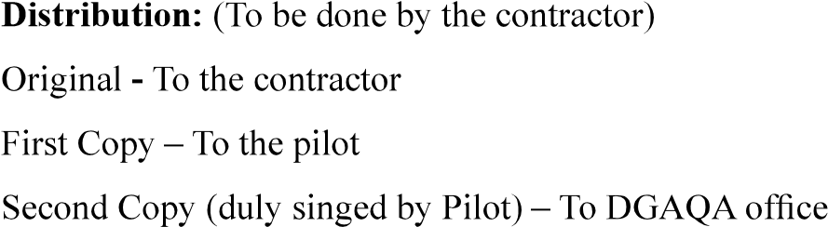
II is revalidated.
………………………………………………………
Part - IV
