Version : 2.0 | Date: August 2023

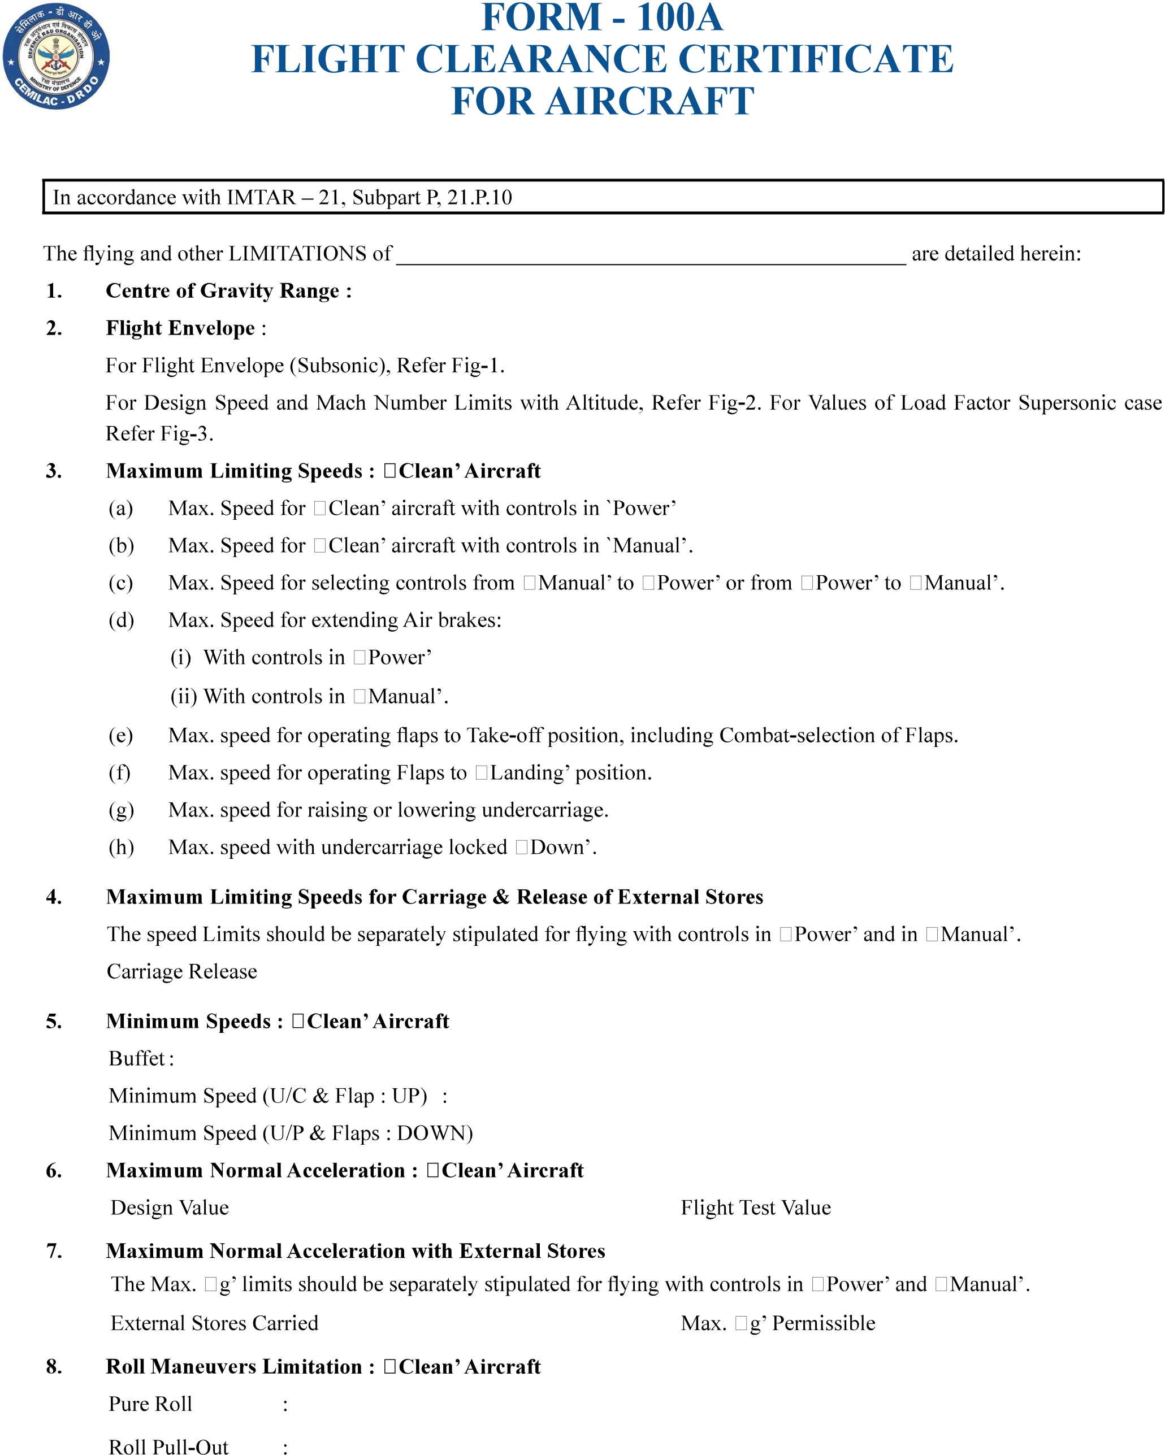

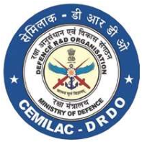
FORM - 100A FLIGHT CLEARANCE CERTIFICATE FOR AIRCRAFT
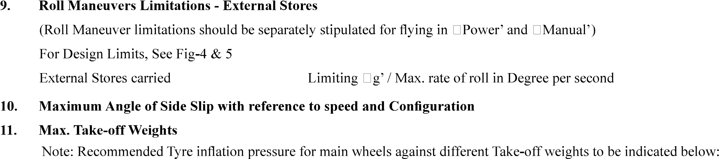
Version : 2.0 | Date: August 2023
13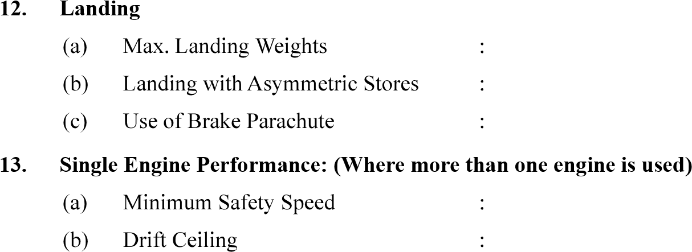.
- One Engine Failure During Take-off : (Where more than one engine is used) (Min Safety Speed)
- Engine Relights (Relight envelop speed / mach no. vs altitude)
- Pressure Error Correction
- Use of AVTAG (JP-4) Fuel
- Gun Firing
- Ejection Seat

- Engine Limitations

